FINAL BASIC ASSESSMENT REPORT

PROPOSED DEVELOPMENT AND UPGRADING OF INFRASTRUCTURE WITHIN THE GREAT FISH RIVER NATURE RESERVE, EASTERN CAPE PROVINCE
DFFE Ref: 14/12/16/3/3/1/2804

OCTOBER 2023

JG AFRIKA REF NO: 5446

Prepared for:
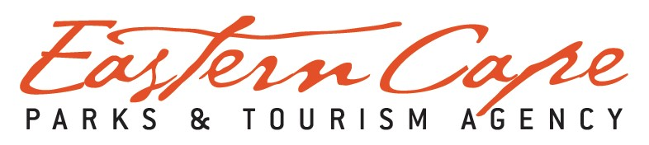

Prepared by:
JG AFRIKA (PTY) LTD
PO Box 27308
Greenacres
6057
Gqeberha
Telephone: 041 390 8700
Email: coetzeec@jgafrika.com
Contact Person: Cherize Coetzee

VERIFICATION PAGE |  |  |  |  |  |  | Qual-frm-026
 |  |  |  |  |  |  | Rev 14
TITLE:
PROPOSED DEVELOPMENT AND UPGRADING OF INFRASTRUCTURE WITHIN THE GREAT FISH RIVER NATURE RESERVE, EASTERN CAPE PROVINCE
JGA REF. NO. |  | DATE: |  |  |  | REPORT STATUS
5446 |  | 16 October 2023 |  |  |  | Final for decision-making
CARRIED OUT BY: |  |  |  | COMMISSIONED BY:
JG AFRIKA (PTY) LTD  GQEBERHA  PO Box 27308  Greenacres  6057 |  |  |  | EASTERN CAPE PARKS AND TOURISM AGENCY  17 – 25 Oxford Street  East London  5201
Tel.: +27 41 390 8700  Email: coetzeec@jgafrika.com |  |  |  | Tel: +27 43 492 0866  Email: Londeka.Jilimane@ecpta.co.za
AUTHOR |  |  |  | CLIENT CONTACT PERSON
Cherize Coetzee |  |  |  | Londeka Jilimane
SYNOPSIS
Final Basic Assessment Report associated with the proposed Development and Upgrading of Infrastructure within the Great Fish River Nature Reserve, Eastern Cape - DFFE Ref: 14/12/16/3/3/1/2804
KEY WORDS:
Basic Assessment; Legislative Requirements; Environmental Authorisation; Infrastructure; Development; Upgrade; Nature Reserve; Protected Area, Listed Activities
© COPYRIGHT: JG Afrika (Pty) Ltd
QUALITY VERIFICATION
This report has been prepared under the controls established by a quality management system that meets the requirements of ISO 9001: 2015 which has been independently certified by DEKRA Certification.
Verification | Capacity |  | Name |  | Signature |  | Date
By Author: | Environmental Scientist |  | Cherize Coetzee |  |  |  | 16 October 2023
Reviewed by: | Snr Environmental Scientist |  | Ryan Jonas |  |  |  | 16 October 2023
Authorised by: | Director |  | Duane Petersen |  |  |  | 16 October 2023
Filename: | C:\Users\mattheusc\JG Afrika (Pty) Ltd\Job5446-GFRNR Infrastructure Development - 101-WIP-Internal-Sci - 101-WIP-Internal-Sci\109-Reports\Final BAR

EXECUTIVE SUMMARY

Protected Areas (PAs) in South Africa are increasingly under threat resulting in adverse impacts on the biodiversity and ecosystems they harbour, on the rural population dependent on them, and on the broader regional and national economies. Illegally traded natural resources contribute significantly to the loss of biodiversity and threaten sustainable and inclusive development. One of such illegal activities is rhino poaching.

The Great Fish River Nature Reserve (GFRNR) supports a particular significant black rhino population that meets the African Rhino Specialist Group (AfRSG) criteria for Key 1 status. The Eastern Cape Parks and Tourism Agency (ECPTA) is responsible for the management of provincial nature reserves in the Eastern Cape, including the GFRNR. The GFRNR has been selected as one of two sites to participate in the World Bank funded Wildlife Conservation Bond (WCB) project, which is an innovative financial instrument that channels investments to achieve conservation outcomes.

The following activities are proposed to be undertaken as part of the infrastructure development and upgrading within the GFRNR to secure the rhino population in the reserve:
- Establishment of a 4 x 4 track and installation of new gabions structures and repair works to existing gabions along the reserve’s perimeter fence;
- Maintenance of sections of the existing internal gravel road network and the development of a new road at the Double Drift airfield strip as well as the refurbishment of existing culverts;
- Upgrading of three (3) existing watering points and the decommissioning of eleven (11) unwanted small farm watering points; and,
- Extension of the Kamadolo airfield strip

As per GNR. 982 of the Environmental Impact Assessment (EIA) Regulations (2014, as amended) a Basic Assessment (BA) Process must be undertaken in such a manner that the environmental outcomes, impacts, and residual risks of the proposed Listed Activities being applied for are noted in the Basic Assessment Report (BAR) and assessed accordingly by the Environmental Assessment Practitioner (EAP). In this regard, the requirements of the Basic Assessment (BA) Process are noted in the EIA regulations (2014, as amended), Appendix 1 of GNR 982 and are consequently adhered to in this report. In addition, a Water Use Authorisation (WUA) will be applied for to the Department of Water and Sanitation for approval.

JG Afrika (Pty) Ltd has been appointed as the independent EAP by the ECPTA to apply for Environmental Authorisation (EA) subject to a BA process, in terms of the EIA Regulations (2014, as amended) promulgated under the NEMA) (Act 107 of 1998), for those proposed infrastructure developments and upgrades in the GFRNR (Figure 1-1). Since the WCB project is a World Bank funded project, the ECPTA must comply with the World Bank’s Environmental and Social Standards (ESSs) which are articulated in its Environmental and Social Framework (ESF). In addition to complying with the ESF, the ECPTA must also adhere to subordinate World Bank policy and good practice documents. Although the current BAR has been produced to meet the requirements of the NEMA: EIA Regulations (2014, as amended) it is also aligned with the requirements of the World Bank for environmental and social impact assessment (ESS 1 of the World Bank ESF).

Five (5) specialist studies have been conducted to date, namely an Aquatic Impact Assessment, Terrestrial Biodiversity & Plant Species Impact Assessment, Faunal Impact Assessment, Archaeological Impact Assessment and Palaeontological Impact Assessment. These specialist studies have informed various sections of the Final BAR.

To date, Public Participation has been conducted in accordance with the requirements in Regulation 41 (2) of Chapter 6 of the EIA Regulations (2014, as amended), which outlines the methods required for Public Participation. Formal Public Participation commenced 17 July 2023 and ended 17 August 2023. An advert was placed in the local newspaper, The Herald, on 17 July 2023 to notify the public of the availability of the Draft BAR for public review and comment. Stakeholders and I&APs were notified of the availability of the Draft BAR via e-mail (where e-mails were available) or WhatsApp on 17 July 2023. Furthermore, a copy of the report was uploaded onto the following websites for public review:
- JG Afrika (Pty) Ltd website: www.jgafrika.com; and,
- ECPTA website: www.visiteasterncape.co.za;
Hard copies of the Draft BAR were also made available for review at the following locations:
- Sam Knott and Double Drift offices of the GFRNR; and,
- Front desks of the Makana Local Municipality, Raymond Mhlaba Local Municipality, and Ngqushwa Local Municipality

Several impacts associated with the listed activities triggered have been identified and assessed for the construction phase. These include:
- Alteration to surface water features;
- Surface water and ground water contamination;
- Site contamination;
- Vegetation (Flora);
- Fauna;
- Soil disturbance;
- Solid waste pollution;
- Archaeological and Palaeontological impacts;
- Air emissions;
- Noise Pollution;
- Visual and aesthetics;
- Fire risk;
- Construction traffic impedance;
- Occupational health and safety, and staff management;
- Safety and security;
- Existing infrastructure disturbance; and,
- Socio-Economic impacts

The greatest impacts of significance, identified for the construction phase, are those associated with vegetation disturbance: loss of natural vegetation; loss of plant SCC’s; illegal harvesting of plant species, and the erosion and degradation of impacted areas. These impacts were rated as ‘high’ pre-mitigation while the remainder of impacts were rated as low to medium. All identified impacts can be reduced to low negative or insignificant with the adequate implementation of mitigation measures as proposed in Table 13-2 and included in the Environmental and Social Management Programme
(ESMPr). In addition, a benefit associated with the proposed development and upgrading relates to that of socio-economic during the construction phase mainly through the creation of job opportunities for skilled personnel (e.g., contractor, specialists etc.) and non-skilled personnel (e.g., labourers), Skills development of the local community through employment opportunities, and possible economic benefits to local suppliers of building materials. As such, it is recommended that the Preferred (and only) Alternative be adopted.

The operational aspect of the proposed activity is anticipated to ensure easier and more rapid access to areas across the reserve, thereby adding to the overall safety and security of the black rhino within the GFRNR. This will enhance conservation efforts, facilitate research activities, and support emergency responses if needed. Socio-economic benefits are also associated with the operational phase of this activity as it is likely to contribute to South Africa’s national economy through tourism and afford job opportunities to local communities of the affected municipal areas through the creation of conservation-related employment. No significant detrimental impacts, associated with the operational phase, have been identified.

The No-Go alternative (current status quo) has negative impacts associated with it. Should the project not proceed in its entirety, the infrastructure in the reserve would not be upgraded, and so, the reserve’s security would not be bolstered, resulting in an increase in poaching interventions which will lead to more black rhino deaths and a further decline in the population. The No-Go alternative will not meet the need of the activity and is thus not the preferred alternative.

The careful implementation of the proposed mitigation measures is likely to significantly reduce the overall significance of the negative impacts as well as enhance the overall significance of the positive impacts (where recommendations have been provided). The location and the scale of the activity is unlikely to pose significant environmental impacts provided that the mitigation measures listed above, as well as those listed in the ESMPr, are adequately adhered to.

Based on the findings of this BA process, it is the opinion of the EAP that the proposed infrastructure development and upgrading within the GFRNR in the Eastern Cape Province should receive a positive EA provided that the ECPTA (Applicant), and those employed by the ECPTA, comply with the mitigation measures listed in Table 13.2 and Table 13.4 as well as those listed in the ESMPr.

Content of a Basic Assessment Report as per EIA Regulations (2014, as amended)
EIA Regulations (2014, as amended) | Description of EIA Regulations Requirements for BARs | Location in the BAR
Appendix 1,  Section 3 (a) | Details of – | Section 6 and Appendix D
- The EAP who prepared the report; and the expertise of the EAP; and
- The expertise of the EAP, including a curriculum vitae.
Appendix 1,  Section 3 (b) | The location of the activity, including –  - The 21-digit Surveyor General code of each cadastral land parcel.  - Where available, the physical address and farm name.  - Where the required information in items (i) and (ii) is not available, coordinates of the boundary of the property or properties | Section 2.1 and Appendix B
Appendix 1,  Section 3 I | A plan which locates the proposed activity or activities applied for at an appropriate scale, or, if it is –  - A linear activity, a description, and coordinates of the corridor in which the proposed activity or activities is to be undertaken; or  - On land where the property has not been defined, the coordinates within which the activity is to be undertaken. | Section 2.2 and Appendix A
Appendix 1,  Section 3 (d) | A description of the scope of the proposed activity, including –  - All listed and specified activities triggered.  - A description of the activities to be undertaken, including associated structures and infrastructure. | Section 2.2
Appendix 1,  Section 3 I | A description of the policy and legislative context within which the development is proposed including an identification of all legislation, policies, plans, guidelines, spatial tools, municipal development planning frameworks and instruments that are applicable to this activity and are to be considered in the assessment process. | Section 8 & 9
Appendix 1,  Section 3 (f) | A motivation for the need and desirability for the proposed development including the need and desirability of the activity in the context of the preferred location. | Section 3
Appendix 1,  Section 3 (h) | A full description of the process followed to reach the proposed preferred activity, site, and location within the site, including-
 | - Details of all alternatives considered; | Section 4
 | - Details of the Public Participation Process undertaken in terms of Regulation 41 of the Regulations, including copies of the supporting documents and inputs; | Section 12
 | - A summary of the issues raised by interested and affected parties, and an indication of the way the issues were incorporated, or the reasons for not including them; | Section 12.6
 | - The environmental attributes associated with the alternatives focusing on the geographical, physical, biological, social, economic, heritage and cultural aspects; | Section 10.1
 | - The impacts and risks identified for each alternative, including the nature, significance, consequence, extent, duration, and probability of the impacts, including the degree to which the impacts-  (aa) Can be reversed.  (bb) May cause irreplaceable loss of resources; and  (cc) Can be avoided, managed, or mitigated. | Section 10.1
 | - The methodology used in deterring and ranking the nature, significance, consequences, extent, duration and probability of potential environmental impacts and risks associated with the alternatives; | Section 13
 | - Positive and negative impacts that the proposed activity and alternatives will have on the environment and on the community that may be affected focusing on the geographic, physical, biological, social, economic, heritage and cultural aspects; | Section 13
 | - The possible mitigation measures that could be applied and level of residual risk; | Section 0
 | - The outcome of the site selection matrix;
 | - If no alternatives, including alternative locations for the activity were investigated, the motivation for not considering such and
 | - A concluding statement indicating the preferred alternatives, including preferred location of the activity.
Appendix 1,  Section 3 (i) | A full description of the process undertaken to identify, assess and rank the impacts the activity will impose on the preferred location through the life of the activity, including-  - A description of all environmental issues and risks that were identified during the environmental impact assessment process; and  - An assessment of the significance of each issue and risk and an indication of the extent to which the issue and risk could be avoided or addressed by the adoption of mitigation measures. | Section 13
Appendix 1,  Section 3 (j) | An assessment of each identified potentially significant impact and risk, including-  - Cumulative impacts.  - The nature, significance and consequences of the impact and risk.  - The extent and duration of the impact and risk.  - The probability of the impact and risk occurring.  - The degree to which the impact and risk can be reversed.  - The degree to which the impact and risk may cause irreplaceable loss of resources; and  - The degree to which the impact and risk can be avoided, managed, or mitigated. | Section 13
Appendix 1,  Section 3 (k) | Where applicable, a summary of the findings and impact management measures identified in any specialist report complying with Appendix 6 to these Regulations and an indication as to how these findings and recommendations have been included in the final report. | Section 13
Appendix 1,  Section 3 (l) | An environmental impact statement which contains-  - A summary of the key findings of the environmental impact assessment.  - A map at an appropriate scale which superimposes the proposed activity and its associated structures and infrastructure on the environmental sensitivities of the preferred site indicating any areas that should be avoided, including buffers; and  - A summary of the positive and negative impacts and risks of the proposed activity and identified alternatives. | Section 14
Appendix 1,  Section 3 (m) | Based on the assessment, and where applicable, impact management measures from specialist reports, the recording of the proposed impact management objectives, and the impact management outcomes for the development for inclusion in the ESMPr. | Section 11
Appendix 1,  Section 3 (n) | Any aspects which were conditional to the findings of the assessment either by the EAP or specialist which are to be included as conditions of authorisation. | Section 11
Appendix 1,  Section 3 (o) | A description of any assumptions, uncertainties, and gaps in knowledge which relate to the assessment and mitigation measures proposed; | Section 11
Appendix 1,  Section 3 (p) | A reasoned opinion as to whether the proposed activity should or should not be authorised, and if the opinion is that it should be authorised, any conditions that should be made in respect of that authorisation. | Section 14
Appendix 1,  Section 3 (q) | Where the proposed activity does not include operational aspects, the period for which the environmental authorisation is required, the date on which the activity will be concluded, and the post construction monitoring requirements finalised. | Section 15
Appendix 1,  Section 3 I | An undertaking under oath or affirmation by the EAP in relation to-  - The correctness of the information provided in the report.  - The inclusion of the comments and inputs from stakeholders and interested and affected parties.  - the inclusion of inputs and recommendations from the specialist reports where relevant; and  - Any information provided by the EAP to interested and affected parties and any responses by the EAP to comments or inputs made by interested and affected parties. | Appendix D
Appendix 1,  Section 3 (t) | Where applicable, any specific information required by the Competent Authority. | N/A.
Appendix 1,  Section 3 (u) | Any other matter required in terms of section 24(4) (a) and (b) of the Act. | N/A.

FINAL BASIC ASSESSMENT REPORT

JG AFRIKA REF NO: 5446

PROPOSED DEVELOPMENT AND UPGRADING OF INFRASTRUCTURE WITHIN THE GREAT FISH RIVER NATURE RESERVE, EASTERN CAPE PROVINCE
DFFE Ref: 14/12/16/3/3/1/2804

TABLE OF CONTENTS

1. INTRODUCTION AND PROJECT BACKGROUND 15
2. PROJECT DETAILS 19
2.1. Project Locality 19
2.2. Description of the project 22
2.2.1. Perimeter fence and perimeter road (4x4 track) and associated gabion structures 22
2.2.2. Internal roads and associated low-level crossings 30
2.2.3. Watering points 37
2.2.4. Runway (airfield) strips 39
2.3. Site Access 41
2.4. Project Proponent 41
2.5. Contractor Management and Employment Opportunities 42
2.6 Construction Camp for laydown of materials and equipment 43
2.7 Contractors Accommodation 43
2.8 Construction Commencement and Duration 43
2.9 Construction Waste Management 43
2.10 Operational Phase Details 43
3. PROJECT NEED AND DESIRABILITY 43
4. ALTERNATIVES CONSIDERED 44
3.1 Preferred Site and Type of Activity Alternative 45
3.2 Preferred Layout Alternative 45
3.3 No-Go Alternative 46
5. AUTHORISING AUTHORITIES 47
6. PROJECT ENVIRONMENTAL ASSESSMENT PRACTITIONER 47
7. EXTERNAL SPECIALISTS 48
8. LEGISLATIVE REQUIREMENTS 49
7.1 National Environmental Management Act 50
7.2 National Water Act 54
7.3 National Heritage Resources Act 54
9. AUTHORISATION PROCESSES REQUIRED 55
9.1. Environmental Authorisation 55
9.2. Water Use Authorisation 55
9.3. Other relevant standards and guidelines 56
9.3.1. World Bank Environmental and Social Standards 56
9.3.2. Relevant ESS and their applicability to this Basic Assessment 56
9.3.3. World Bank Group’s Environmental, Health and Safety Guidelines 56
10. ENVIRONMENTAL & SOCIAL SCREENING ASSESSMENT 57
10.1. Biophysical Environment 57
10.1.1. Climate 57
10.1.2. Geology and Topography 57
10.1.3. Land Use 57
10.1.4. Archaeological & Heritage Resources 58
10.1.5. Vegetation 58
10.1.5.1. Vegetation Type 59
10.1.5.2. Conservation Status 60
10.1.5.3. Critical Biodiversity Areas 61
10.1.6. Aquatic Features 61
10.1.7. Fauna 64
10.2. Socio-Economic Environment 65
10.2.1. Makana Local Municipality 65
10.2.1.1. Demographic Profile & Trends 65
10.2.1.2. Education Levels 66
10.2.1.3. Employment & Unemployment 67
10.2.1.4. Household Information & Income Levels 68
10.2.2. Raymond Mhlaba Local Municipality 69
10.2.2.1. Demographic Profile & Trends 69
10.2.2.2. Education Levels 70
10.2.2.3. Employment & Unemployment 71
10.2.2.4. Household Information & Income Levels 73
10.2.3. Ngqushwa Local Municipality 73
10.2.3.1. Demographic Profile & Trends 73
10.2.3.2. Education Levels 73
10.2.3.3. Unemployment 73
10.2.3.4. Household Information & Income Levels 74
10.3. Findings of National web-based Environmental Screening Tool 75
11. FINDINGS OF SPECIALIST INVESTIGATIONS 77
11.1. Aquatic Assessment 78
11.2. Terrestrial Biodiversity and Plant Species Assessment 85
11.3. Terrestrial Animal Species Impact Assessment 92
11.4. Phase 1 Archaeological Impact Assessment 95
11.5. Palaeontological Impact Assessment 97
12. PUBLIC PARTICIPATION PROCESS 99
12.1. Newspaper Notice 99
12.2. Site Notice 99
12.3. Interested and Affected Party Register 99
12.4. Written notification 99
12.5. Other Notification Methods 100
12.6. Comments Received from Interested and Affected Parties 100
12.7. Circulation of Draft BAR for Public Review and Comment 100
12.8. Public Meeting 100
12.9. Adherence to ESS10 101
12.10. Public engagement during construction phase 102
13. IMPACT ASSESSMENT 102
13.1. Impact Assessment Methodology 102
13.2. Mitigation 105
13.3. Impact Management Hierarchy 105
13.4. Construction Phase 107
13.4.1. Impacts and Mitigation Measures 107
13.4.2. Impact Ratings 116
13.5. Operational Phase 117
13.5.1. Impacts and Mitigation Measures 117
13.5.2. Impact Ratings 119
13.6. No-Go Alternative 119
14. ENVIRONMENTAL IMPACT STATEMENT 121
15. RECOMMENDATIONS OF THE EAP 122
16. CONSTRUCTION TIMEFRAMES 123
17. UNDERTAKING 124

LIST OF FIGURES
Figure 1-1: Locality map showing the study area, i.e., the Great Fish River Nature Reserve, and the type of infrastructure to be developed and/or upgraded. 18
Figure 2-1: Three reserves that make up the GFRNR. Indalo Protected Environment (to the west) is located adjacent to the GFRNR. 20
Figure 2-2: GFRNR intersected by two District Municipalities, Amathole District and Sarah Baartman District. 21
Figure 2-3: Perimeter fence and 4x4 track sections requiring 1m wide’s vegetation to be cleared. 25
Figure 2-4: Perimeter fence and 4x4 track sections requiring 2m wide’s vegetation to be cleared. 26
Figure 2-5: Proposed gabions to be installed along perimeter fence. 27
Figure 2-6: Existing gabions to be repaired along perimeter fence. 28
Figure 2-7: Location of sections of the GFRNR internal road network that will undergo maintenance. 32
Figure 2-8: Location of existing low-level crossings (culverts) along the GFRNR internal road network that requires refurbishment. 35
Figure 2-9: Localities of watering points to be decommissioned. 37
Figure 2-10: Localities of watering points to be upgraded. 39
Figure 10-1: Land Cover of the study site and surrounding areas. 58
Figure 10-2: National Vegetation classification of the GFRNR. 59
Figure 10-3: Fine scale Vegetation classification of the GFRNR. 60
Figure 10-4: Map indicating the Critical Biodiversity Areas and Ecological Support Areas in relation to the proposed site. 61
Figure 10-5: Inland Aquatic Ecosystems (indicated in pink) identified by the SAIIAE database (2018). 62
Figure 10-6: GFRNR watercourse information, obtained through the 1:50 000 Topographical Maps (mapped by the ECPTA). 63
Figure 10-7: Map indicating the aquatic features within the reserve and within the immediate vicinity. 63
Figure 10-8: Sex & Age Distribution of residents in Makana Municipality (Makana LM IDP, 2021/22). 66
Figure 10-9: Formal and informal employment by sector within the Makana Local Municipality (MLM IDP 2021-22). 68
Figure 10-10: Number of unemployed & unemployment rate for residents of Makana Municipality (MLM IDP 2021-22). 68
Figure 10-11: Population structure of the Raymond Mhlaba Local Municipality residents (RMLM IDP 2022). 70
Figure 10-12: The formal and informal employment sector of the Raymond Mhlaba Local Municipality (RLM IDP, 2022). 72
Figure 10-13: The number of unemployed & the unemployment rate within the Raymond Mhlaba Local Municipality (RMLM IDP 2022). 72
Figure 10-14: Sex and age of residents of Ngqushwa Municipality (Stats SA, 2016). 73
Figure 10-15: Employment rate vs poverty rate of residents in the Ngqushwa Local Municipality (Stats SA, 2011). 74
Figure 10-16: Household incomes depicted for the Ngqushwa Local Municipality (ECSEC 2019). 74
Figure 11-1: Location of Watering point 1 on a high point in the topography (1:50 000 topographical map sheet 3326BB) 79
Figure 11-2: Location of Watering point 3 on a high point in the topography (1:50 000 topographical map sheet 3326BB). 79
Figure 11-3: Watering point 2 is associated with a watercourse draining into the basin from the southwest (1:50 000 topographical map sheet 3226DC). 80
Figure 11-4: Hydropedological characteristics of the interflow soils in the study area. 82
Figure 11-5: Buffers indicated around fossiliferous sites as identified through the PIA. 98
Figure 13-1: Impact Mitigation Hierarchy 106

LIST OF TABLES
Table 2-1: Affected municipal wards. 19
Table 2-2: Size and location of proposed gabions to be installed and existing gabions to be repaired along perimeter fence of the GFRNR. 29
Table 2-3: Size and location of sections of the GFRNR internal road network. Existing sections are to undergo maintenance and a new section of road is proposed around Double Drift Airstrip. 33
Table 2-4: Size and location of existing low-level crossings (gabions or culverts) along the GFRNR internal road network that requires refurbishment. 36
Table 2-5: Size and location of watering points in the GFRNR to be decommissioned. 37
Table 2-6: Size and location of watering points in the GFRNR to be upgraded. 38
Table 2-7: Proposed measurements and location of the extension of the Kamadolo runway (No. 1) and grading of the Double Drift runway (No. 2) in GFRNR. 40
Table 2-8: Breakdown of the duration of each activity and the number of labourers required. 42
Table 6-1: JG Afrika Project Team 47
Table 7-1: External Project Team. 49
Table 8-1: List of Applicable Legislation, Policies and/or Guidelines. 49
Table 8-2: Listed Activities triggered in terms of the EIA Regulations (2014, as amended). 50
Table 10-1: Species present within the GFRNR as well as their national conservation status. 64
Table 10-2: Total population for Makana Municipality in context with the district municipality, province and on a national scale (Makana LM IDP, 2021). 65
Table 10-3: Percentage of educated individuals in each age category. 66
Table 10-4: Level of Education in Makana Municipality (Makana LM IDP, 2021/22). 67
Table 10-5: Household Information – Dwelling Type designation for Makana Municipality among other local municipalities in the Sarah Baartman District Municipality (Makana LM IDP 2021/22). 69
Table 10-6: Household income category for 2020 residents of Makana Municipality (Makana LM IDP, 2021/22). 69
Table 10-7: Education levels of the residents of the Raymond Mhlaba Local Municipality (RMLM IDP 2022). 71
Table 10-8: Summary of the environmental sensitivities for the themes identified by the Screening Tool Report 75
Table 10-9: Specialist Assessments Recommended as per the Screening Tool Report and motivations/ opinions detailing why the studies have or have not been conducted as part of the Basic Assessment Process. 75
Table 11-1: Present Ecological State and Ecological Importance and Sensitivity of the watercourses (per quaternary catchment) (Kleynhans, 2000). 81
Table 11-2: Albany Thicket Vegetation Units present within the GFRNR as well as the activities proposed within each vegetation unit. 86
Table 11-3: Savanna Vegetation Unit present within the GFRNR as well as the activities proposed within the vegetation unit. 87
Table 11-4: List of plant SCC that may occur on site. 88
Table 11-5: List of plant species requiring permits. 88
Table 12-1: Details regarding JG Afrika’s adherence to ESS10. 101
Table 13-1: Criteria by which impacts identified are assessed. 102
Table 13-2: Construction phase impacts identified and associated mitigation measures (blue text indicates proposed mitigation measures from the World Bank ESMF) 107
Table 13-3: Assessment of the Construction Phase Impacts for Preferred (and only) Alternative 116
Table 13-4: Operational phase impacts identified and associated mitigation measures (blue text indicates proposed mitigation measures from the World Bank ESMF) 117
Table 13-5: Assessment of the Operational Phase Impacts for Preferred (and only) Alternative 119
Table 13-6: Assessment of Impacts for No-Go Alternative 119

LIST OF PHOTOS
Photo 2-1: The existing perimeter fence at the GFRNR. 23
Photo 2-2: An example of the perimeter fence line which requires repair and maintenance work. 24
Photo 2-3: An example of an existing gabion structure (circled in red) installed at a low-lying area along the fence line. 24
Photo 2-4: View of an example of the internal gravel roads to undergo maintenance within their existing footprint. 30
Photo 2-5: View of an example of the internal gravel roads to undergo maintenance within their existing footprint. 30
Photo 2-6: View of the location of the new road which will be developed around the eastern side of the Double Drift airfield strip and to connect with the existing gravel road on the left. 31
Photo 2-7: View of the existing watering point at Inkerman proposed for upgrading. 39
Photo 2-8: View of the existing watering point at Inkerman proposed for upgrading. 39
Photo 2-9: View of the existing airfield (runway) strip at Kamadolo (left) and the area where the extension will take place (right). 40
Photo 2-10: View of the existing airfield (runway) strip at Kamadolo (left) and the area where the extension will take place (right). 40

LIST OF APPENDICES
Appendix A: Project Maps
Appendix B1: Surveyor General codes
Appendix B2: Co-management agreements
Appendix B3: Notorial lease agreement
Appendix C: Details of perimeter fence and 4x4 track sections
Appendix D: CV’s
Appendix E: Specialist Reports
Appendix F: Public Participation
Appendix G: Environmental and Social Management Programme
Appendix H: Screening Tool Report

LIST OF ABBREVIATIONS

AfRSG | African Rhino Specialist Group
BA | Basic Assessment
CBA | Critical Biodiversity Area
DEDEAT | Department of Economic Development, Environmental Affairs and Tourism
DFFE | Department of Forestry, Fisheries, and the Environment
DWS | Department of Water and Sanitation
ECBCP | Eastern Cape Biodiversity Conservation Plan
ECO | Environmental Control Officer
ECPHRA | Eastern Cape Provincial Heritage Resources Agency
ECPTA | Eastern Cape Parks and Tourism Agency
EIA | Environmental Impact Assessment
ESMPr | Environmental and Social Management Programme
ESCP | Environmental and Social Commitment Plan
ESMF | Environmental and Social Management Framework
ESS | Environmental and Social Standards
e-WULAAS | electronic Water Use Licence Application and Authorisation System
GEF | Global Environmental Facility
GFRNR | Great Fish River Nature Reserve
GPS | Global Positioning System
HIA | Heritage Impact Assessment
I&AP | Interested and Affected Party
IDP | Integrated Development Plan
ISD | Institutional and Social Development
IUCN | International Union for Conservation of Nature
LMP | Labour Management Procedures
MEC | Member of the Executive Council
NBA | National Biodiversity Assessment
NEMA | National Environmental Management Act (Act 107 of 1998)
NEMBA | National Environmental Management Biodiversity Act
NEM:PAA | National Environmental Management: Protected Areas Act
NFEPA | National Freshwater Ecosystem Priority Area
NWA | National Water Act (Act 36 of 1998)
OHS | Occupational Health and Safety
PA | Protected Area
PES | Present Ecological State
PPP | Public Participation Process
S&R | Search and Rescue
SAIIAE | South African Inventory of Inland Aquatic Ecosystems
SANBI | South African National Biodiversity Institute
SAHRA | South African Heritage Resources Association
SAHRIS | South African Heritage Resources Information System
SCC | Species of Conservation Concern
SDG | Sustainable Development Goals
SEP | Stakeholder Engagement Plan
ToPS | Threatened or Protected Species
WCB | Wildlife Conservation Bond
WULA | Water Use Licence Application

FINAL BASIC ASSESSMENT REPORT

JG AFRIKA REF NO: 5446

PROPOSED INFRASTRUCTURE DEVELOPMENT AND UPGRADES IN THE GREAT FISH RIVER NATURE RESERVE, EASTERN CAPE PROVINCE
DFFE Ref: 14/12/16/3/3/1/2804

INTRODUCTION AND PROJECT BACKGROUND
South Africa is one of most biologically diverse countries in the world. With a varied geography ranging from plains and savannah to deserts and high mountains, its ecosystems support over
95 000 species, and its rich biodiversity contributes significantly to the national economy, particularly through nature-based tourism.

Protected Areas (PAs) are increasingly under threat; resulting in adverse impacts on the biodiversity and ecosystems they harbour, on the rural population dependent on them, and on the broader regional and national economies. Illegally traded natural resources contribute significantly to the loss of biodiversity and threaten sustainable and inclusive development. Illegal activities erode countries’ natural capital and undermine their ability to achieve many of the Sustainable Development Goals (SDGs).

One of such illegal activities is rhino poaching. Since 2008, rhino poaching pressures have been extremely high, particularly in South Africa. The black rhino (Diceros bicornis) was the most numerous of the world's five rhino species, and at one stage could have numbered around 850 000. By 1960, an estimated 100 000 remained, and as poaching intensified and pressure on their habitat increased, their numbers declined to just 5 495 individuals today. Black rhinos are listed as Critically Endangered on the IUCN Red List, meaning they are extremely vulnerable to extinction in the wild. The biggest drivers of this decline remain reduction in habitat and poaching.

The Eastern Cape Parks and Tourism Agency (ECPTA), established and mandated in terms of the Eastern Cape Parks and Tourism Agency Act (Act 2 of 2010), is responsible for the management of provincial nature reserves in the Eastern Cape, including the Great Fish River Nature Reserve (GFRNR) – refer to Figure 1-1. It’s appointment as management authority of the GFRNR is in terms of the Member of the Executive Council (MEC) from the Eastern Cape Department of Economic Development, Environmental Affairs and Tourism (DEDEAT), in line with the National Environmental Management: Protected Areas Act (NEM:PAA) (Act 57 of 2003).

The GFRNR supports a particular significant black rhino population that meets the African Rhino Specialist Group (AfRSG) criteria for Key 1 status. As such, the GFRNR has been selected as one of two sites to participate in the World Bank funded Wildlife Conservation Bond (WCB) project, which is an innovative financial instrument that channels investments to achieve conservation outcomes.

Activities for the project were defined through a “Theory of Change” process. In addition to aspects relating to rhino population management, several activities will be undertaken to secure the rhino population in the GFRNR:

- Habitat Management: Activities will support improved water management in the GFRNR by creating secure water points in parts of the reserve and removing some existing watering points (created under the previous livestock farming era) in high-risk poaching areas. The proposed project will also invest in developing and/or upgrading roads, fences, and infrastructure in the reserve.

- Containment and Counter-Poaching: Major security interventions are needed at the GFRNR given the predicted increase in poaching in the Eastern Cape and the current law enforcement capacity at the site. Interventions will include restructuring the security staff under a newly appointed security manager, recruitment of additional staff, procurement of equipment, training of new security personnel, upgrading fences, establishment of an operations room and a communications network, and upgrading access control and aerial support. Training and capacity building will be conducted to improve capability to react to poaching incidents, information collection and technology use. Security staff will receive mandatory annual human rights training which provides the necessary knowledge and mandate to enforce the law.

An Environmental Impact Assessment (EIA) in terms of the National Environmental Management Act, 1998 (Act No. 107 of 1998) (NEMA) is a systematic process to identify potential positive and negative impacts (biophysical, socio-economic, and cultural) on the environment associated with a proposed activity. It examines management measures to minimise negative and optimise positive consequences. The aim is to prevent substantial detrimental effects on the environment. According to the NEMA, sustainable development requires the integration of social, economic, and environmental factors in the planning, implementation, and evaluation of decisions to ensure that development serves present and future generations. To give effect to the above, several listed activities have been identified, which may have a detrimental effect on the environment and require authorisation prior to such activities commencing. Three separate listing notices, detailing the listed activities, are published in GN R327 (R983), GN R325 (R984) and GN R324 (R985) contained in the EIA Regulations (2014, as amended), promulgated in terms of the NEMA (Act 107 of 1998) are applicable. Activities listed in GN R327 and GN R324 require that a Basic Assessment (BA) process be undertaken. These are generally smaller scale activities or activities where the predicted impacts are generally known and can be easily managed. Applications subject to GN R325 require that an Environmental Scoping Report and EIA Report be compiled. Regulation 12 of the NEMA Regulations (GN R982 in GG 38282 of 4 December 2014), stipulates that an applicant wishing to undertake any listed activity must appoint an independent Environmental Assessment Practitioner (EAP) to manage the application process on behalf of the applicant.

To this end, JG Afrika (Pty) Ltd has been appointed as the independent EAP by the ECPTA to apply for EA subject to a BA process, in terms of the EIA Regulations (2014, as amended) promulgated under the NEMA) (Act 107 of 1998), for those proposed infrastructure developments and upgrades in the GFRNR (Figure 1-1 and Appendix A).

Since the WCB project is a World Bank funded project, the ECPTA must comply with the World Bank’s Environmental and Social Standards (ESSs) which are articulated in its Environmental and Social Framework (ESF). The relevant ESSs for the project are:

- ESS 1: Assessment and management of environmental and socials risks and impacts,
- ESS 2: Labour and working conditions,
- ESS 3: Resource efficiency and pollution prevention and management,
- ESS 4: Community health and safety,
- ESS 6: Biodiversity conservation and sustainable management of living natural resources,
- ESS 8: Cultural Heritage, and,
- ESS 10: Stakeholder engagement and information disclosure.

In addition to complying with the ESF, the ECPTA must also adhere to subordinate World Bank policy and good practice documents. The ECPTA’s commitments to the World Bank in relation to the WCB are further outlined in the following project-specific documents:

- Environmental and Social Management Framework (ESMF) and associated Labour Management Procedures (LMP),
- Environmental and Social Commitment Plan (ESCP), and
- Stakeholder Engagement Plan (SEP).

Although the current BAR has been produced to meet the requirements of the NEMA: EIA Regulations (2014, as amended) it is aligned with the requirements of the World Bank for environmental and social impact assessment (ESS 1 of the World Bank ESF).

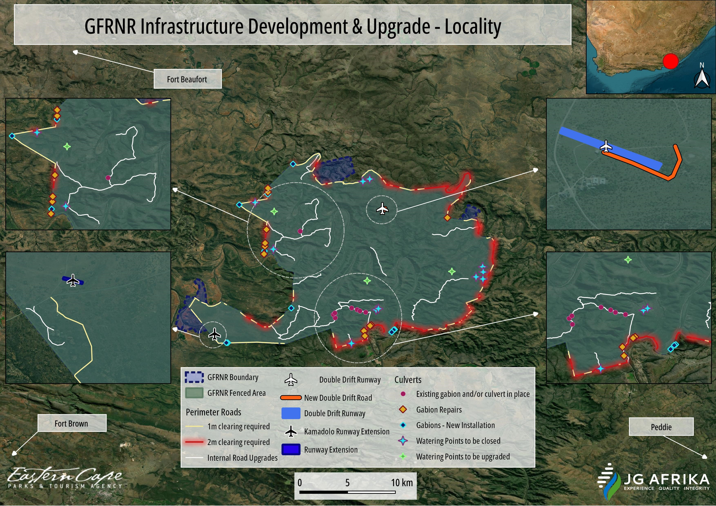
Figure 1-1: Locality map showing the study area, i.e., the Great Fish River Nature Reserve, and the type of infrastructure to be developed and/or upgraded.

PROJECT DETAILS

Project Locality
The GFRNR, approximately 40 000 Ha in extent, straddles the Great Fish River in the south-east of the Eastern Cape Province, and is located north-west of the N2, midway between Makhanda (previously Grahamstown) and Qonce (previously King William’s Town) (Figure 1-1). The border between two District Municipalities, (Sarah Baartman and Amathole – Figure 2-2) cuts through the GFRNR, and three local municipalities (Makana, Raymond Mhlaba and Ngqushwa) intersect with the nature reserve. The affected municipal wards from each municipality are indicated in the table below. The central GPS co-ordinates of the project site are Latitude: 33°06'38.55" S; Longitude: 26°49'41.83" E.

Table 2-1: Affected municipal wards.
District Municipality | Local Municipality | Ward
Sarah Baartman | Makana | 1 and 8
Amathole | Raymond Mhlaba | 13
 | Ngqushwa | 8

The proposed infrastructure development and upgrades will occur within 46 of the 70 farm portions that make up the GFRNR of which all are managed by the ECPTA (see Appendix B1 for Surveyor General codes of land parcels). The GFRNR comprises of three contiguous areas: Double Drift (Lennox Sebe) Game Reserve, Sam Knott Nature Reserve, and Andries Vosloo Kudu Reserve (Figure 2-1). The area for the proposed development and upgrading is also located (west) within five kilometres from the Indalo Protected Environment which is, however, not managed by the ECPTA.

A large part of the Double Drift Section of GFRNR (north of the Great Fish River) was part of a successful land claim which was settled in 2012. There is an agreement that the land use will not change, and a Co-management Agreement has been entered into with the claimants. See Appendix B2 for a copy of the Co-management Agreement.

WWF-SA hold the title deeds for Sam Knott Nature Reserve and the area was managed under an agreement with the previous Cape Provincial Administration (later to become the Provincial Administration of the Western and Eastern Cape). The management agreement has been transferred by the Provincial Administration of the Eastern Cape (Department of Economic Development and Environmental Affairs) to the ECPTA. The ECPTA has a management agreement in place to manage it as part of the GFRNR - see Appendix B3 for a copy of the Notorial Agreement of Lease. The servitudes on GFRNR include Eskom powerlines and a provincial public road (R345).

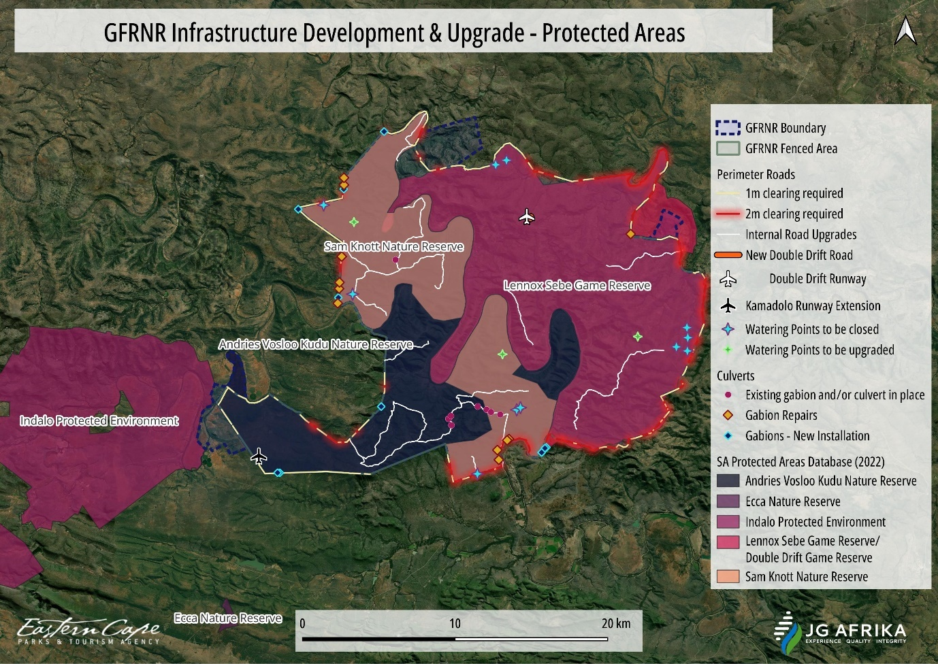
Figure 2-1: Three reserves that make up the GFRNR. Indalo Protected Environment (to the west) is located adjacent to the GFRNR.

As per Section 50 (5) of the NEM:PAA (Act 57 of 2003), “No development, construction or farming may
be permitted in a national park, nature reserve or world heritage site without the prior written approval of the management authority”. As such, a Section 50 (5) approval, in terms of NEM:PAA, from ECPTA as the management authority, will be enclosed with the application submission to the DFFE.

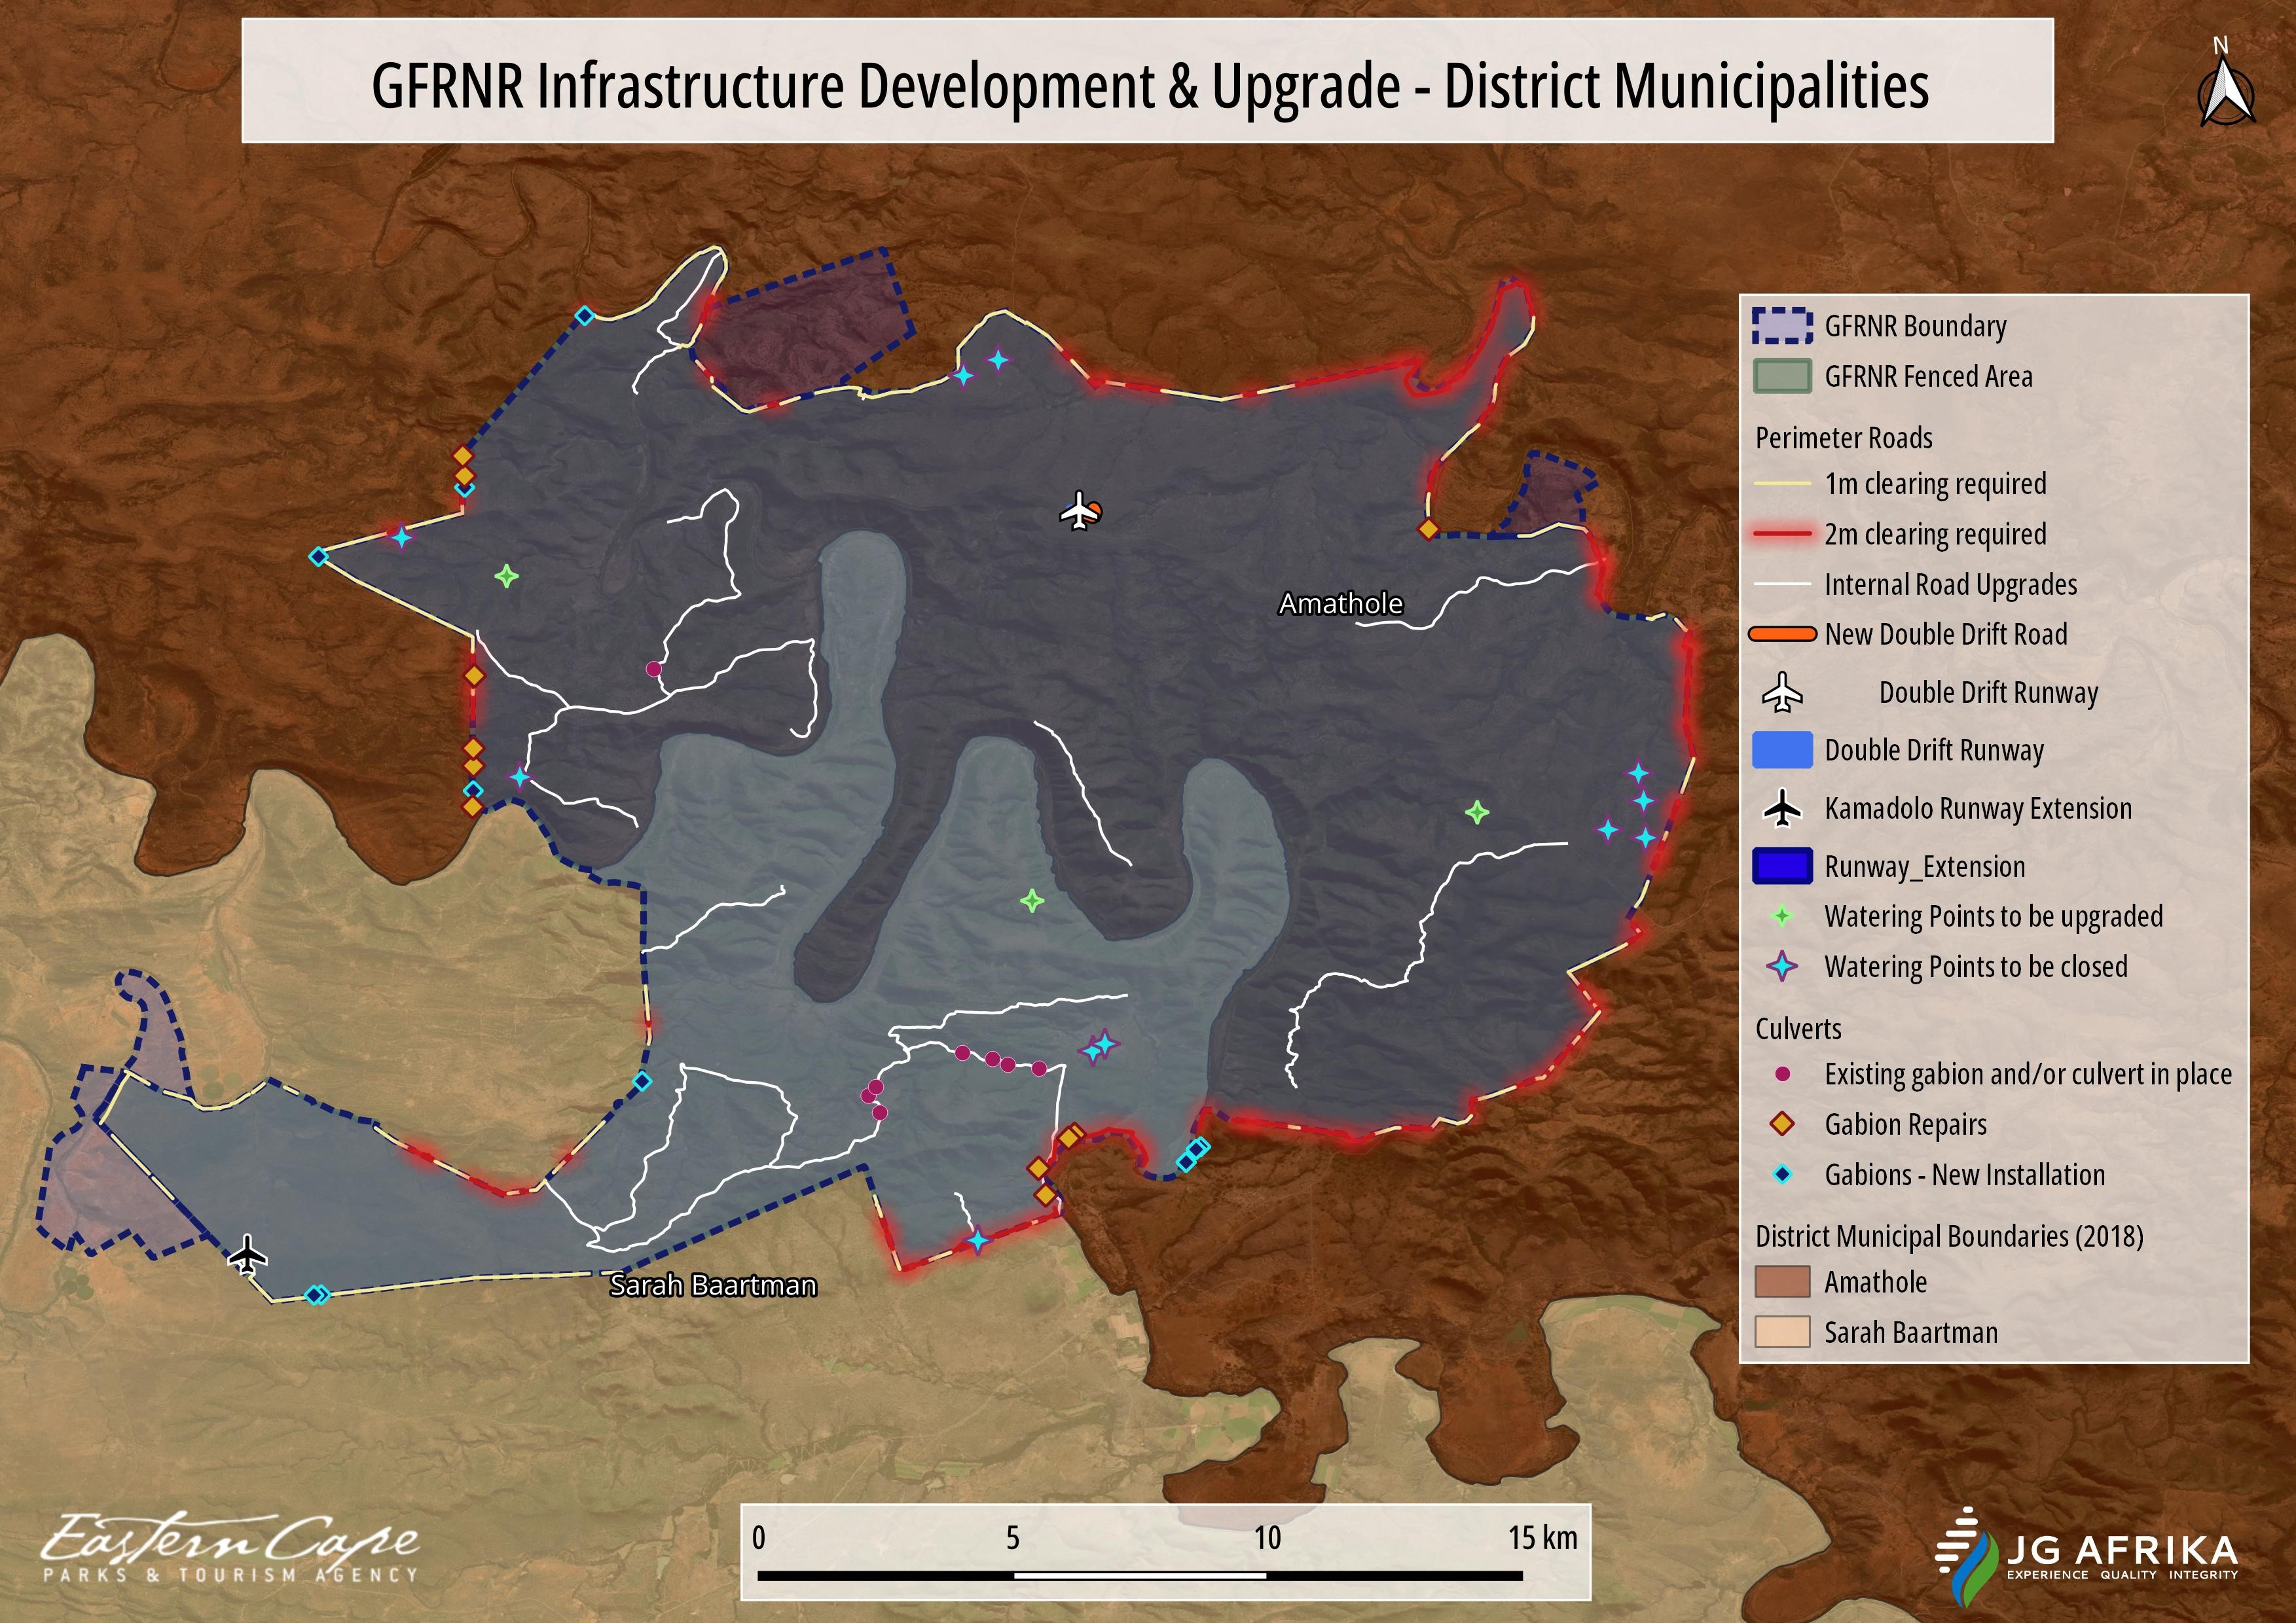
Figure 2-2: GFRNR intersected by two District Municipalities, Amathole District and Sarah Baartman District.

Description of the project
The proposed project is comprised of two main parts, namely the upgrade of infrastructure (i.e., construction of new infrastructure) and secondly, the maintenance and refurbishment of existing infrastructure within the GFRNR. Each of these project components is described in detail below.

Perimeter fence and perimeter road (4x4 track) and associated gabion structures
This activity will comprise of four (4) sub-components:
- Repair and maintenance to sections of the approximately 100 km perimeter fence around the reserve;
- Establishment of a 4 x 4 track on the internal side of the fence which will require the clearing of vegetation along a cumulative length of 89 km and up to a maximum width of 2 m;
- Installation of new gabions structures and repair works to existing gabions along this perimeter track; and
- Refurbishment of existing river crossings within their current footprint.

The existing perimeter fence is approximately 100 km in length. It consists of a 22-strand high-strain fence that is 2.4 m high with steel inline poles at 20 m intervals (Photo 2-1). The poles are concreted into 800 mm x 600 mm deep pits and are 100 mm thick. Steel Y-standard poles are placed at 4 m intervals between the poles and steel droppers at one metre intervals between these. There are also five electrified strands that are offset from the main line. Areas under the fence have been closed and secured with gabion baskets. Sections of the fence require maintenance (Photo 2-2), which will entail securing poles, re-tensioning or replacement of strands, and re-establishment of damaged or missing energizers and solar panels.

Currently, there is an area that was cleared of woody vegetation, of approximately 1–2 m in width on either side of the fence, for the purpose of fire breaking and for allowing ease of movement of quad bikes and vehicles during patrols. In places where this area has become partly overgrown, it will be cleared of vegetation to ensure the integrity of the fence and the proper functioning of the electrification system. This will be done by hand with chainsaws and brush cutters.

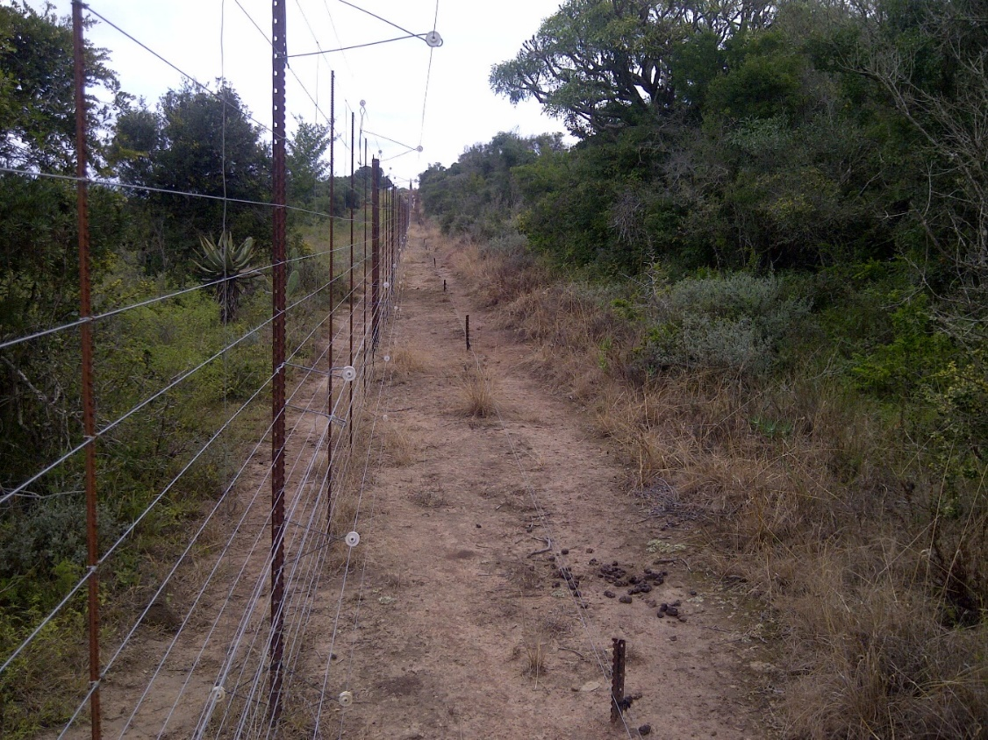
Photo 2-1: The existing perimeter fence at the GFRNR.

In addition, the cleared area will be extended along much of the perimeter (Figure 2-3, Figure 2-4) to allow for vehicular access for routine fence maintenance and security patrols. This will entail the establishment of a 4 x 4 track, which will extend the cleared area on the internal side of the fence to a maximum width of 3 m. Approximately 109 sections along the fence, with a cumulative length of 89 km, have been identified to require additional clearing of vegetation of 1–2 m to accommodate the 4 x 4 track. Those sections requiring clearance of 1m in width amount to approximately 5.5 Ha while those sections requiring clearance of 2 m in width add up to approximately 7 Ha, and thus 13 Ha in total. Figure 2-3 indicates the yellow sections as those requiring clearing of a width of 1 m, while the red sections will require clearing of a width of 2 m (Figure 2-4). The lengths and co-ordinates of these individual sections have been included in Appendix C. To minimise environmental damage, all efforts will be made to reduce the clearing of vegetation to the absolute minimum required. Where possible, clearing of vegetation to accommodate the 4 x 4 track will be done by hand with chainsaws and brush cutters. In addition, an attempt will be made to trim individual trees rather than to fell trees to accommodate the track, where possible. Where this is not possible (e.g., due to the vegetation being too dense), a bulldozer and/or excavator will be used to clear the vegetation and to shape the surface for the 4 x 4 track.

There are existing gabion structures along the perimeter fence that were installed in places where the fence crosses drainage lines and other low-lying areas (Photo 2-3). These structures are permeable to water and their purpose is to stabilise the soils during flood events. Some of the gabions have fallen into a state of disrepair and require maintenance. Areas where additional gabion structures may be required as a storm water management measure have also been identified (Table 2-2). They will be wire-mesh, stone-filled gabions (with typical mesh baskets ranging from 1–2 m in length and 0.5–1 m in width and height) that can be stacked as required. Gabions will be installed by hand. Baskets will be placed on prepared, level surfaces and then stacked with stones (100–250 mm) brought in from a registered quarry. Individual gabion baskets will be secured to adjacent baskets with binding wire.
Existing river crossings will also be refurbished. The crossings comprise of a cable strung across the river, with suspended conveyor belting. The purpose is to create a visual barrier to animals rather than a physical barrier. The river crossings will not obstruct water flow and no earthworks will be done inside the river course during the refurbishing of the crossings.

This component will require a team of 25 individuals (including a bulldozer / excavator operator, and general workers) and is estimated to take 24 months to complete.

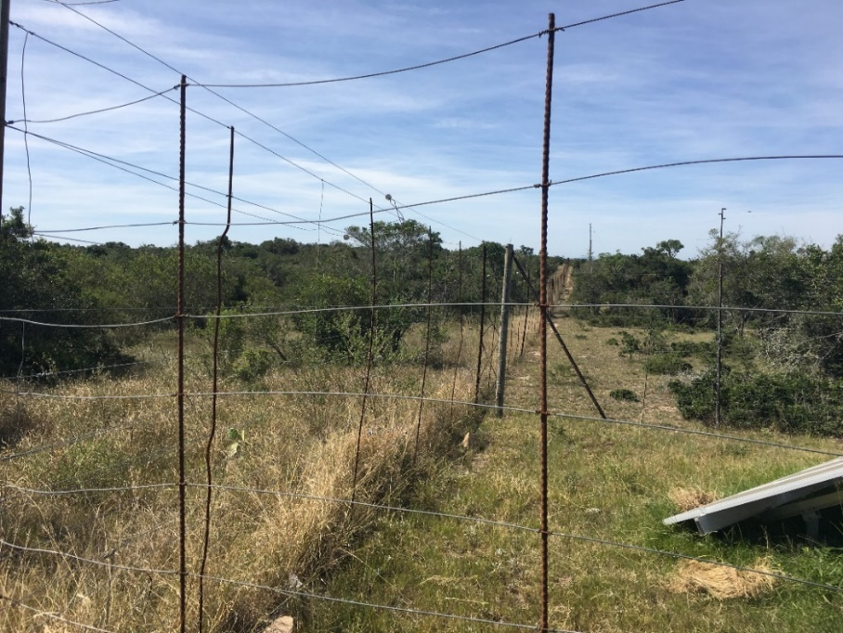
Photo 2-2: An example of the perimeter fence line which requires repair and maintenance work.
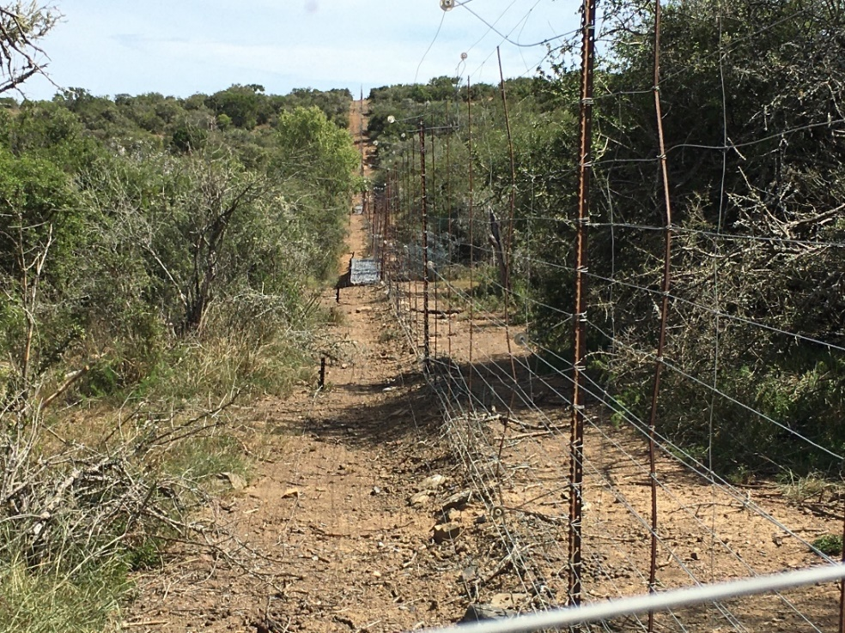
Photo 2-3: An example of an existing gabion structure (circled in red) installed at a low-lying area along the fence line.

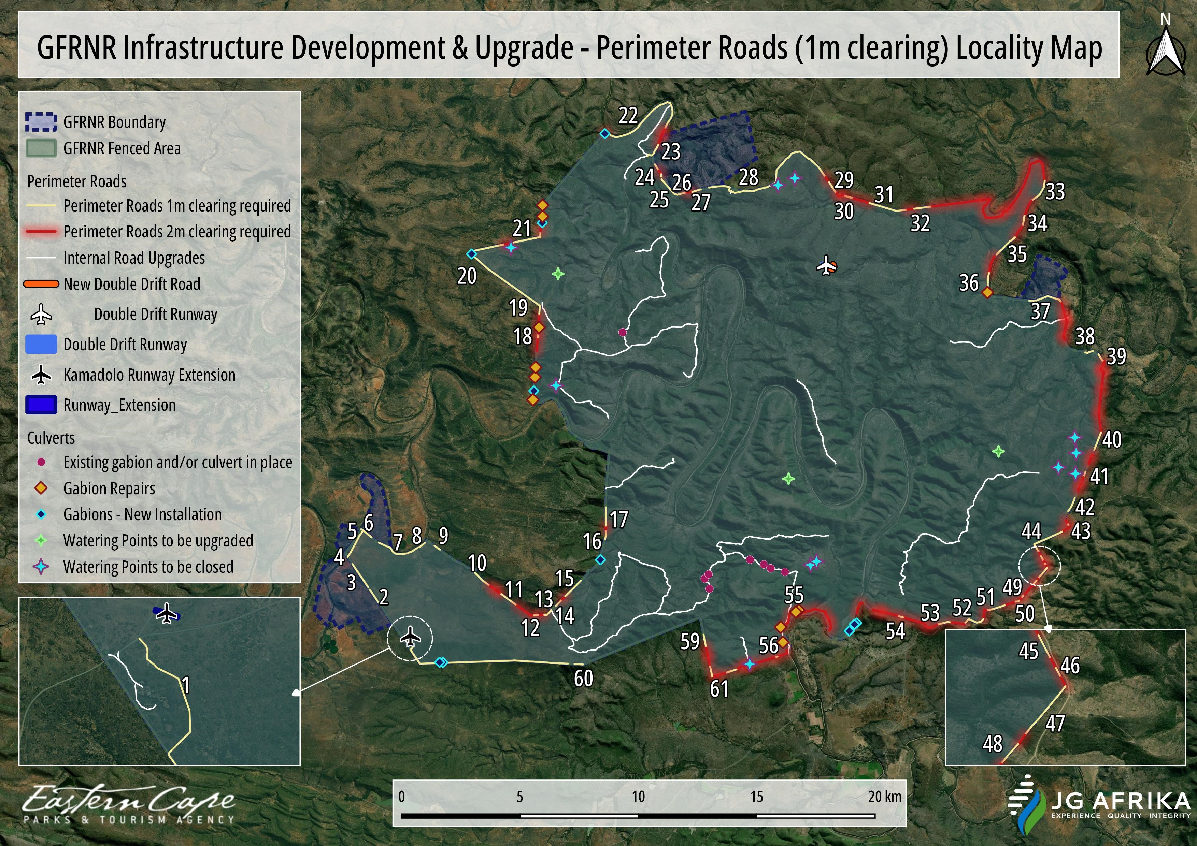
Figure 2-3: Perimeter fence and 4x4 track sections requiring 1m wide’s vegetation to be cleared.
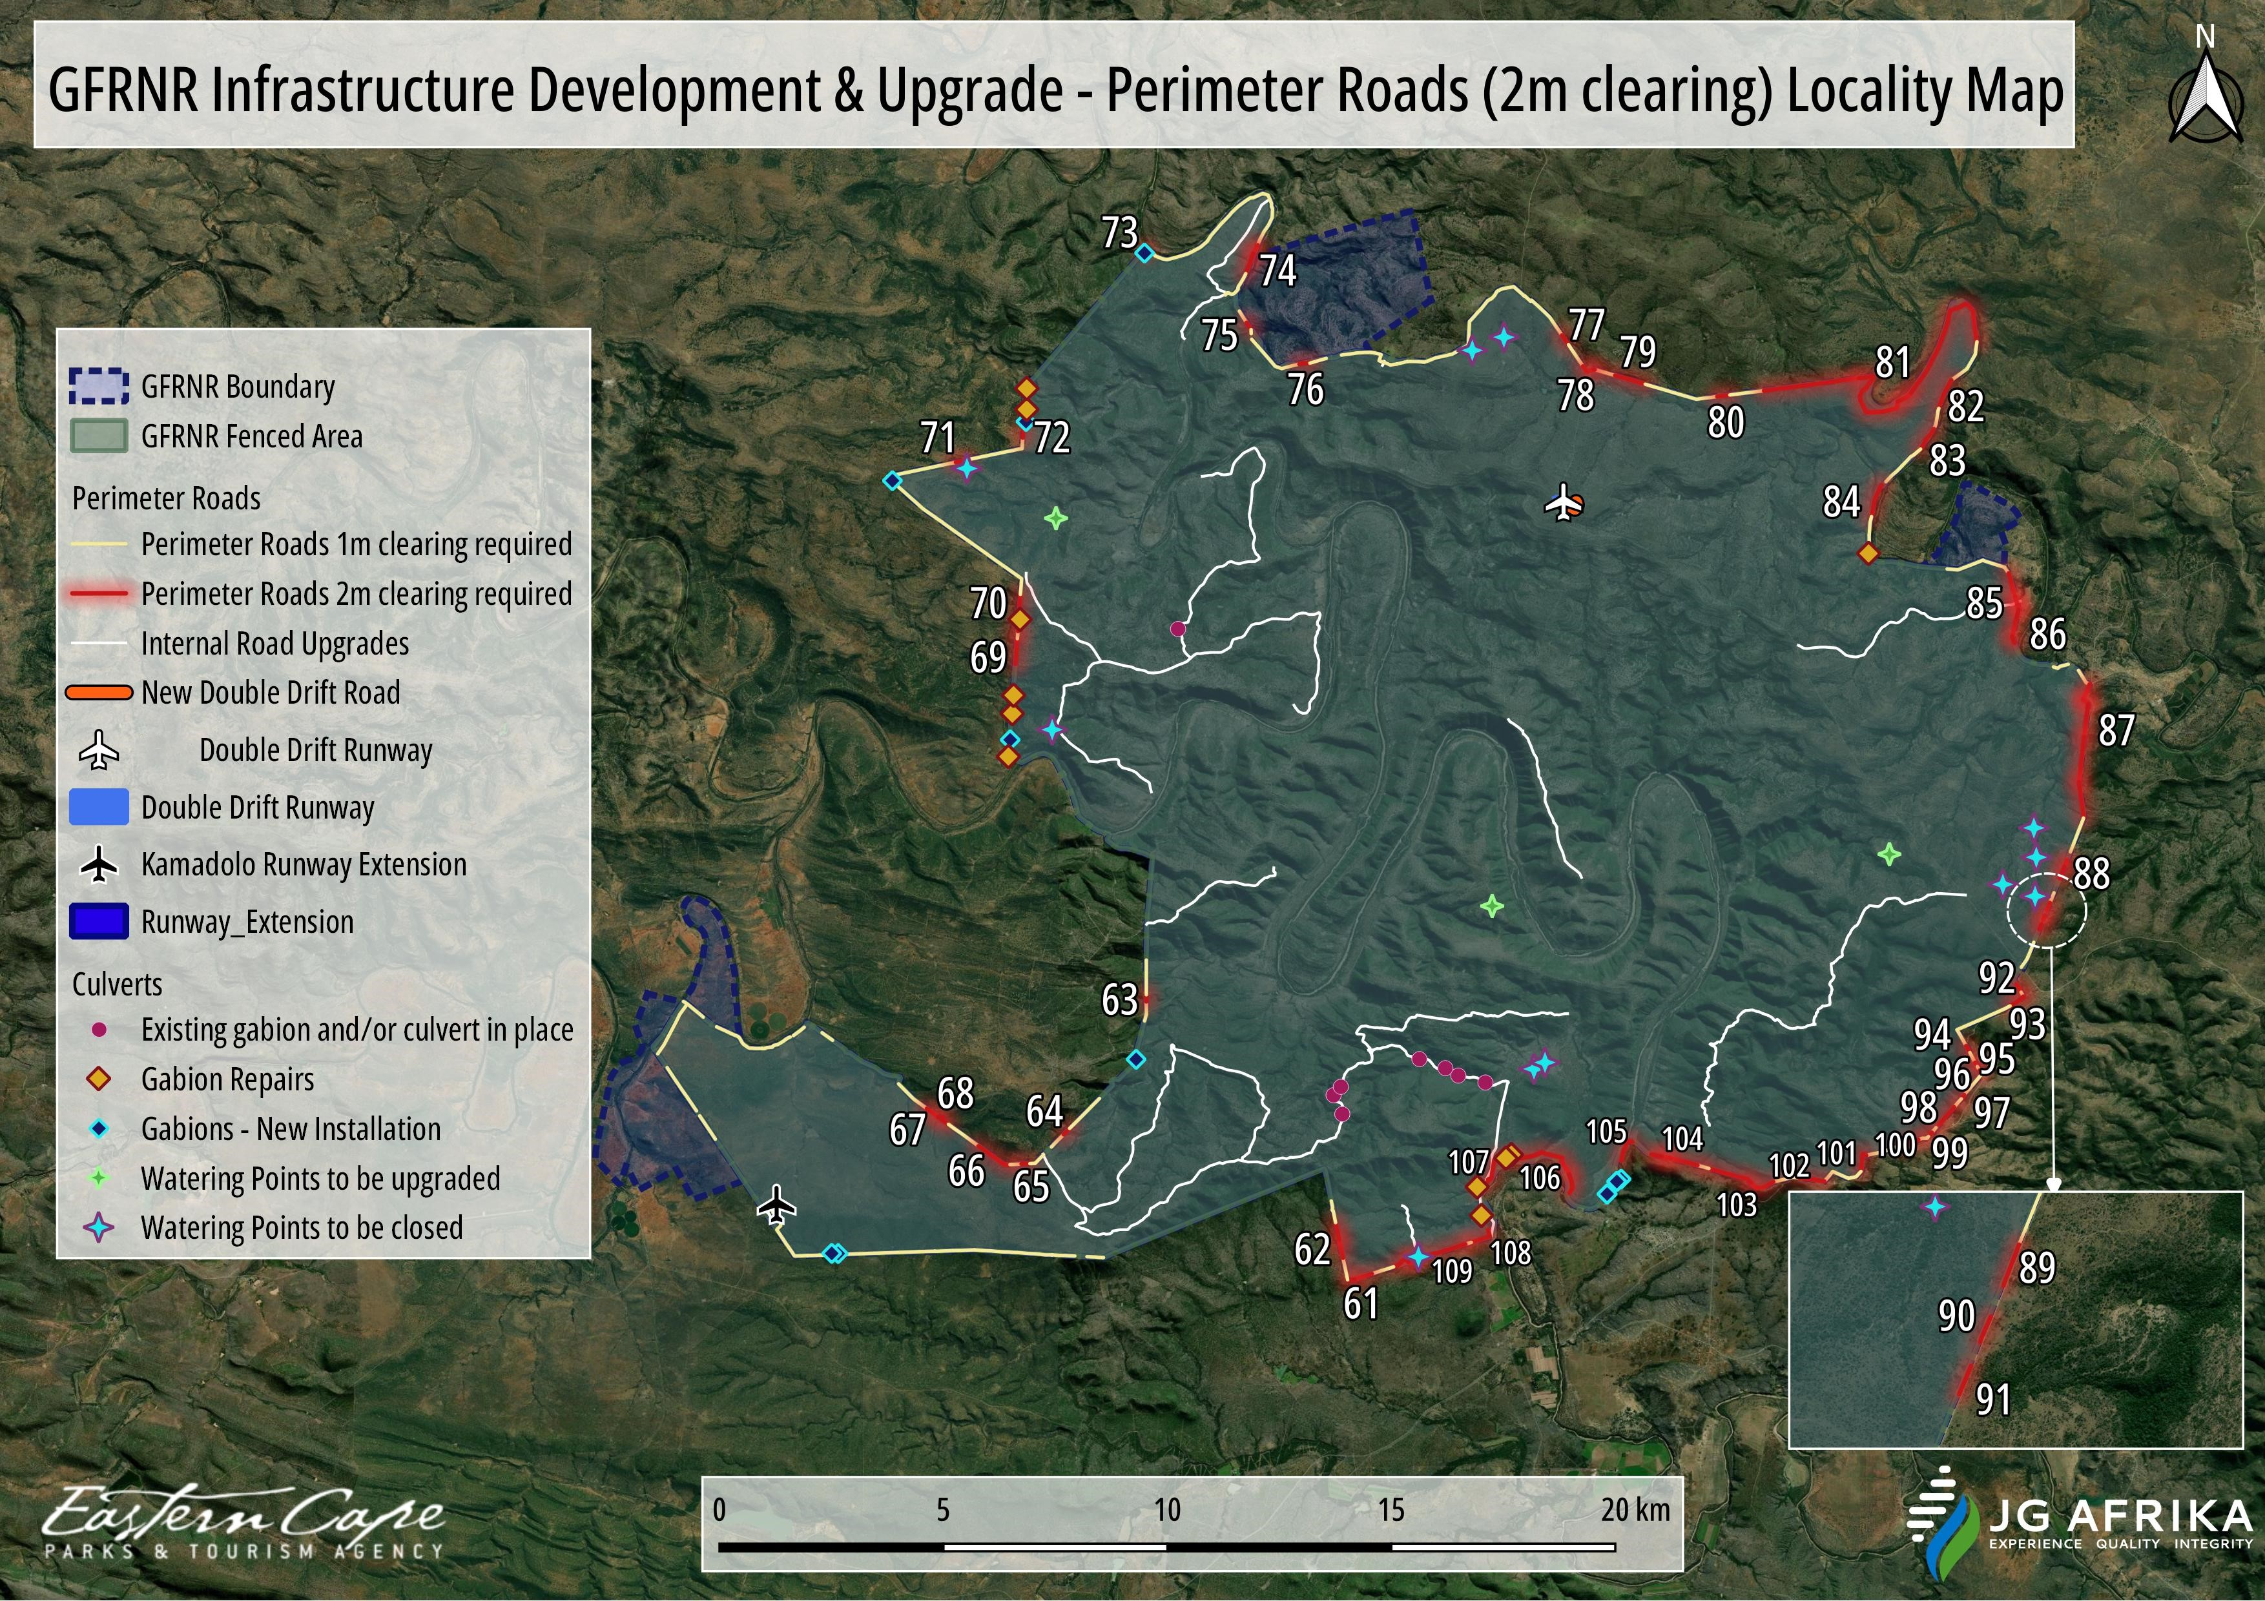
Figure 2-4: Perimeter fence and 4x4 track sections requiring 2m wide’s vegetation to be cleared.
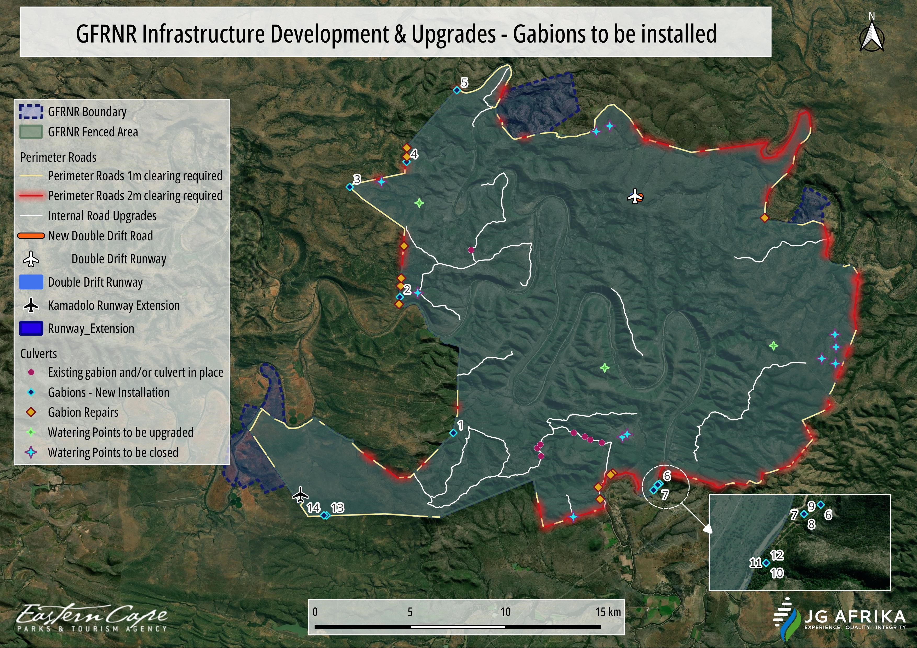
Figure 2-5: Proposed gabions to be installed along perimeter fence.
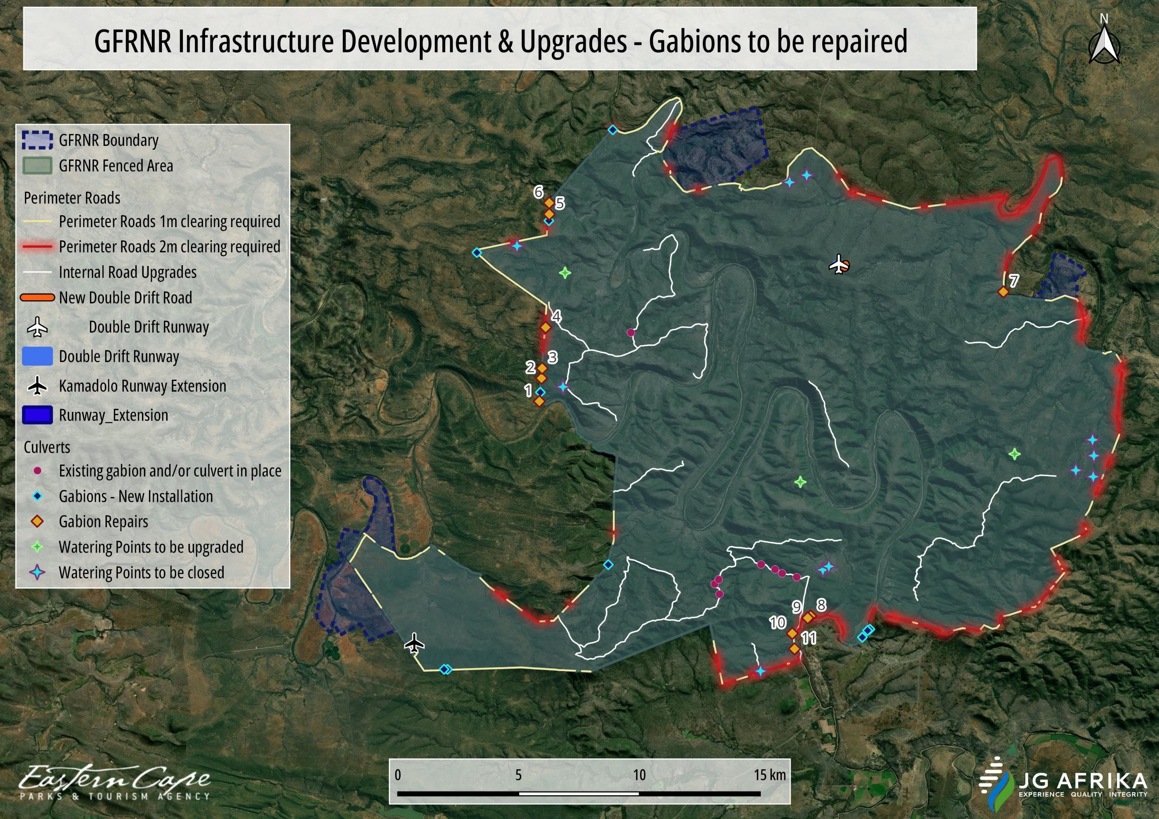
Figure 2-6: Existing gabions to be repaired along perimeter fence.

Table 2-2: Size and location of proposed gabions to be installed and existing gabions to be repaired along perimeter fence of the GFRNR.
Gabion No. | Gabion size | Central Co-ordinates (Degrees, minutes, seconds) |  | ECPTA No.
 |  | Latitude | Longitude
New Gabion 1 | 2m x 1m x 1m | 33° 6'7.66"S | 26°44'15.32"E | Gabion (9).JPG
New Gabion 2 | 2m x 1m x 1m | 33° 2'16.67"S | 26°42'26.77"E | Gabion (16).JPG
New Gabion 3 | 2m x 1m x 1m | 32°59'9.23"S | 26°40'45.22"E | Gabion (20).JPG
New Gabion 4 | 2m x 1m x 1m | 32°58'26.43"S | 26°42'40.37"E | Gabion (21).JPG
New Gabion 5 | 2m x 1m x 1m | 32°56'24.46"S | 26°44'22.57"E | Gabion (25).JPG
New Gabion 6 | 2m x 1m x 1m | 33° 7'34.16"S | 26°51'13.51"E | Gabion (43).JPG
New Gabion 7 | 2m x 1m x 1m | 33° 7'35.90"S | 26°51'9.81"E | Gabion (44).JPG
New Gabion 8 | 2m x 1m x 1m | 33° 7'35.90"S | 26°51'9.81"E | Gabion (45).JPG
New Gabion 9 | 2m x 1m x 1m | 33° 7'35.90"S | 26°51'9.81"E | Gabion (46).JPG
New Gabion 10 | 2m x 1m x 1m | 33° 7'44.95"S | 26°51'1.44"E | Gabion (47).JPG
New Gabion 11 | 2m x 1m x 1m | 33° 7'44.95"S | 26°51'1.44"E | Gabion (48).JPG
New Gabion 12 | 2m x 1m x 1m | 33° 7'44.95"S | 26°51'1.44"E | Gabion (49).JPG
New Gabion 13 | 2m x 1m x 1m | 33° 8'27.97"S | 26°39'58.41"E | Gabion (58).JPG
New Gabion 14 | 2m x 1m x 1m | 33° 8'27.83"S | 26°39'52.85"E | Gabion (59).JPG
Gabion repair 1 | 2m x 1m x 1m | 33° 2'28.75"S | 26°42'25.21"E | Gabion (15).JPG
Gabion repair 2 | 2m x 1m x 1m | 33° 1'57.73"S | 26°42'28.58"E | Gabion (17).JPG
Gabion repair 3 | 2m x 1m x 1m | 33° 1'44.43"S | 26°42'29.63"E | Gabion (18).JPG
Gabion repair 4 | 2m x 1m x 1m | 33° 0'49.59"S | 26°42'35.23"E | Gabion (19).JPG
Gabion repair 5 | 2m x 1m x 1m | 32°58'17.71"S | 26°42'40.99"E | Gabion (22).JPG
Gabion repair 6 | 2m x 1m x 1m | 32°58'2.53"S | 26°42'40.99"E | Gabion (23).JPG
Gabion repair 7 | 2m x 1m x 1m | 33° 0'1.86"S | 26°54'46.90"E | Gabion (35).JPG
Gabion repair 8 | 2m x 1m x 1m | 33° 7'16.54"S | 26°49'38.88"E | Gabion (50).JPG
Gabion repair 9 | 2m x 1m x 1m | 33° 7'19.08"S | 26°49'34.16"E | Gabion (51).JPG
Gabion repair 10 | 2m x 1m x 1m | 33° 7'39.82"S | 26°49'9.41"E | Gabion (52).JPG
Gabion repair 11 | 2m x 1m x 1m | 33° 8'0.40"S | 26°49'13.06"E | Gabion (53).JPG

Internal roads and associated low-level crossings
This activity will involve the maintenance of about 22 sections of the existing gravel road network (Photo 2-4; Photo 2-5), which has roads measuring approximately 3 m wide and a cumulative length of approximately 63 km. The individual sections, along with their length and co-ordinates are indicated in Table 2-3. This will include the re-establishment of old, disused roads. Any vegetation that has become established within the existing sections of road will be cleared. Most of the roads will be graded, while some will need to be ripped by a bulldozer and then graded. It is not planned to bring in new material to surface the roads. Standard storm water measures will be implemented, including grading the roads to a cambered surface and the installation of earthen cross ditches and berms (which will drain into vegetated areas) at regular intervals. All road maintenance activities will occur within the current footprints.

A total number of eight (8) existing low-level crossings (gabions or pipe culverts or concrete crossings) that have fallen into a state of disrepair will also be repaired (to their original specification) within their current footprint (Figure 2-8 and Table 2-4). Blocked pipe culverts under the road will be cleared, and repairs will be undertaken to any damaged concrete work and the road surface over the pipes. Concrete surfaces of the crossings will be cleared of accumulated materials and any damaged concrete works will be repaired. No more than 10m³ (cumulative total for all 8 crossings) of material will be removed and/or excavated from the drainage lines for the proposed refurbishment works at these existing low-level crossings.

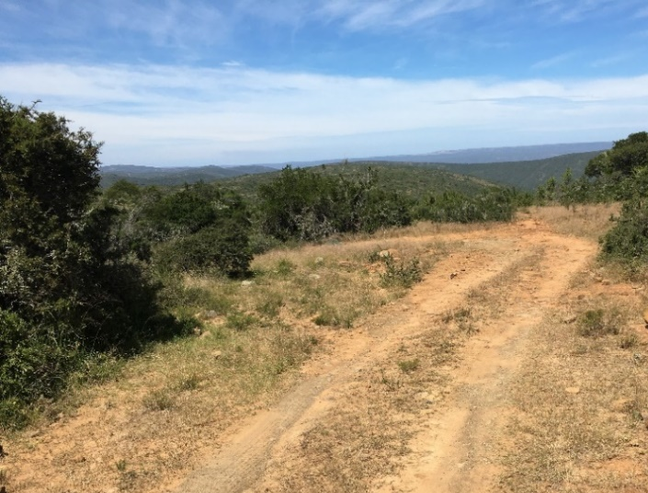 | 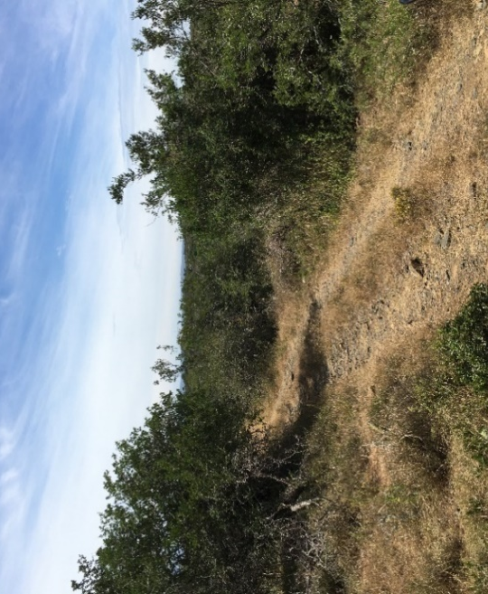
Photo 2-4: View of an example of the internal gravel roads to undergo maintenance within their existing footprint. | Photo 2-5: View of an example of the internal gravel roads to undergo maintenance within their existing footprint.

Additionally, a new road will be developed around the eastern side of the Double Drift airfield strip (Photo 2-6). The current road crosses the runway, and this new road diversion is required to prevent degradation to the surface of the runway. Although alignment around the western end of the runway is possible (linking to the main road between the Double Drift and Sam Knott offices), this is not preferred due to the limited visibility along the bend at this point. Such an alignment would therefore pose a safety risk to road and runway users. An alignment around the eastern end of the runway is therefore preferred. The new section will connect two ends of a management road that experiences low volumes of traffic. The new section of road will measure approximately 470 m in length and 3 m in width. It will be a dirt road, that will be created by shaping the new alignment with a grader. Efforts will be made to avoid Albany thicket bush-clumps when deciding on the final alignment for this road, but it is possible that a small number of trees would need to be removed. An artificial pan to the north-east of the airfield will also be avoided.

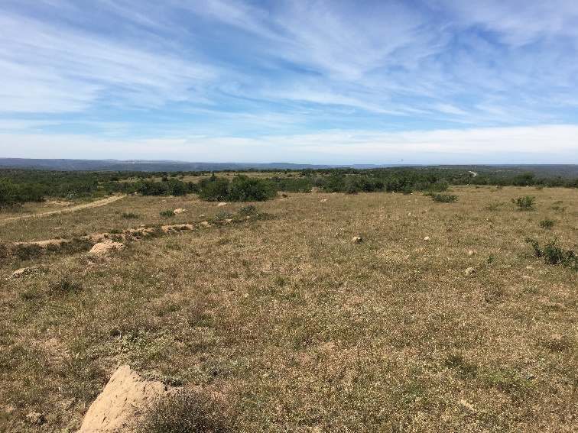
Photo 2-6: View of the location of the new road which will be developed around the eastern side of the Double Drift airfield strip and to connect with the existing gravel road on the left.

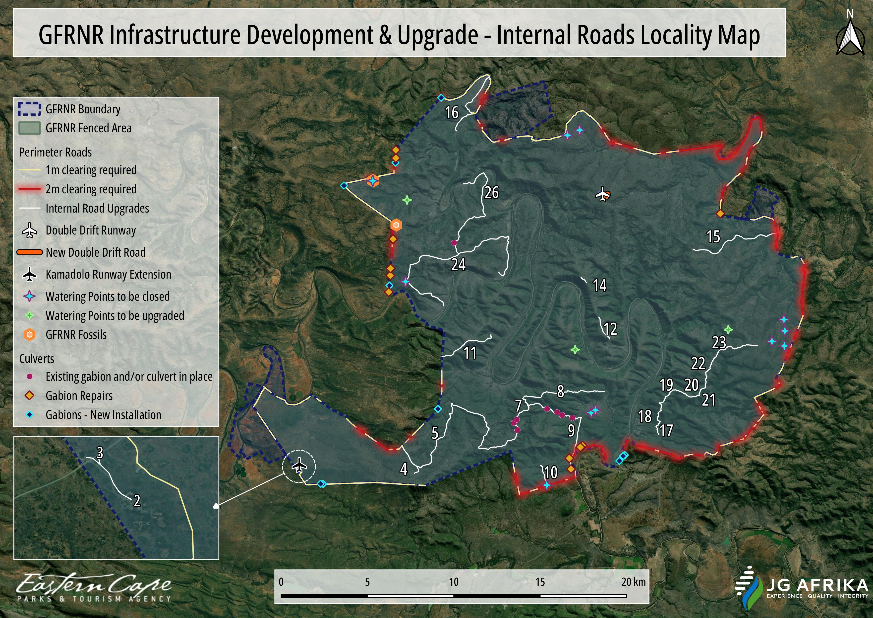
Figure 2-7: Location of sections of the GFRNR internal road network that will undergo maintenance.

Table 2-3: Size and location of sections of the GFRNR internal road network. Existing sections are to undergo maintenance and a new section of road is proposed around Double Drift Airstrip.
Internal Road Section No. | Existing or new | Width (m) | Length (m) | Co-ordinates of infrastructure (Degrees, minutes, seconds)
 |  |  |  | Start |  | Middle |  | End
 |  |  |  | Latitude | Longitude | Latitude | Longitude | Latitude | Longitude
Internal road section 2 | Existing | 3 | 35.49 | 33° 8'1.42"S | 26°39'0.34"E | 33° 8'1.70"S | 26°39'0.92"E | 33° 8'1.98"S | 26°39'1.51"E
Internal road section 3 | Existing | 3 | 34.18 | 33° 7'57.39"S | 26°38'57.67"E | 33° 7'57.90"S | 26°38'57.59"E | 33° 7'58.47"S | 26°38'57.76"E
Internal road section 4 | Existing | 3 | 2098.92 | 33° 7'15.75"S | 26°42'54.83"E | 33° 7'41.93"S | 26°43'12.90"E | 33° 8'8.03"S | 26°43'23.21"E
Internal road section 5 | Existing | 3 | 9432.02 | 33° 7'56.78"S | 26°43'29.07"E | 33° 6'39.55"S | 26°44'35.66"E | 33° 7'20.88"S | 26°45'46.63"E
Internal road section 7 | Existing | 3 | 110.00 | 33° 6'1.18"S | 26°47'36.14"E | 33° 6'2.86"S | 26°47'37.46"E | 33° 6'4.10"S | 26°47'38.38"E
Internal road section 8 | Existing | 3 | 48.61 | 33° 6'0.96"S | 26°47'35.73"E | 33° 6'0.74"S | 26°47'36.45"E | 33° 5'59.81"S | 26°47'36.71"E
Internal road section 9 | Existing | 3 | 5842.41 | 33° 6'0.99"S | 26°47'39.28"E | 33° 5'38.59"S | 26°48'40.62"E | 33° 5'34.62"S | 26°50'27.32"E
Internal road section 10 | Existing | 3 | 1425.70 | 33° 7'53.47"S | 26°48'5.01"E | 33° 8'17.08"S | 26°48'14.05"E | 33° 8'31.48"S | 26°48'16.90"E
Internal road section 11 | Existing | 3 | 3577.94 | 33° 4'30.14"S | 26°44'24.36"E | 33° 4'4.05"S | 26°45'16.37"E | 33° 3'49.36"S | 26°46'14.03"E
Internal road section 12 | Existing | 3 | 1440.84 | 33° 3'16.43"S | 26°50'15.70"E | 33° 3'42.03"S | 26°50'24.51"E | 33° 3'56.33"S | 26°50'39.41"E
Internal road section 14 | Existing | 3 | 406.25 | 33° 2'2.00"S | 26°49'36.44"E | 33° 2'6.68"S | 26°49'43.40"E | 33° 2'10.22"S | 26°49'48.41"E
Internal road section 15 | Existing | 3 | 5781.49 | 33° 1'8.36"S | 26°53'46.35"E | 33° 0'49.64"S | 26°55'16.10"E | 33° 0'36.27"S | 26°56'57.79"E
Internal road section 16 | Existing | 3 | 4471.76 | 32°57'26.48"S | 26°44'56.85"E | 32°56'50.05"S | 26°45'25.31"E | 32°55'45.41"S | 26°46'10.73"E
Internal road section 17 | Existing | 3 | 745.52 | 33° 6'37.68"S | 26°52'28.36"E | 33° 6'46.92"S | 26°52'25.77"E | 33° 6'55.23"S | 26°52'29.60"E
Internal road section 18 | Existing | 3 | 1783.12 | 33° 5'56.75"S | 26°52'30.50"E | 33° 6'20.35"S | 26°52'29.04"E | 33° 6'37.49"S | 26°52'28.42"E
Internal road section 19 | Existing | 3 | 1193.96 | 33° 5'33.08"S | 26°52'59.36"E | 33° 5'49.16"S | 26°52'42.80"E | 33° 5'56.68"S | 26°52'30.43"E
Internal road section 20 | Existing | 3 | 1774.93 | 33° 5'32.97"S | 26°52'59.41"E | 33° 5'39.96"S | 26°53'30.17"E | 33° 5'42.30"S | 26°54'0.76"E
Internal road section 21 | Existing | 3 | 278.28 | 33° 5'42.27"S | 26°53'59.34"E | 33° 5'38.00"S | 26°54'0.14"E | 33° 5'34.29"S | 26°54'1.95"E
Internal road section 22 | Existing | 3 | 1451.85 | 33° 5'34.14"S | 26°54'2.09"E | 33° 5'22.30"S | 26°54'13.28"E | 33° 4'58.17"S | 26°54'16.23"E
Internal road section 23 | Existing | 3 | 3931.30 | 33° 4'58.06"S | 26°54'16.32"E | 33° 4'11.68"S | 26°55'3.14"E | 33° 4'8.89"S | 26°56'10.39"E
Internal road section 24 | Existing | 3 | 13109.52 | 33° 2'54.39"S | 26°44'28.52"E | 33° 1'25.02"S | 26°44'47.50"E | 33° 1'51.96"S | 26°46'31.67"E
Internal road section 26 | Existing | 3 | 3600.06 | 32°59'6.11"S | 26°45'12.25"E | 33° 0'11.63"S | 26°45'26.73"E | 33° 1'17.50"S | 26°45'2.45"E
Double Drift Airstrip: new road | New | 3 | 470.00 | 32°59'25.48"S | 26°50'23.41"E | 32°59'29.76"S | 26°50'33.61"E | 32°59'24.60"S | 26°50'34.81"E

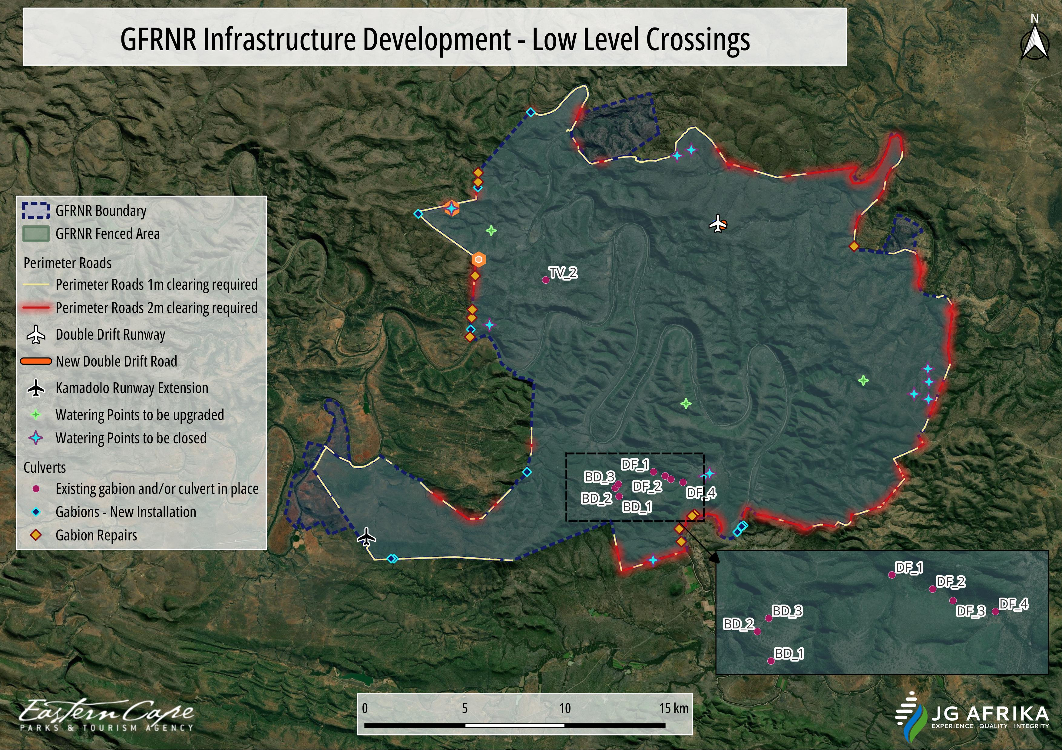
Figure 2-8: Location of existing low-level crossings (culverts) along the GFRNR internal road network that requires refurbishment.
Table 2-4: Size and location of existing low-level crossings (gabions or culverts) along the GFRNR internal road network that requires refurbishment.
Low-level crossing (ECPTA no.) | Average size | Central Co-ordinates of infrastructure
 |  | Latitude | Longitude
BD_1 | 3m x 3m x 3m | 33° 6 ’47.196”S | 26° 47’13.092”E
BD_2 | 3m x 3m x 3m | 33° 6 ’33.588”S | 26° 47’5.568”E
BD_3 | 3m x 3m x 3m | 33° 6 ’27.504”S | 26° 47’11.832”E
DF_1 | 3m x 3m x 3m | 33° 6 ’7.488”S | 26° 48’19.584”E
DF_2 | 3m x 3m x 3m | 33° 6 ’14.04”S | 26° 48’41.976”E
DF_3 | 3m x 3m x 3m | 33° 6 ’19.368”S | 26° 48’53.136”E
DF_4 | 3m x 3m x 3m | 33° 6 ’24.372”S | 26° 49’16.5”E
TV_2 | 3m x 3m x 3m | 33° 0 ’56.52”S | 26° 44’51.504”E

Watering points
A total of eleven (11) unwanted small farm watering points are to be decommissioned (Figure 2-9;Table 2-5). This is due to their proximity to the boundary of the reserve (all within 2 km of the boundary), and the resultant security concern of rhino utilising these areas. These watering points have an average diameter of 40 m and height of 2.5 m and are generally shallow only holding water for short periods. Decommissioning of the watering points will be done when they are dry and will involve breaking the watering point walls with a bulldozer and then spreading the material over the surface of the watering point (i.e., reversing the process that was used to create the watering points). The areas will then be shaped to approximate the natural contours. Rehabilitation will entail revegetation with Spekboom (Portulacaria afra) or indigenous grasses and removing any invasive alien species that become established.

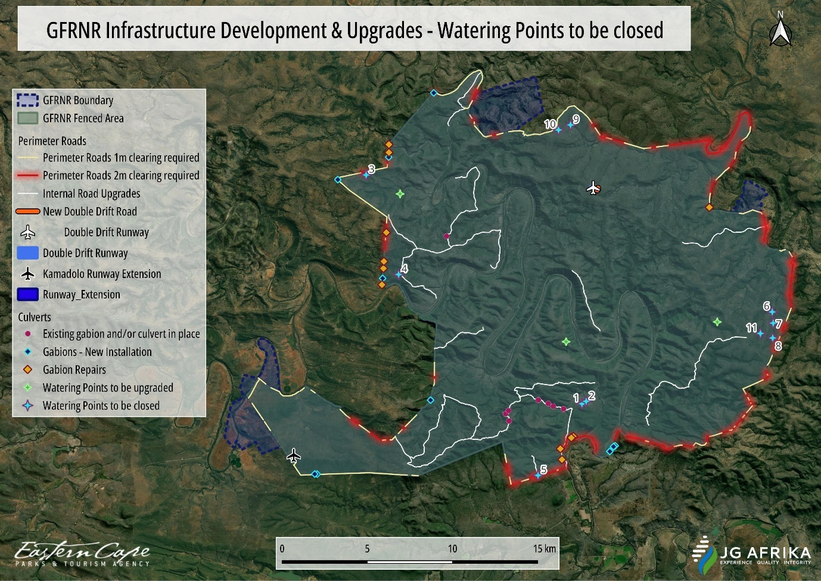
Figure 2-9: Localities of watering points to be decommissioned.

Table 2-5: Size and location of watering points in the GFRNR to be decommissioned.
Watering point No. | Estimated Volume (m³) | Central Co-ordinates (Degrees, minutes, seconds)
 |  | Latitude | Longitude
Watering point to be closed 1 | 1 050 | 33° 6'14.61"S | 26°49'58.33"E
Watering point to be closed 2 | 1 050 | 33° 6'9.92"S | 26°50'7.87"E
Watering point to be closed 3 | 1 050 | 32°59'0.41"S | 26°41'49.44"E
Watering point to be closed 4 | 1 050 | 33° 2'9.33"S | 26°43'2.94"E
Watering point to be closed 5 | 1 050 | 33° 8'30.23"S | 26°48'18.79"E
Watering point to be closed 6 | 1 050 | 33° 3'20.37"S | 26°57'9.39"E
Watering point to be closed 7 | 1 050 | 33° 3'41.59"S | 26°57'11.50"E
Watering point to be closed 8 | 1 050 | 33° 4'9.79"S | 26°57'10.47"E
Watering point to be closed 9 | 1 050 | 32°57'25.37"S | 26°49'32.46"E
Watering point to be closed 10 | 1 050 | 32°57'34.91"S | 26°49'5.17"E
Watering point to be closed 11 | 1 050 | 33° 4'1.18"S | 26°56'42.64"E

Three (3) watering points are proposed for improvement, located at Botha’s Post, Ballysaggart, and Inkerman (Table 2-6; Figure 2-10). These are small farm watering points consisting of earth berms, and their improvement will not pose safety risks as outlined in the World Bank ESF (see ESS 4, para 5 and footnote 9). The improvement of these watering points has been identified as necessary to compensate for the closure of the watering points mentioned above. The Botha’s Post watering point requires improvement because there is only one other watering point with high water retention capacity in the area, and this has been identified for closure. The Ballysaggart watering point requires improvement because there is only one other watering point in the area that retains water during dry periods. The Inkerman watering point (Photo 2-7; Photo 2-8) improvement will compensate for the four watering points that will be closed near to the boundary of the reserve. Each of the watering points have a current capacity not exceeding 600 m³ and a height not exceeding 2.5 m. The improvement will entail removal of accumulated silt by means of excavation, and repairs to the walls. The works will occur during times when the watering points are dry. A bulldozer will be used, and the excess material will be pushed to the watering point wall and compacted. There is no intention to increase the height of the watering point walls. It is anticipated that each watering point will have a new capacity not exceeding 2 000 m³. The watering points will be dependent on rain and will not be supplemented by water from other sources.

Table 2-6: Size and location of watering points in the GFRNR to be upgraded.
Watering point No. | Volume (m³) once upgraded | Central Co-ordinates (Degrees, minutes, seconds)
 |  | Latitude | Longitude
Watering point to be upgraded at Botha’s Post | 2 000 | 32°59'36.36"S | 26°43'6.26"E
Watering point to be upgraded at Ballysaggart |  | 33° 4'16.83"S | 26°49'22.38"E
Watering point to be upgraded at Inkerman |  | 33° 3'39.35"S | 26°55'4.86"E

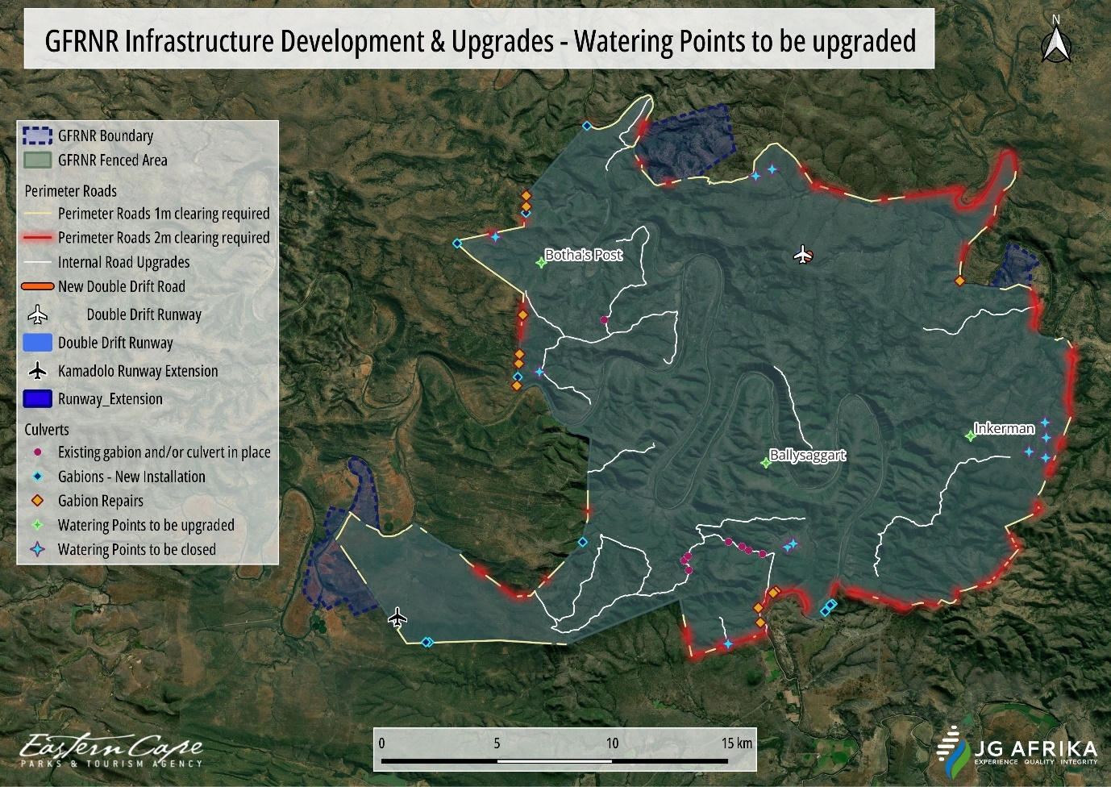
Figure 2-10: Localities of watering points to be upgraded.

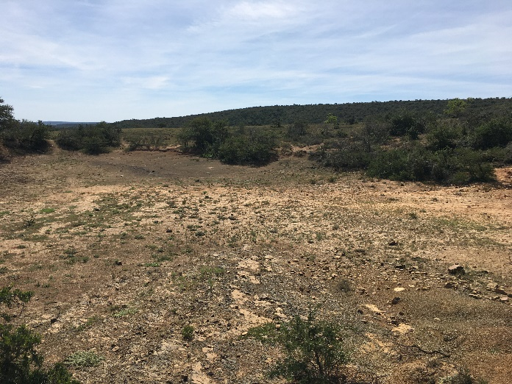 | 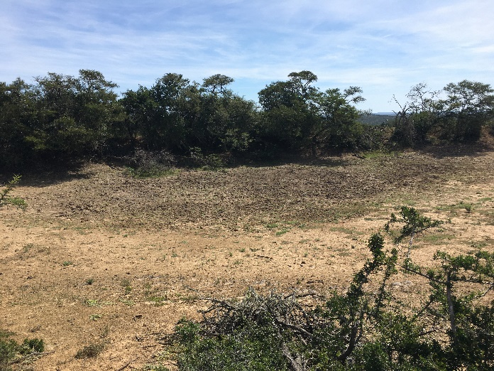
Photo 2-7: View of the existing watering point at Inkerman proposed for upgrading. | Photo 2-8: View of the existing watering point at Inkerman proposed for upgrading.

Runway (airfield) strips
The runways at Kamadolo and Double Drift will be refurbished. This is required because they are currently not safe for light aircraft operations. They have become overgrown with tufted perennial grass and other encroaching vegetation. The perennial grass, in particular, has resulted in an uneven surface, and the individual tufts could snag especially the nose gear of light aircraft. The existing alignment of the Double Drift runway will only be graded while the Kamadolo runway will undergo earthworks (and grading) to extend it by 100 m x 15 m, thereby increasing the footprint of this airfield by 1 500 m² (0.15 Ha) (Photo 2-9; Photo 2-10). The additional length is also required for safety reasons, i.e., to allow for long enough take-off and landing runs during hot (high density-altitude) conditions or with heavy aircraft configurations.

Table 2-7: Proposed measurements and location of the extension of the Kamadolo runway (No. 1) and grading of the Double Drift runway (No. 2) in GFRNR.
No | Extension |  | Co-ordinates of infrastructure (Degrees, minutes, seconds)
 | Width (m) | Length (m) | Start |  | Middle |  | End
 |  |  | Latitude | Longitude | Latitude | Longitude | Latitude | Longitude
1 | 15 | 100 | 33° 7'52.11"S | 26°39'3.25"E | 33° 7'52.32"S | 26°39'4.17"E | 33° 7'52.56"S | 26°39'5.20"E
2 | No extension |  | 32°59'25.59"S | 26°50'23.30"E | 32°59'27.52"S | 26°50'28.53"E | 32°59'29.70"S | 26°50'33.85"E

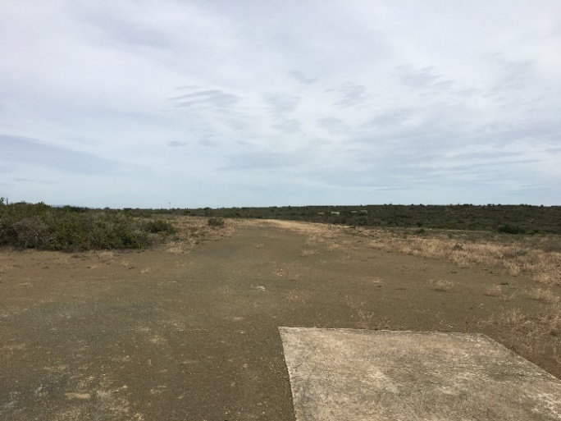
Photo 2-9: View of the existing airfield (runway) strip at Kamadolo (left) and the area where the extension will take place (right). |  | Photo 2-10: View of the existing airfield (runway) strip at Kamadolo (left) and the area where the extension will take place (right).

The presence of functional airstrips on the reserve will allow for more efficient aerial monitoring and security operations. Currently, the Makhanda aerodrome is used, which is approximately an hour-long drive from the reserve. By having functional runways on the reserve, travel time will be reduced, and additional fuel (time) can be allocated to monitoring rather than to ferrying from Makhanda. Additionally, if both runways are functional, staff can be moved from one side of the reserve to the other quickly and this will enable more rapid response and deployment in the event of emergencies (e.g., poaching incidents). The runways will be shaped to a smooth, level surface with a grader and then the surface will be compacted using a heavy roller attached to a tractor.

PLEASE NOTE: The infrastructure requiring EA are represented in blue text below.

In summary, the proposed upgrade and maintenance work consists of:

- Perimeter fence and perimeter road (4 x 4 track) and associated gabion structures:
- Repair and maintenance to sections of the approximately 100 km perimeter fence around the reserve;
- Establishment of a 4 x 4 track on the internal side of the fence which will require the clearing of vegetation along a cumulative length of 89 km and up to a maximum width of 2 m;
- Installation of new gabions structures and repair works to existing gabions along this perimeter track; and
- Refurbishment of existing low-level crossings within their current footprint.

- Internal roads and associated low-level crossings:
- Maintenance of sections of the existing internal gravel road network measuring approximately 3 m wide and with a cumulative length of approximately 63 km. All road maintenance activities will occur within the current footprints; however, any vegetation that has become established within these existing sections of road will be cleared;
- Existing low-level crossings, along these internal roads, that have fallen into a state of disrepair will also be repaired within their current footprint – No more than 10m³ (cumulative total for all 8 crossings) of material will be removed and/or excavated from the drainage lines for the proposed repair/maintenance works at these existing low-level crossings; and,
- Additionally, a new road will be developed around the eastern side of the Double Drift airfield strip measuring approximately 470 m in length and 3 m in width.

- Watering points:
- Upgrading of three (3) existing watering points at Botha’s Post, Ballysaggart and Inkerman. Each of these watering points have a current capacity not exceeding 600 m³. Once upgraded by means of excavation and repairing the walls, each watering point will have a new capacity not exceeding 2 000 m³; and,
- Decommissioning of eleven (11) unwanted small farm watering points by removal of watering point walls and the earth to be spread over the area of the watering points.

- Airfields (runway) strips:
- Refurbishment of the airfield (runway) strips at Kamadolo and Double Drift. Refurbishment activities will occur within the current footprints; however, vegetation that has established on these runways will be cleared; and,
- The existing alignment of the Double Drift runway will only be graded while the Kamadolo airfield strip will undergo both earthworks and grading to extend it by 100 m x 15 m, thereby increasing the footprint of the airfield by 1 500 m² (0.15 Ha).

Kindly refer to Table 8-2 for a more detailed description of those listed activities triggered by the proposed project, and which require Environmental Authorisation.

Site Access
Access into the GFRNR can be gained from the two entrance points into Sam Knott/Andries Vosloo–Kamadolo Nature Reserves in the south-west and the Sam Knott Memorial Gate in the north-west. The two main gates into Double Drift Nature Reserve are located along the R345, between Peddie in the south and Alice in the north.

Project Proponent
The Eastern Cape Parks and Tourism Agency (ECPTA) is the project applicant. The project is financed through the grant of the Global Environmental Facility (GEF) administered by the World Bank.

Contractor Management and Employment Opportunities
Any contractors or sub-contractors engaged under the project will be required to adhere to national standards and the provisions specified in the LMP (part of the ESMF). The LMP pertains to having a strict code of conduct to prevent sexual harassment as well as procedures for settling complaints or grievances. To reflect these procedures, and associated GBV or SEA, as well as procedures required to adhere to good procedures for OHS, all persons engaged under the Project must adhere to standard principles reflected in the PA’s Code of Conduct related to promote exemplary conduct in the workplace. In addition, the contractors will need to follow the Labour Management and Occupational Health and Safety (OHS) Procedures developed for the project. Employment opportunities will be available during the construction phase of this project, and the local communities will get preference. This will benefit the local communities experiencing high levels of unemployment. A Grievance Redress Mechanism has been developed that will be available to people employed on the project. The ESS2 within the ESF Framework addresses its own GRM in which project workers are addressed according to non-discrimination and equal opportunity, however where national law restricts workers’ organizations, the project will not restrict project workers from developing alternative mechanisms to express their grievances and protect their rights regarding working conditions and terms of employment. The Contractor/Borrower should not seek to influence or control these alternative mechanisms. The Contractor/Borrower will not discriminate or retaliate against project workers who participate, or seek to participate, in such workers’ organizations and collective bargaining or alternative mechanisms.

The ESMF outlines a protocol for the reporting of incidents to the World Bank while the OHS Plan will capture the reporting, recording and management of incidents on the project site in line with the protocol set out in the ESMF. Incidents or near misses must be recorded, together with the date and location and any corrective action. Incidents must be reported to the World Bank as soon as possible, and no later than 24 hours after the incident has occurred.

Table 2-8: Breakdown of the duration of each activity and the number of labourers required.
Activity | Duration | Labourers Required
Perimeter fence and perimeter road (4x4 track) and associated gabion structures (100 km long) | 24 months (Taking into consideration the delays due to terrain and inclement weather conditions) | 25 labourers, based on assumption that it is maintenance and not a completely new erection.
This activity will involve the maintenance of about 22 sections of the existing gravel road network, which has roads measuring approximately 3 m wide and a cumulative length of approximately 63 km and construction of a new road. In addition, 8 low-level crossings will be refurbished. | 24 months (Taking into consideration the delays due to terrain and inclement weather conditions) | 15 Labourers, excluding the professional team.
A total of 11 unwanted small farm watering points are to be decommissioned | 6 Months | 20 labourers
Refurbishment and upgrading of runways | 8 Months | 15 labourers

Construction Camp for laydown of materials and equipment
The construction camp will be situated within the GFRNR. Once a contractor has been appointed, the contractor should liaise with the appointed Environmental Control Officer (ECO) to find the best suitable location for the construction camp to ensure that the camp is situated outside of sensitive environmental areas.

Contractors Accommodation
Contractors will overnight in Peddie or Grahamstown and will travel to site daily. Transport will be provided by the contractor. Should there be a need to accommodate contractors inside the Reserve’s premises only key construction crew members will be accommodated internally. Vacant units at the Retreat and Botha’s post staff village will be availed as and when the need arise. It is anticipated that local community leaders and chiefs as well as the appointed Community Liaison Officer (CLO) will interact in the recruiting process of local labourers.

Construction Commencement and Duration
Should the DFFE decide to grant authorisation for this project, construction will likely commence in 2024. Activities will run concurrently and therefore the construction period is anticipated to be for a duration of 24 months (Table 2-8). A Water Use Authorisation (WUA) is also required for this project, which must be in place, prior to the undertaking of any construction activities within areas regulated by the DWS. The application process for the WUA is being undertaken concurrently with the Basic Assessment process.

Construction Waste Management
Although little solid construction waste is anticipated to be generated during the construction phase, contractors will nonetheless be required to develop a waste management plan or a construction site management plan that will outline how construction management waste will be dealt with. This plan will include aspects such as the management of litter, provision of on-site bins, disposal of waste, and prohibited activities relating to waste. Waste management will conform to standard good practice principles and the guidelines in ESS 3 of the World Bank ESF.

The ESMPr attached to this BAR discusses waste management during the construction and operational phases in more detail.

Operational Phase Details
Maintenance of the road will be undertaken when required. The most common maintenance activities to be undertaken will be vegetation maintenance within the road reserve, and inspection of the stormwater management infrastructure, and road surface.

PROJECT NEED AND DESIRABILITY
The Great Fish River Nature Reserve (GFRNR) supports a globally significant black rhino population. The black rhino, once the most numerous of the world's five rhino species, has declined from a global population of around 850 000 individuals to about 5 600 individuals. The species is listed by the IUCN as Critically Endangered, meaning that it is extremely vulnerable to extinction in the wild. The biggest drivers of this decline are habitat loss and poaching.

Since 2008, South Africa has experienced exceptionally high levels of rhino poaching. It has recently been reported that poaching is reaching a critical point and that if the current rates continue, rhino deaths will soon exceed births. Although much of this has been experienced in the Kruger National Park, there is some evidence to suggest that poachers have shifted their efforts to other parts of the country, including the Eastern Cape, as anti-poaching interventions in Kruger have intensified.

In response, the ECPTA has entered a partnership with the World Bank to implement several interventions to help secure the population in the GFRNR. While the interventions extend beyond this, a component is the development and upgrading of infrastructure on the reserve.

The need and desirability it outlined for each of the components below:
- Closing of watering points – the watering points to be closed are on the periphery of the reserve and, as such, they allow animals to occupy areas away from the more secure core of the reserve. Closing these watering points will serve to lower the density of rhino on the edge of the reserve, where they are more vulnerable to poaching.
- Upgrading of watering points – to compensate for the reduced surface water availability resulting from the above activity, and to provide water in other areas with low surface water availability, the ECPTA proposes to upgrade several watering points to improve their water retention ability. Water is a key factor in rhino distribution, and the ECPTA therefore must ensure that surface water availability, and its influence on habitat utilisation, is aligned to security objectives for the reserve.
- Upgrading of internal roads and access to the fence line – there is a need to upgrade the road network to enable rapid access to key areas of the reserve including enhanced access to the fence line. This will allow for detection and rapid response to poaching incursions and allow for access by maintenance teams to keep the fence in good condition. The GFRNR fence is in poor condition in many sections, particularly on the eastern boundary of the reserve, which abuts onto communal land or adjacent villages. Maintaining the fence is currently difficult given the lack of access to the perimeter of the reserve, primarily due to overgrown vegetation along the fence line.
- Runway upgrading – the two runways in the reserve require resurfacing to be able to safely accommodate aircraft used for security and monitoring flights. Currently flights are conducted from the Makhanda aerodrome, which is approximately 50 km away from the reserve. Having functional runways on the reserve would therefore increase efficiency and enable more rapid response to security threats.

ALTERNATIVES CONSIDERED
As per GNR 982, Appendix 1(2)(b), alternatives for the proposed development are to be identified and considered. Chapter 1 of the EIA Regulations (2014, as amended) provides an interpretation of the word “alternatives”, which is to mean -

“in relation to a proposed activity, means different means of meeting the general purpose and requirements of the activity, which may include alternatives to the -
- Property on which or location where the activity is proposed to be undertaken;
- Type of activity to be undertaken;
- Design or layout of the activity;
- Technology to be in the activity; or (N/A to this application)
- Operational aspects of the activity. (N/A to this application)

Preferred Site and Type of Activity Alternative
The preferred site for the proposed activity is the current site and existing facility of the GFRNR. The current land use is the proclaimed provincial nature reserve with land cover consisting of predominantly Albany Thicket and thicket mosaics with secondary grasslands. The infrastructure components applicable to this authorisation, the perimeter road (4 x 4 track), gabions structures along the perimeter track, internal gravel road network, watering points, and airfield (runway) strips), are directly dependant on the current locality of the existing facility, and as such, it is not feasible to place this infrastructure within an alternative site or location.
Therefore, as the proposed activity constitutes the upgrade and maintenance of infrastructure components within an existing nature reserve, it would be neither feasible nor reasonable to investigate an alternate site for the undertaking of the proposed activity. This site alternative is therefore the only site alternative which can meet the need and desirability of the Application, and as such, no alternate sites have been investigated.

Preferred Layout Alternative
The activities were conceptualised through the Theory of Change process for the project and have undergone review and redesign through inputs from the ECPTA reserve management, scientific services, and planning unit teams, to reduce negative environmental and social impacts, enhance positive environmental and social impacts, and to find efficiencies and reduce costs.

Examples of project redesign are outlined below:
- The early plan was to develop a graded road along the inside boundary of the perimeter fence. This was changed to instead develop a 4 x 4 track, and along portions of the perimeter fence. This would still allow for vehicular access to most of the fence, but will have a smaller footprint, require less vegetation clearing, and reduce the need for structures at drainage lines and streams (steeper areas have been avoided in the new layout), and reduce the potential for accelerated soil erosion.
- The initial plans included a new workshop building to be built at the Sam Knott Office. The current plan is to upgrade the existing garage section of the Sam Knott Office. This will reduce the footprint of the development and remove the requirement to clear natural vegetation for this component.
- It was initially planned to increase watering point capacity by raising watering point walls. The scope was subsequently changed to instead excavate the watering points within their existing footprint, to remove accumulated silt and to deepen the watering points. This has reduced the potential footprints of these watering points.
- It was initially planned to supplement watering points with groundwater new or existing boreholes. The boreholes would be connected to the watering points via underground pipes (up to 2 km). This plan has been abandoned to reduce the need to clear vegetation to install pipes and due to a desire to minimize pipeline infrastructure on the reserve (due to the potential impacts of elephant on pipeline infrastructure).

The site layout alternatives provided are practical site alternatives which can meet the need and desirability of the Application and given that these are largely dependent on existing infrastructure, is the most feasible layout available. No alternative layouts will be investigated.

No-Go Alternative
The EIA Process is obligated to assess the status quo (i.e., the “No-Go” alternative) of the development. The No-Go alternative provides the assessment with a baseline against which predicted impacts resulting from the proposed development can be compared. The No-Go alternative assumes the site remains in its current state, i.e., the poor condition of most infrastructure within the reserve. Should the project not proceed in its entirety, the infrastructure in the reserve would not be upgraded, and so, the reserve’s security would not be bolstered, resulting in an increase in poaching interventions which will lead to more black rhino deaths and a further decline in the population. The No-Go alternative will not meet the need of the activity and is thus not the preferred alternative.

The No-Go alternative will be used as a baseline throughout the assessment process against which potential impacts will be compared, in an objective manner, and assessed in this report.

AUTHORISING AUTHORITIES
In terms of the Environmental Authorisation phase, the National Department of Forestry, Fisheries, and the Environment (DFFE) will be the authorising / decision making authority.
In terms of the Water Use Authorisation, the Department of Water and Sanitation (DWS) will be the authorising / decision making authority.

PROJECT ENVIRONMENTAL ASSESSMENT PRACTITIONER
JG Afrika (Pty) Ltd is a specialist consultancy firm, offering services in the following sectors, amongst others:
- Environmental impact and environmental management.
- Geotechnical engineering.
- Geohydrology.
- Hydrology.
- Waste management.
- Various engineering sectors (roads, structures, municipal, etc.).
JG Afrika (Pty) Ltd is one of the longest established consulting engineering practices in South Africa, with over 100 years of engineering and environmental consultancy experience since its founding. The company has offices throughout South Africa and employs a staff of approximately 200. The company has offices in Johannesburg, Cape Town, Durban, Pietermaritzburg, and Gqeberha (Port Elizabeth). The company also has international offices in Maun, in Botswana and in Maputo, in Mozambique.
The environmental department of the company has developed over the years and can provide a full spectrum of services including water use authorisation applications environmental impact assessments, environmental management plans, strategic environmental assessments, integrated waste management plans and the development and implementation of environmental management systems in terms of ISO 14001:2004.
In September 2017, JG Afrika (Pty) Ltd obtained ISO 9001:2015 Certification for its quality standards for all its offices in South Africa, by the DEKRA Certification Board.
JG Afrika (Pty) Ltd is a Level 1 BBBEE company partly owned by black professionals who are registered civil engineers, technologists, Institutional and Social Development (ISD) and training consultants. In addition, JG Afrika (Pty) Ltd is committed to ensuring greater representation in the ownership and management of the company. To this end, the company strives to continually seek opportunities to expand its black empowerment programme.
Details of the project team members are provided in Table 6-1.
Table 6-1: JG Afrika Project Team
Name, Position in Firm,  Qualification | Years’ Experience | Experience
Project Manager and EAP:  Mrs Cherize Coetzee  Position in Firm:  Environmental Scientist  Qualification:  MSc Zoology  Registration:  IAIA - International Association of Impact Assessment  (Membership number: 3551) | 10 Years | Through her postgraduate studies she has conducted research in the rocky shore habitat and estuarine systems. She has, over the years, gained experience with Basic Environmental Impact Assessments (BA), Environmental Management Programmes (EMPr), Environmental Compliance Monitoring, Licence Applications for Waste Management activities, Application for Water Use Authorisations, and Pre-Application Environmental Screening Assessments. She has been involved with a wide range of projects, amongst others, substation upgrades, augmentation of bulk water supply systems and bulk sewer infrastructure, bridge and causeway reconstructions, road upgrades, wind farm establishment, etc.
Reviewer:  Mr Ryan Jonas  Position in Firm:  Senior Environmental Scientist  Qualification:  M.Sc (Environmental Science), BSc (Natural Sciences)  Registration:  EAPASA - Environmental Assessment Practitioner Association (Membership number: 2019/1674)  SACNASP - Professional Natural Scientist (Environmental Science) (Registration no: 400159/15)  IAIA - International Association of Impact Assessment  (Membership number: 5065) | 16 Years | Ryan Emslie Jonas is a professionally registered Environmental Scientist and works in the field of environmental management for large infrastructure-related developments, mining and Renewable Energy projects (solar and wind energy facilities) within Africa.  He has acquired 16 years consulting experience in managing and executing various application processes for a diverse range of large infrastructure developments, mining and renewable energy (solar and wind energy facilities) projects in order to obtain environmental authorisations, licenses for waste management, water uses, air emissions release and compiling and implementing environmental management programmes.  Ryan has also fulfilled numerous environmental compliance monitoring functions for infrastructure-related developments (e.g., roads, pipelines, airport developments, housing, and mixed-used projects), renewable energy and various mining and industrial sites throughout Southern Africa. His project management experience includes client liaison, scheduling, professional services contract (i.e., NEC3) management, progress reporting, managing sub-consultants and junior staff, invoicing and ensuring the quality of deliverables to a Client. Also proficient in tender, expression of interest and proposal writing for local as well as IFC / World Bank projects.  Ryan has gained an excellent working knowledge of African (i.e., South Africa, Zambia, Kenya, Lesotho, Mauritius, Namibia) and International Finance Corporation / World Bank environmental legislative requirements for major infrastructure, renewable energy, and mining developments.

Curriculum Vitae of the JG Afrika (Pty) Ltd project teams members are enclosed under Appendix D.

EXTERNAL SPECIALISTS
Details of the external specialists involved in this project are provided in Table 7-1 overleaf.
Table 7-1: External Project Team.
Sub-Consultant | Nature and Extent of Work
GCS Water and Environmental Consultants (Pty) Ltd | Aquatic Assessment
Eastern Cape Heritage Consultants cc | Phase 1 Archaeological Impact Assessment
Banzai Environmental | Palaeontological Impact Assessment
Blue Leaf Environmental (Pty) Ltd | Terrestrial Biodiversity and Plant Species Impact Assessment  Animal Species Impact Assessment

LEGISLATIVE REQUIREMENTS
A list of all legislation, policies and/or guidelines of any sphere of government that are applicable to the application as contemplated in the EIA regulations are provided in Table 8-1:
Table 8-1: List of Applicable Legislation, Policies and/or Guidelines.
Title of legislation, policy, or guideline: | Administering authority: | Promulgation Date:
The Constitution of South Africa (No 108 of 1996) | National | 18 December 1996
National Environmental Management Act No. 107 of 1998 as amended. | National & Provincial | 27 November 1998
Environmental Impact Assessment Regulations, 2014, as amended | National & Provincial | 07 April 2017
National Water Act 36 of 1998 | National & Provincial | 20 August 1998
National Heritage Resource Act No. 25 of 1999 | National & Provincial | 28 April 1999
National Environmental Management: Biodiversity Act, 2004 (Act no. 10 of 2004) | DFFE | 07 June 2004
National Forest Act 84 of 1998 | National | 20 October 1998
National Environmental Management: Protected Areas Act (Act 57 of 2003) | National | 2003
National Environmental Management: Biodiversity Act (Act 10 of 2004) | Department of Economic Development, Environmental Affairs and Tourism (DEDEAT) | 2004
Eastern Cape Parks and Tourism Agency Act (ECPTAA) (Act No 2 of 2010) | ECPTA | 2010
National Environmental Management: Waste Act (Act 59 of 2008) | National | 2008
National Environmental Management Air Quality (Act 39 of 2004) | National | 2004
Occupational Health and Safety Act (OHSA) (Act 85 of 1993) | National | 1993
Nature and Environmental Conservation Ordinance (No. 19 of 1974) | National & Provincial | 1974
The Conservation of Agricultural Resources Act (CARA) (Act 43 of 1983) | National | 1983
Hazardous Substances Act (HSA) (Act 15 of 1973) | National | 1973
A summary of the main pieces of legislation pertaining to this project is provided below.

National Environmental Management Act
The EIA Regulations, 2014, as amended, as promulgated in terms of Section 24(5) and Section 44 of the NEMA, Act 107 of 1998 consists of the following:
- Regulation 982 provide details on the processes and procedures to be followed when undertaking an Environmental Authorisation process.
- Listing Notice 1 define activities which will trigger the need for a Basic Assessment process.
- Listing Notice 2 define activities which trigger an EIA process. If activities from both R983 and R984 are triggered, then an EIA process will be required.
- Listing Notice 3 define certain additional listed activities for which a Basic Assessment process would be required within identified geographical areas.

The above regulations were reviewed to determine which activities in terms of the above listing notices would be triggered by the proposed project, and what Environmental Authorisation Process would be required. Details of the listed activity triggered is provided in Table 8-2.

Table 8-2: Listed Activities triggered in terms of the EIA Regulations (2014, as amended).
ACTIVITY AND NOTICE NUMBER | LISTED ACTIVITY | DISCUSSION IN TERMS OF APPLICABILITY
Activity 12  Listing Notice 1 of GNR. 327 (983)  (EIA Regulations (2014, as amended)) | The development of—  (ii) infrastructure or structures with a physical footprint of 100 square metres or more;  where such development occurs—  (a) within a watercourse;  (c) if no development setback exists, within 32 metres of a watercourse, measured from the edge of a watercourse; — | Perimeter fence and perimeter road (4x4 track) and associated gabion structures:  The establishment of a 4x4 track as well as the installation of gabion structures along the road and perimeter fence will exceed the cumulative footprint of 100 m² and works will occur both within and within 32 m of watercourses. This Listed Activity is therefore TRIGGERED.
Activity 19  Listing Notice 1 of GNR. 327 (983)  (EIA Regulations (2014, as amended)) | The infilling or depositing of any material of more than 10 cubic metres into, or the dredging, excavation, removal or moving of soil, sand, shells, shell grit, pebbles, or rock of more than 10 cubic metres from a watercourse;  but excluding where such infilling, depositing, dredging, excavation, removal or moving— | Perimeter fence and perimeter road (4x4 track) and associated gabion structures:  The installation of gabion structures along the road and perimeter fence will involve the excavation, removal and/or moving of material (soil) of a cumulative volume of more than 10 m³ from watercourses. This Listed Activity is therefore TRIGGERED.  Watering points to be upgraded:  The proposed activity of expanding three (3) existing watering points will involve the dredging, excavation, removal or moving of soil of more than 10 m³ for each dam. As these watering points are considered ‘watercourses’, this Listed Activity is TRIGGERED.  Watering points to be closed:  The proposed activity of closing eleven (11) unwanted farm watering points will involve earthworks by bulldozer, removal of the watering point walls and the earth to be spread over the area of the watering points. The watering points are considered ‘watercourses’, and the closing of the watering points will include the moving of soil. As such, this Listed Activity is TRIGGERED.
Activity 48  Listing Notice 1 of GNR. 327 (983)  (EIA Regulations (2014, as amended)) | The expansion of –  - infrastructure or structures where the physical footprint is expanded by 100 square metres or more; or  Where such expansion occurs-  - within a watercourse;  (c) if no development setback exists, within 32 metres of a watercourse, measured from the edge of a watercourse… | Watering points to be upgraded:  The proposed activity of expanding three (3) existing watering points will involve the dredging, excavation, removal or moving of soil of more than 10 m³ for each dam. As these watering points are considered ‘watercourses’, this Listed Activity is TRIGGERED.
Activity 12  Listing Notice 3 of GNR. 324 (985)  (EIA Regulations (2014, as amended)) | The clearance of an area of 300 square metres or more of vegetation where 75% or more of indigenous vegetation except where such clearance of indigenous vegetation is required for maintenance purposes undertaken in accordance with a maintenance management plan.  - In the Eastern Cape  - Within critical biodiversity areas identified in bioregional plans;  (v) On land, where, at the time of the coming into effect of this Notice or thereafter such land was zoned open space, conservation or had an equivalent zoning. | Perimeter fence and perimeter road (4x4 track) and associated gabion structures AND Internal roads and associated low-level crossings:  If it is assumed that all vegetation to be cleared is indigenous, and so, more than 300 m² of indigenous vegetation will be cleared along the fence line for the development of the new 4x4 track along the fence. For the internal roads, any vegetation that has become established within the roads itself will be cleared.  The proposed clearing activity falls within ecosystems not identified as critically endangered or endangered according to Section 52 of the NEMBA (2004). In addition, the NBA (2018) listed these areas as “Least Concern”. Furthermore, the Eastern Cape Biodiversity Conservation Plan (ECBCP, 2019) itself is not a Bioregional Plan, but is rather deemed in terms of the EIA Regulations (2014, as amended) to be a Systematic Biodiversity Conservation Plan adopted by the competent authority. Therefore, although the site falls within a CBA as contemplated in the ECBCP, this is not one of the geographical areas as contemplated in Activity 12. However, the zoning of the land is conservation. As such, this Listed Activity is therefore TRIGGERED.  Watering points to be upgraded:  Each watering point will be expanded by 300 m² or more, and so the expansion activity will require the clearance of vegetation. It is likely that 75% or more of the vegetation to be cleared is indigenous. The proposed development falls within ecosystems not identified as critically endangered or endangered according to Section 52 of the NEMBA (2004). In addition, the NBA (2018) listed these areas as “Least Concern”. Furthermore, the Eastern Cape Biodiversity Conservation Plan (ECBCP, 2019) itself is not a Bioregional Plan, but is rather deemed in terms of the EIA Regulations (2014, as amended) to be a Systematic Biodiversity Conservation Plan adopted by the competent authority. Therefore, although the site falls within a CBA as contemplated in the ECBCP, this is not one of the geographical areas as contemplated in Activity 12. However, However, the zoning of the land is conservation. This Listed Activity is therefore TRIGGERED.  Airfields (runway) strips:  The airfield strips will require the clearance of vegetation of an area of more than 300 m². It is likely that that 75 % or more of the vegetation to be cleared is indigenous. The proposed activity falls within ecosystems not identified as critically endangered or endangered according to Section 52 of the NEMBA (2004). In addition, the NSBA (2004) listed these areas as “Least Concern”. Furthermore, the Eastern Cape Biodiversity Conservation Plan (ECBCP, 2019) itself is not a Bioregional Plan, but is rather deemed in terms of the EIA Regulations (2014, as amended) to be a Systematic Biodiversity Conservation Plan adopted by the competent authority. Therefore, although the site falls within a CBA as contemplated in the ECBCP, this is not one of the geographical areas as contemplated in Activity 12. However, the zoning of the land is conservation. This Listed Activity is TRIGGERED.
Activity 14  Listing Notice 3 of GNR. 324 (985)  (EIA Regulations (2014, as amended)) | The development of –  (ii) infrastructure or structures with a physical footprint of 10 square metres or more;  where such development occurs –  - Within a watercourse;  - …within 32 meters of a watercourse, measured from the edge of the watercourse;  - In Eastern Cape:  i. Outside urban areas:  (aa) A protected area identified in terms of NEMPAA, excluding conservancies;  (ff) Critical biodiversity areas or ecosystem service areas as identified in systematic biodiversity plans adopted by the competent authority or in bioregional plans;  (hh) Areas within 10 kilometres from national parks or world heritage sites or 5 kilometres from any other protected area identified in terms of NEMPAA or from the core area of a biosphere reserve; | Perimeter fence and perimeter road (4x4 track) and associated gabion structures:  The establishment of a 4x4 track as well as the installation of gabion structures along the road and perimeter fence will exceed the cumulative footprint of 100 m². These developments will occur both within and within 32 m of watercourses.  The developments will occur outside urban areas within a protected area in terms of NEMPAA (2003), i.e., the Great Fish River Nature Reserve (GFRNR). In addition, the GFRNR also falls within CBA’s as identified by the ECBCP (2019). This Listed Activity is therefore TRIGGERED.
Activity 23  Listing Notice 3 of GNR. 324 (985)  (EIA Regulations (2014, as amended)) | The expansion of—  (ii) infrastructure or structures where the physical footprint is expanded by 10 square metres or more;  where such expansion occurs—  (a) within a watercourse;  (c) if no development setback has been adopted, within 32 metres of a watercourse, measured from the edge of a  watercourse;  a. Eastern Cape  i. Outside urban areas:  (aa) A protected area identified in terms of NEMPAA, excluding conservancies;  (ee) Critical biodiversity areas as identified in systematic biodiversity plans adopted by the competent authority or in bioregional plans;  (gg) Areas within 10 kilometres from national parks or world heritage sites or 5 kilometres from any other protected area identified in terms of NEMPAA or from the core area of a biosphere reserve; | Watering points to be upgraded:  All three (3) watering points will be expanded by more than 10 m² cumulatively. These existing watering points are considered ‘watercourses’. The development occurs outside urban areas within a protected area in terms of NEMPAA (2003), i.e., the Great Fish River Nature Reserve (GFRNR). In addition, the GFRNR also falls within CBA’s as identified by the ECBCP (2019). This Listed Activity is therefore TRIGGERED.

National Water Act
Section 21 of the National Water Act (Act 36 of 1998) defines a list of activities which require a Water Use Authorisation. Listed activities in terms of Section 21 include the following:
- 21(a) taking water from a water resource.
- 21(b) storing water.
- 21(c) impeding or diverting the flow of water in a watercourse.
- 21(d) engaging in a stream flow reduction activity contemplated in Section 36 of the Act.
- 21(e) engaging in a controlled activity identified as such in section 37(1) or declared under section 38(1).
- 21(f) discharging waste or water containing waste into a water resource through a pipe, canal, sewer, sea outfall or other conduit.
- 21(g) disposing of waste in a manner which may detrimentally impact on a water resource.
- 21(h) disposing in any manner of water which contains waste from, or which has been heated in, any industrial or power generation process.
- 21(i) altering the bed, banks, course, or characteristics of a watercourse.
- 21(j) removing, discharging, or disposing of water found underground if it is necessary for the efficient continuation of an activity or for the safety of people: and
- 21(k) using water for recreational purposes.

The proposed development and upgrading works will engage in Section 21 (c) and (i) water uses where the infrastructure to be developed / upgraded occurs within the “regulated area of a watercourse” as defined in the NWA and will thus require a Water Use Authorisation (WUA) from DWS to be applied for via the electronic Water Use Licence Application and Authorisation System (e-WULAAS).

National Heritage Resources Act
In terms of Section 38 of the Heritage Resources Act (Act 25, 1999), a Heritage Impact Assessment must be undertaken for the following developments:
- The construction of a road, wall, power line, pipeline, canal or other similar form of linear development or barrier exceeding 300 m in length.
- The construction of a bridge or similar structure exceeding 50 m in length.
- Any development or other activity which will change the character of a site.
  - Exceeding 5 000 m² in extent; or
  - Involving three or more existing erven or subdivisions thereof; or
  - Involving three or more erven or divisions thereof which have been consolidated within the past five years; or
  - The costs of which will exceed a sum set in terms of regulations by SAHRA or a provincial heritage resources authority.
- The re-zoning of a site exceeding 10 000 m² in extent; or
- Any other category of development provided for in regulations by SAHRA or a provincial heritage resources authority, must at the very earliest stages of initiating such a development, notify the responsible heritage resources authority and furnish it with details regarding the location, nature, and extent of the proposed development.
A Heritage Impact Assessment is required in terms of Section 38 of the Heritage Act.

AUTHORISATION PROCESSES REQUIRED

Environmental Authorisation
In terms of the Legislative Review as provided in Section 6 of the Basic Assessment Report, a Basic Environmental Assessment is required for this project.
The aim of the BA process is to identify and assess the potential impacts associated with the proposed project and to develop measures through which potential negative biophysical and socio-economic impacts can be mitigated and positive benefits can be enhanced. The BA will ensure that all issues are integrated into the lifecycle of the project. This will occur during the planning, construction, and operational phases.
A Basic Assessment Process includes amongst others the following phases:
- A Public Participation Process as described in Regulation 41 of the EIA Regulations (2014, as amended).
- The undertaking of Specialist Studies, where necessary, in accordance with Appendix 6 of the EIA Regulations (2014, as amended).
- The compilation of a Draft and Final Basic Assessment Report in accordance with Regulation 19 of the EIA Regulations (2014, as amended); and
- The compilation of an Environmental Management Programme in accordance with Appendix 4 of the EIA Regulations (2014, as amended). This document will also consider the Standard Good Practice measures outlined in the ESMF for the project (Annex 2).
The Draft Basic Assessment was made available for public review for a 30-day review period.

According to ESS 10 of the World Bank ESF, the Basic Assessment Report and details of the public participation process must be disclosed on the World Bank and ECPTA websites.

Water Use Authorisation
A General Authorisation Process is applicable to this project, based on the outcome of the department of Water and Sanitation’s (DWS) Risk Assessment that was completed by GCS Water and Environmental Consultants (Pty) Ltd (Appendix E1). The General Authorisation Process will consist of the following:
- Completion of the Pre-Application Forms on the DWS electronic Water Use Authorisation Application System (e-WULAAS).
- Completion of the Phase 1 Application Forms.
- Completion and Submission of all relevant technical information that will be included in the General Authorisation Report.
- DWS review and decision making.

Other relevant standards and guidelines

World Bank Environmental and Social Standards
The World Bank Environmental and Social Standards (ESSs) constitute the requirements relating to the identification and assessment of environmental and social risks and impacts associated Project activities. ESS1, Assessment and Management of Environmental and Social Risks and Impacts, provides the overarching guidance to identify, evaluate and manage the environment and social risks and impacts of the activities in a manner consistent with the ESSs. ESS1 also sets out the principles for activities to be designed to avoid, minimize, reduce, or mitigate the adverse environmental and social risks and impacts. The applicable ESSs are:

Relevant ESS and their applicability to this Basic Assessment
- ESS1: Assessment and Management of Environmental and Social Risks and Impacts - Small scale civil works may have some environmental and social impacts which have been screened and assessed using the screening tool set out in the ESMF. This Basic Assessment Report was prepared to address and mitigate and manage identified impacts. Gap Analysis: Section 4.6 of the ESMF for the WCB provides a gap assessment of the World Bank and National Requirements, providing an overview of World Bank’s Environmental and Social Standards and how it is integrated with the laws and regulations applicable to the project.
- ESS2: Labour and Working Conditions - The small-scale civil works will require inputs from labour forces which will be hired from the local community by the contractor, therefore ESS2 applies.
- ESS3: Resource Efficiency and Pollution Prevention and Management - Small quantities of construction and domestic waste will be produced during construction works. Also, cement and other substances which may cause pollution if not adequately managed will be used during construction.
- ESS4: Community Health and Safety - There may be some interaction with community due to the transportation of construction equipment and sourcing of labour from nearby local communities.
- ESS8: Cultural Heritage – The requirements of this ESS8 apply to this project as it is likely to have risks or impacts on cultural heritage due to the project being located within a legally protected area, and infrastructure developments and upgrades which will involve excavations and movement of earth, and other changes in the physical environment.
- ESS10: Stakeholder Engagement and Information Disclosure - The Basic Assessment Report has been consulted upon through the Park Forum and contractors are required to prioritise recruitment from adjacent communities.

World Bank Group’s Environmental, Health and Safety Guidelines
The World Bank Group Environment, Health and Safety guidelines are technical reference documents with general and industry-specific examples of Good International Industry Practice. As part of the identification and evaluation of environmental and social risks and impacts, consideration was given to identifying potential occupational health and safety hazards and risk in accordance with ESS2. Mitigation measures have been proposed in line with the South Africa legislation for Occupational health and Safety and those propose in the World Bank Group’s EHS guidelines of which the more stringent levels or measures than has been applied.

ENVIRONMENTAL & SOCIAL SCREENING ASSESSMENT
The following sections provide an overview of the biophysical and socio-economic environment within which the proposed development and upgrade of infrastructure are to be undertaken.

Biophysical Environment

Climate
The area is generally semi-arid with the mean annual rainfall ranging from 430 mm in the low-lying areas to 620 mm in the higher regions. The variations in altitude result in moderately wide-ranging temperature conditions which can vary from hot low-lying areas to cool and wet conditions at the higher altitudes. Aspect also plays a role with southern slopes experiencing cooler more moist conditions than the north facing drier slopes. Inter-annual variation in rainfall is high, winters are generally dry, and rainfall peaks over October (spring) and March (autumn).

Geology and Topography
The geology of the area is predominantly grey/red mudstone, sandstone and arenite of the Middleton formation derived from the Adelaide and Escort formations (Subgroup: Bedford group, Karoo Super Group), with sandstone dominating the formation. The soils are susceptible to accelerated erosion and are considered as shallow (less than 1 cm) clay soils derived from geological parent material in the area.

The valleys of the Great Fish River contain nutrient rich mudstones with resistant sandstones on the inter-basin ridges. Clayey, dystrophic soils occur throughout the nature reserve and surrounding area, except close to the river where alluvial silt is deposited. Fertility is generally high, with the western sectors of the nature reserve (shale) being inclined to erosion. There are quarzitic and sandstone ridges on the southern sector of the GFRNR while the middle sector is composed of undulating hills with wide valleys and the northern and western sections are a mosaic of highly fissured valleys and drainage lines. The geology of the middle, west and northern sections is dominated by shales and mudstones. The south is composed of sandstones, tillites and quartz parent material. The topographical variation together with the geological substrate results in a great degree of plant community diversity both between and within vegetation types of this nature reserve. Elevation ranges between 500 meters above sea level (m.a.s.l) at its highest points to 100 m.a.s.l. at the Great Fish River.

Land Use
The current land use is the proclaimed provincial nature reserve with land cover consisting of predominantly Albany Thicket and thicket mosaics with secondary grasslands (Provincial Nature Reserve South African National Land Cover 2020 dataset) – see Figure 10-1. Minimal development occurs.

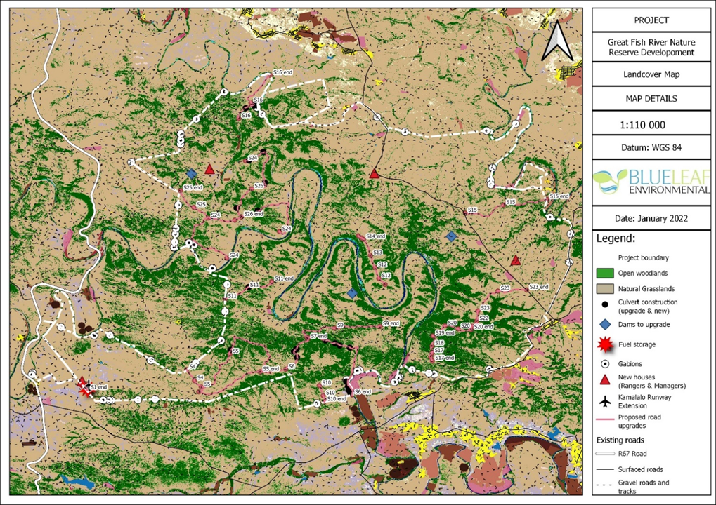
Figure 10-1: Land Cover of the study site and surrounding areas.

Archaeological & Heritage Resources
The area has a rich documented historical past of conflict, change, adaptation and interaction between different groups and individuals (Mostert 1992). The pre-colonial archaeology as well as well as the colonial history of the GFNR has been described in detail by Lita Webley in her report for the Eastern Cape Cultural Resource Pilot Project on the Great Fish River Reserve (Webley 1996) and will not be repeated here. It is however important to note that the proposed activities will take place within a cultural landscape of high significance due to the location of several heritage resources within the GFRNR, such as pre-colonial archaeological sites, colonial period military sites, European farmhouses and associated buildings and graves as well as Xhosa cultural sites and sites associated with living heritage such as rain trees, the umhlawayelo river ritual and isivivane stone cairns (Webley 1996). A small shelter at Adam’s Kranz in the Great Fish River Nature Reserve has also been excavated and apart from other archaeological material dating from the Later Stone Age a hafted arrowhead, the first to be found in southern Africa, was recovered from the site (Binneman 1994). There were also reports of finds of Early Stone Age and Middle Stone Age artefacts as well as badly faded rock paintings and a freshwater shell midden from other locations in the GFNR. In addition to these finds there is a collection of historical material from the Botha’s Post area in the Albany Museum (Webley 1996). The information contained in the Webley report on the Great Fish River Reserve has been included in the Great Fish River Heritage Management Plan and there are also references and recommendations to heritage resources within the GFRNR in the Protected Area Management Plan 2019 - 2029.

Vegetation
The geology, topography and climatic variations have resulted in high levels of plant diversity and a high incidence of plant endemism. Subtropical Fish River Thicket is the dominant vegetation type, interspersed with areas of savanna and grassland. Generally, the vegetation at the higher elevations has greater grass content whereas in the low-lying areas the vegetation is short and thorny or succulent thicket. Annual rainfall has an effect on the amount of grass growth available to herbivores.

Vegetation Type
The SA VEGMAP (Mucina and Rutherford, 2006 and the subsequent 2018 amendments done by Grobler et al., 2018) has identified six (6) vegetation types within the GFRNR (Figure 10-2):

- Fish Arid Thicket;
- Fish Valley Thicket;
- Fish Mesic Thicket;
- Crossroads Grassland Thicket;
- Doubledrift Karroid Thicket; and
- Bhisho Thornveld.

By far the most extensive vegetation type in the reserve is Fish Valley Thicket, while the remaining vegetation types only extend marginally into the reserve. Fish Valley Thicket is a medium to tall (3-5 m) thicket dominated by small trees (including Euclea undulata, Pappea capensis, Schotia afra) and woody shrubs. (Azima tetracantha, Capparis separia var. citrifolia) with tall Euphorbia curvirama and E. tetragona emerging above the canopy. Portulacaria afra occurs in this vegetation type, but its abundance varies from site to site and is locally dominant in some places (see Grobler et al. 2018; Hoare et al. 2006).

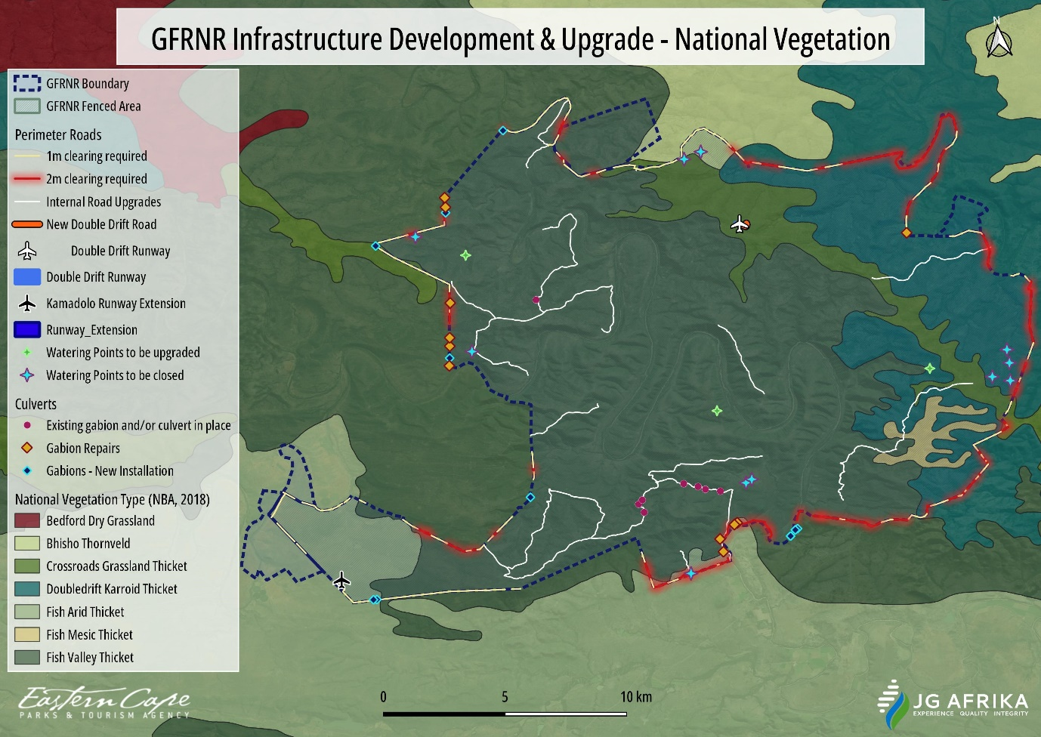
Figure 10-2: National Vegetation classification of the GFRNR.
A finer-scale vegetation map was developed for the reserve in 2015 (Vlok 2015) and, at this scale, eight distinct vegetation types were identified (Figure 10-3). These vegetation types occur in specific habitat units along a clear environmental gradient. In sites where the topography is highly broken, the transition from one vegetation unit to another is abrupt, but along the gradual extended slopes the boundaries are not as distinct. The (eight) 8 vegetation types are:
- Cross Road Grass Thicket.
- Cross Road Spekboom Grass Thicket.
- Dooring and Combretum Veld.
- Fish Shrubland Thicket.
- Fish Spekboom Thicket.
- Fish Thicket.
- Karroid Thicket.
- Spekboom Noorsveld.

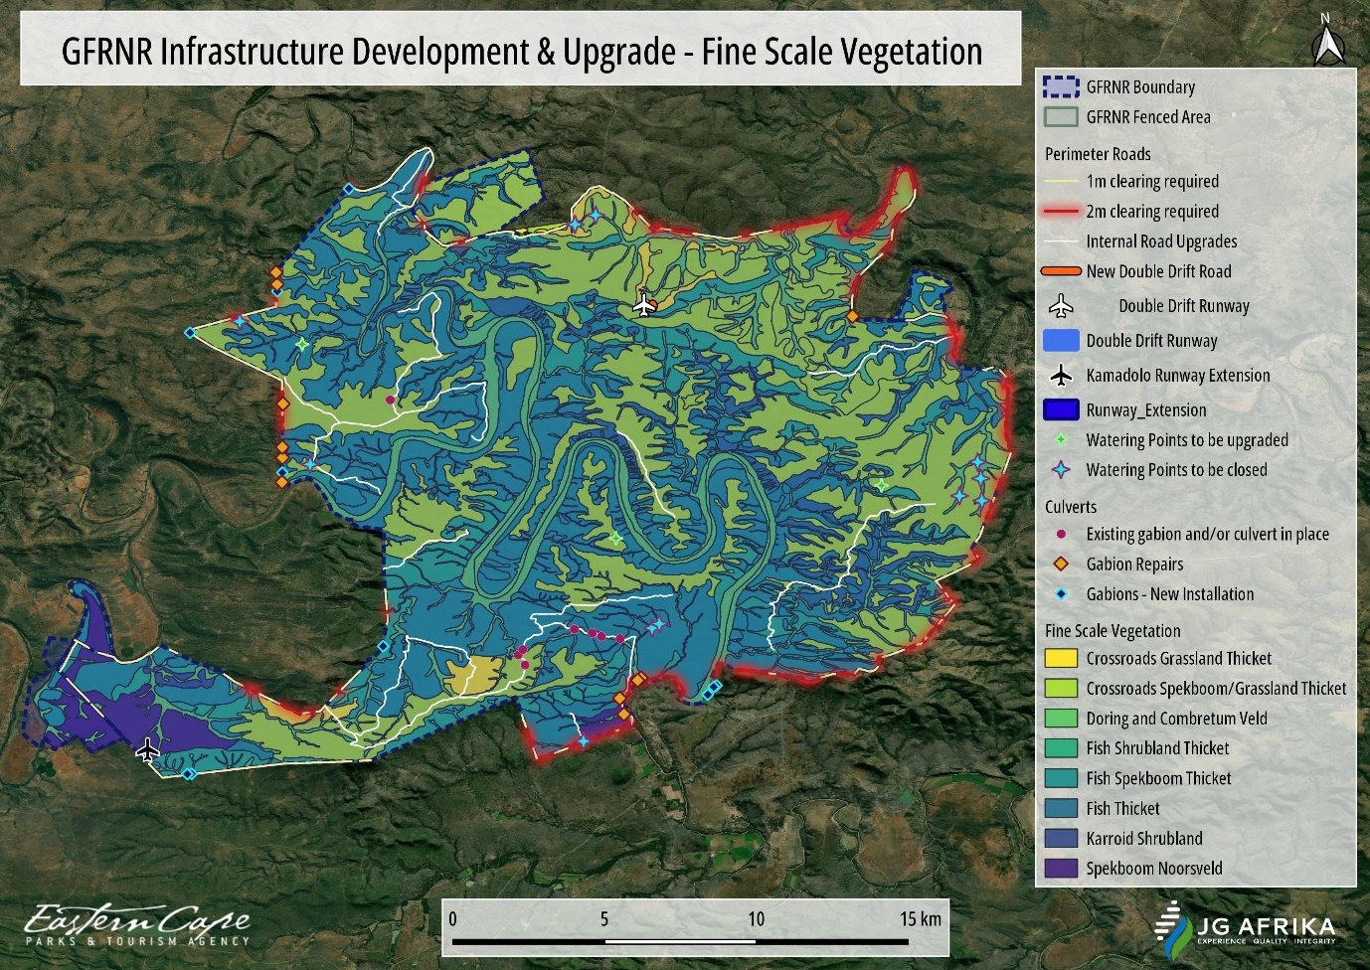
Figure 10-3: Fine scale Vegetation classification of the GFRNR.

Conservation Status
In terms of the conservation status of these, the 2018 South African National Biodiversity Assessment (NBA) classified the above vegetation types as “Least Concern”. In addition, none of these are listed as critically endangered or endangered in terms of the ‘National List of Ecosystems that are Threatened and in Need of Protection’ (published in GN 1002 of 9 December 2011), as promulgated under Section 52 of the National Environmental Management Biodiversity Act, 2004 (Act No. 10 of 2004) (NEMBA).

Critical Biodiversity Areas
The study area is situated within Critical Biodiversity Areas (CBA) according to the Eastern Cape Biodiversity Conservation Plan (ECBCP) (2019) (Figure 10-4). The ECBCP is currently recognised by the Provincial Authority (DEDEAT) in the EIA Regulations (2014, as amended) as a Systematic Conservation Plan regardless that it has not been gazetted as a Bioregional Plan. Certain Listed Activities contained in Listing Notice 3 (Activities in Geographical areas) are triggered by development in CBAs identified in terms of these Systematic Conservation Plans.

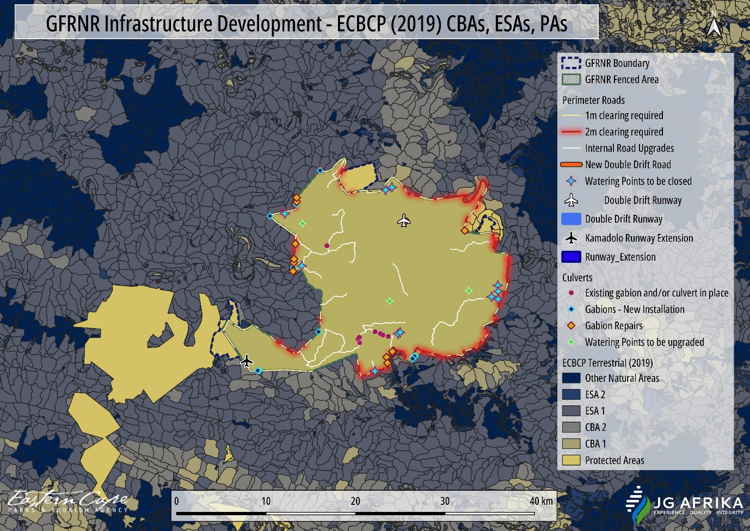
Figure 10-4: Map indicating the Critical Biodiversity Areas and Ecological Support Areas in relation to the proposed site.

Aquatic Features
The NFEPA database (2011-2014) indicated the presence of a large number of areas that are classified as “artificial wetland features” and a number of Channelled Valley Bottom Wetlands that are directly associated with the macro channels of the Kat, Great Fish, Koonap and Keiskamma Rivers as identified by the South African Inventory of Inland Aquatic Ecosystems (SAIIAE) dataset (Figure 10-5). As these wetland areas are located within the macro channel of these rivers, they are considered to be part of the river rather than wetland areas.
The South African National Biodiversity Institute (SANBI) database indicated the presence of many waterbodies (wetlands and watercourses) which are present within the nature reserve. The presence of several artificial wetland areas (stock watering points) is also indicated in this dataset.
The study area falls predominantly within Ecoregion 18 – Drought Corridor and to a far lesser extent within Ecoregion 19 – Southern Folded Mountains. The Great Fish River is the prominent aquatic feature in the region with very few other prominent aquatic features due to the generally low annual rainfall.

The three NFEPA watercourses that occur within the GFRNR is the Great Fish River, the Keiskamma River and the Kat River. These rivers are large lowland rivers with all the seasonal streams that form part of the assessment being classified as seasonal mountain streams that drain into one of these large lowland rivers.

Most of the rivers fall within the quaternary catchment, Q93A, with smaller portions of the reserve occurring in quaternary catchments Q93B, R10k, R10J, Q94F and Q91C which all forms part of the larger Fish to Tsitsikamma and Keiskamma to Mzimvubu Water Management Areas.

The wetland Ecosystem Type is classified as the Albany Thicket Valley Bushveld with the landcover predictably being classified as “natural” based on the protected area classification of the reserve.

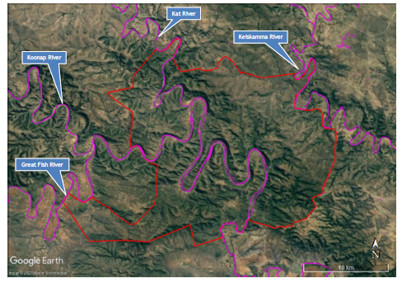
Figure 10-5: Inland Aquatic Ecosystems (indicated in pink) identified by the SAIIAE database (2018).

The watercourse information that was gathered from the 1:50 000 Topographical Maps has indicated the presence of a number of watercourses within the nature reserve (Figure 10-6). The majority of these are seasonal watercourses that will only carry water during rainfall events directly in their catchments. As these watercourses are small and seasonal in nature, the riparian vegetation along them is not well developed. These seasonal watercourses all form part of the Great Fish River catchment.
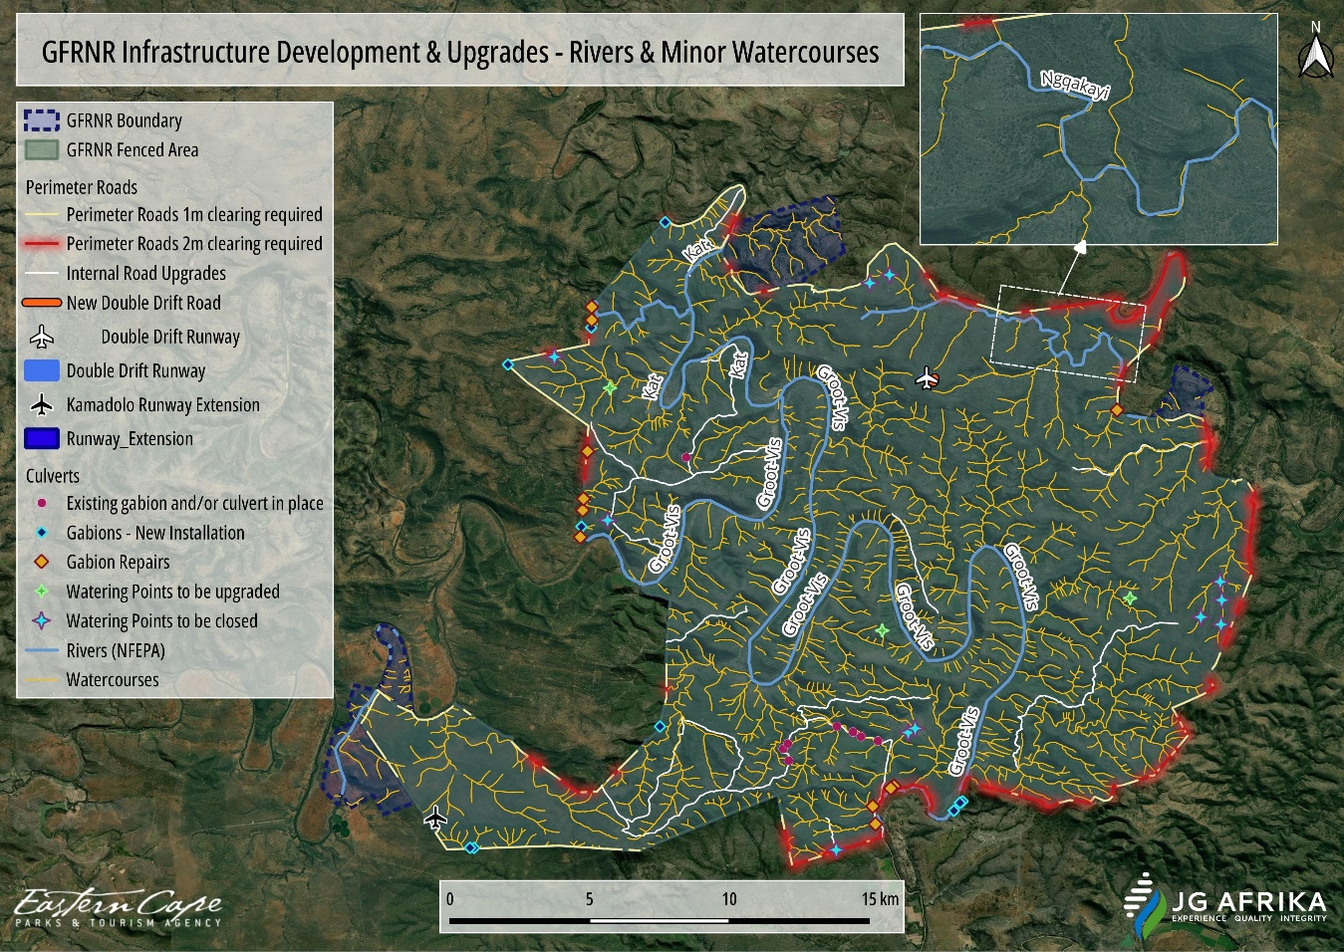
Figure 10-6: GFRNR watercourse information, obtained through the 1:50 000 Topographical Maps (mapped by the ECPTA).
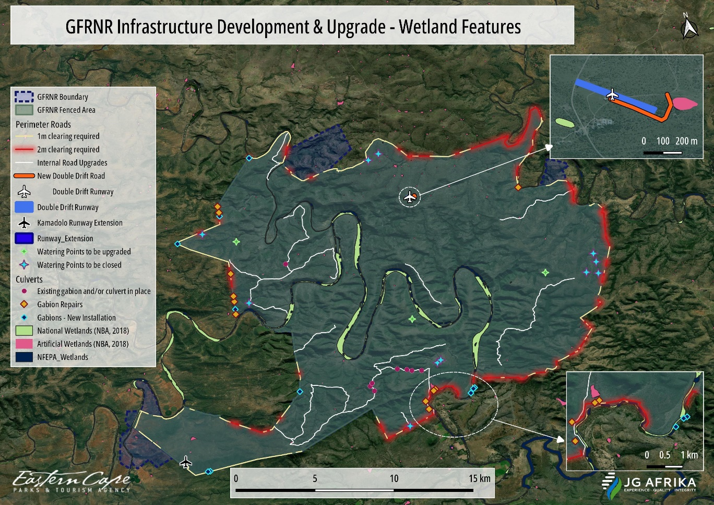
Figure 10-7: Map indicating the aquatic features within the reserve and within the immediate vicinity.

Fauna
Historically, when the large mammal complement was being initially restored after the change in land use, several extra-limital species were introduced into the Double Drift Nature Reserve. The understanding of ecological functioning is that extra-limital species are undesirable and an effort has been made to remove these through game auctions or culling. They include blue wildebeest, nyala, waterbuck and white rhino. Warthog from Zululand were introduced on the understanding that they were the same as the species which was extirpated from the Eastern Cape in the mid-1800s. This has subsequently however been demonstrated to be incorrect and they are now considered to be an alien invasive species.
Restoration of indigenous large mammals has however progressed well and the GFRNR currently has a large and diverse population of indigenous mammal species, particularly large and medium-sized herbivores. The large predator component remains to be re-established although though there are signs of leopard in the area. In total 73 mammal species, including hippopotamus, aardvark, honey badger, black-backed jackal, brown hyena, caracal, and Cape clawless otter have been noted in the GFRNR. Currently, the reserve has large populations (over 300 individuals) of buffalo, eland, kudu, zebra, and red hartebeest. GFRNR also boasts an important population of black rhino (Diceros bicornis minor).
There is limited documentation on the birdlife in the GFRNR although 245 species, including Cape Vulture, Verreaux’s Eagle, Martial Eagle, Kori Bustard, Denham’s Bustard, Ground Hornbill, Giant Eagle Owl and Blue Crane, have been noted (Table 10-1). ECPTA conducted a herpetofauna inventory was survey in 2020. The reptile and amphibian list for the reserve currently includes 51 reptiles (including Tent Tortoise, Eastern Cape Albany Scrub Lizard and African Python) and 16 amphibians (including African Bullfrog and Bushveld Rain Frog). The pythons were reintroduced in the 1980’s – but have not been seen since.

Table 10-1: Species present within the GFRNR as well as their national conservation status.
Scientific Name | Common Name | IUCN Status
Diceros bicornis | Black Rhino | CR
Anthropoides paradiseus | Blue Crane | NT A2acde
Syncerus caffer | Buffalo | LC
Gyps coprotheres | Cape Vulture | EN A2a
Neotis denhami | Denham's Bustard | VU A2bcd+3bcd+4bcd; C1
Tragelaphus oryx | Eland | LC
Bubo africanus | Giant Eagle Owl | LC
Bucorvus leadbeateri | Ground Hornbill | EN A2bcd+4bcd; C1
Ardeotis kori | Kori Bustard | NT A2bcd+3bcd+4bcd
Tragelaphus strepsiceros | Kudu | LC
Polemaetus bellicosus | Martial Eagle | EN A2cde ; C1
Alcelaphus buselaphus lichtensteinii | Red Hartebeest | LC
Aquila verreauxii | Verreaux's Eagle | VU A2c; C1
Equus quagga | Zebra | LC

Socio-Economic Environment
The proposed infrastructure development and upgrading of the GFRNR is situated within three local municipalities: Makana Local Municipality, Raymond Mhlaba Local Municipality, and Ngqushwa Local Municipality. Information on the socio-economic environment within which the upgrade will occur has therefore been sourced from the Makana LM IDP (2021-22), Raymond Mhlaba LM IDP (2022-2027), and Ngqushwa LM IDP (2023-24). Reserve management has identified the involvement of stakeholders in contributing to the management of the GFRNR as a key to the success of the nature reserve. Activities and developments near the GFRNR as well as around the area can have an impact on the reserve and, as such, key performance areas relate to securing and managing the areas of influence around the nature reserve and the reserve buffer zone and for the contractor to engage with and source labour from the local communities.

Makana Local Municipality
Makana Local Municipality (Makana) is a category B Municipality approximately halfway between East London and Port Elizabeth that forms part of the seven local municipalities of the Sarah Baartman (formerly Cacadu) District Municipality in the Eastern Cape Province. Makana’s area is bordered in the north-east by Amathole District Municipality with the cities of Port Elizabeth 120 km to the west and East London 180 km to east, north-west by Blue Crane Route Local Municipality, in the south by Ndlambe Local Municipality and in the south-west by the Sundays River Valley Local Municipality. In 2011 the Municipality was delimited into fourteen wards.

Demographic Profile & Trends
Population statistics is important when analysing an economy, as the population growth directly and indirectly impacts employment and unemployment, as well as other economic indicators such as economic growth and per capita income (Makana Municipality IDP 2021-22).

Table 10-2: Total population for Makana Municipality in context with the district municipality, province and on a national scale (Makana LM IDP, 2021).
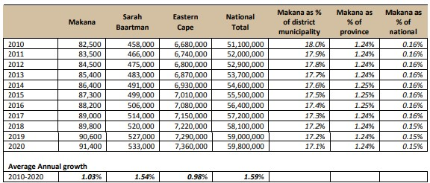

As seen in Table 10-2 above, with 91 400 people, the Makana Local Municipality housed 0.2 % of South Africa's total population in 2020. Between 2010 and 2020 the population growth averaged 1.03 % per annum which is close to half than the growth rate of South Africa as a whole (1.59 %). Compared to Sarah Baartman's average annual growth rate (1.54 %), the growth rate in Makana's population at 1.03 % was close to half than that of the district municipality.

As seen in 2020 (in Figure 10-8), there is a significantly larger share of young working age people between 20 and 34 (30.6 %), compared to what is estimated in 2025 (28.4 %). This age category of young working age population will decrease over time. The fertility rate in 2025 is estimated to be slightly higher compared to that experienced in 2020. The share of children between the ages of 0 to 14 years is projected to be significant smaller (20.8 %) in 2025 when compared to 2020 (22.4 %).

In 2020 (Figure 10-8), the female population for the 20 to 34 years age group amounts to 14.4 % of the total female population while the male population group for the same age amounts to 16.2 % of the total male population. In 2025, the male working age population at 15.0 % still exceeds that of the female population working age population at 13.4 %, although both are at a lower level compared to 2020.

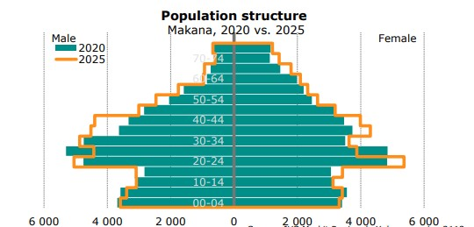
Figure 10-8: Sex & Age Distribution of residents in Makana Municipality (Makana LM IDP, 2021/22).

Education Levels
Education is the cornerstone to sustainable development, and it is therefore very important to be prioritised because 66 % of the population fall between 0-34 years of age in Makana (Table 10-3).

Table 10-3: Percentage of educated individuals in each age category.
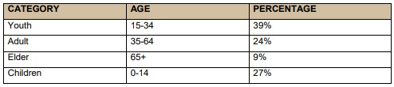

Education is a useful socio-economic indicator to examine as it directly impacts on the poverty levels of a community. A community that has high levels of education generally has higher levels of income than areas with low levels of education. Education impacts infrastructure directly and indirectly.

The more educated a population is the more they can contribute to infrastructure provision and maintenance. A more educated population can provide higher tariffs and taxes in order to maintain key infrastructure.

Makana is amongst the municipalities who have the lowest proportion of people without schooling, at 8.2 % (Table 10-4). Makana has the highest proportion of people who have a matric or higher at 22.7 %. The Municipality’s high proportion of people who have a matric or higher could be related to the fact that many university students and highly qualified lecturers reside in Makhanda.

Table 10-4: Level of Education in Makana Municipality (Makana LM IDP, 2021/22).
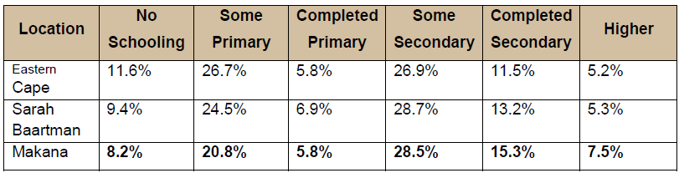

- 46.4 % of the population is younger than 24 years old, which indicates a relatively young population profile.
- 15 % of the population completed secondary school and 7.5 % post-secondary or higher education.
- The education levels of Makana (completed secondary and higher education) are significantly higher than the District and the Province.

Employment & Unemployment
Total employment can be broken down into formal and informal sector employment. Formal sector employment is measured from the formal business side, and the informal employment is measured from the household side where, formal businesses have not been established.

Formal employment is much more stable than informal employment. Informal employment is much harder to measure and manage, simply because it cannot be tracked through the formal business side of the economy. Informal employment is however a reality in South Africa and cannot be ignored.

The number of formally employed people in Makana Local Municipality counted 18 200 in 2020, which is about 73.6 % of total employment, while the number of people employed in the informal sector counted 6 540 or 26.4 % of the total employment (see Figure 10-9 for formal and informal employment by sector). Informal employment in Makana increased from 5 730 in 2010 to an estimated 6 540 in 2020.

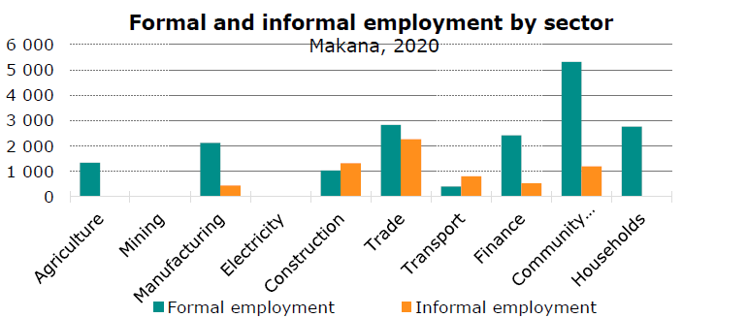
Figure 10-9: Formal and informal employment by sector within the Makana Local Municipality (MLM IDP 2021-22).

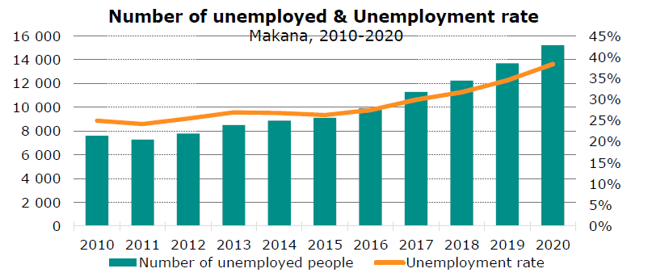
Figure 10-10: Number of unemployed & unemployment rate for residents of Makana Municipality (MLM IDP 2021-22).

In 2020, there were a total number of 15 200 people unemployed in Makana, which is an increase of 7 610 from 7 590 in 2010 (Figure 10-10). The total number of unemployed people within Makana constitutes 22.59 % of the total number of unemployed people in Sarah Baartman District Municipality. The Makana Local Municipality experienced an average annual increase of 7.19 % in the number of unemployed people, which is better than that of the Sarah Baartman District Municipality which had an average annual increase in unemployment of 8.18 %.

Household Information & Income Levels
The number of households is grouped according to predefined income categories or brackets, where income is calculated as the sum of all household gross disposable income: payments in kind, gifts, homemade goods sold, old age pensions, income from informal sector activities, subsistence income, etc.). Note that income tax is included in the income distribution.

Table 10-5: Household Information – Dwelling Type designation for Makana Municipality among other local municipalities in the Sarah Baartman District Municipality (Makana LM IDP 2021/22).
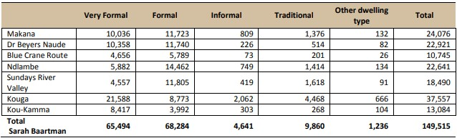

It was estimated that in 2020 14.59 % of all the households in the Makana Local Municipality, were living on R 30 000 or less per annum. In comparison with 2010's 27.44 %, the number is about half. The 30 000 - 42 000 income category has the highest number of households with a total number of 2 640, followed by the 192 000 - 360 000 income category with 2 550 households. Only 1.5 households fall within the 0-2400 income category.

Table 10-6: Household income category for 2020 residents of Makana Municipality (Makana LM IDP, 2021/22).
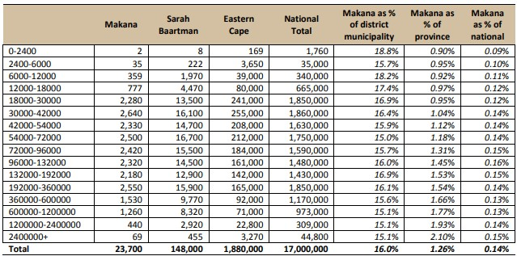

Raymond Mhlaba Local Municipality

Demographic Profile & Trends
In 2020 HIS Markit eXplorer indicates that the total population in Raymond Mhlaba Municipality is 163 000. The municipality has 23 wards; and it is dominated by large populace which is indigent. Much of the population of Raymond Mhlaba (>70 %) reside in villages and/or on farms and minorities are in urban dwellings. Urbanisation is mainly concentrated in Alice, Fort Beaufort, Adelaide, and Bedford.

In 2020, the population of the Raymond Mhlaba Local Municipality was 162 000 of these residents, the largest share of the population is within the working age category (25 - 44 years) with a total of 46 200 or 28.5 % of the total population. The age category with the second largest number of people is babies and children (0 - 14 years) with a total share of 27.3 %, followed by the older working age (45-64 years) with 33 000 people. The age category with the least number of people is the retired/old age (65 years and older) with only 14 500 people.

As seen in Figure 10-11, the population pyramid indicates that the population of Raymond Mhlaba Local Municipality is dominated by youth and women, ages from 25 - 39.

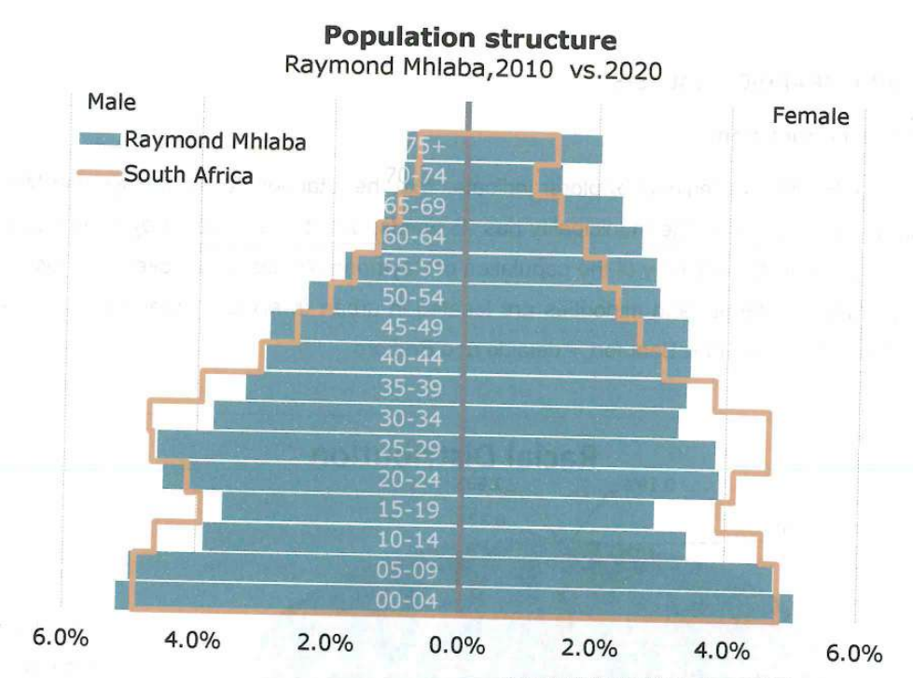
Figure 10-11: Population structure of the Raymond Mhlaba Local Municipality residents (RMLM IDP 2022).

Education Levels
Education is a key dimension that directly influences the potential employability of community members. The level of education and skills within a region impacts on many factors, including: the productive efficiency of investments, employment potential, the gender gap, productivity, and income levels. The Raymond Mhlaba Local Municipality is showing great improvement in terms of education. The number of people without any schooling decreased in the past ten years from 2010 to 2020. The average rate of people with “matric only” increased from 16 300 to 23 600 (Table 10-7Error! Reference source not found.).

Table 10-7: Education levels of the residents of the Raymond Mhlaba Local Municipality (RMLM IDP 2022).
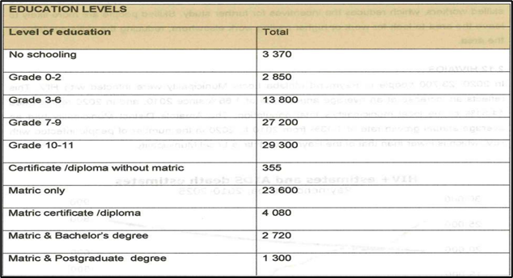

Employment & Unemployment
A total of 27 780 people within the municipality were employed in 2020. The number of formally employed people amounted to 20 900, which is about 75.24 % of the total employment, while the number of people employed in the formal sector counted 6 880 or 24.76 % of the total employment.

As seen in Figure 10-12, the trade sector recorded the highest number of informally employed, with a total of 2 970 employees of 43.16 % of the total informal employment. This can be expected as the barriers to enter the trade sector in terms of capital and skills required is less than with most of the other sectors.

In terms of unemployment, in 2020, there were a total of 27 000 people unemployed in Raymond Mhlaba, which is an increase of 12 300 from 14 700 in 2010 as seen in Figure 10-13.

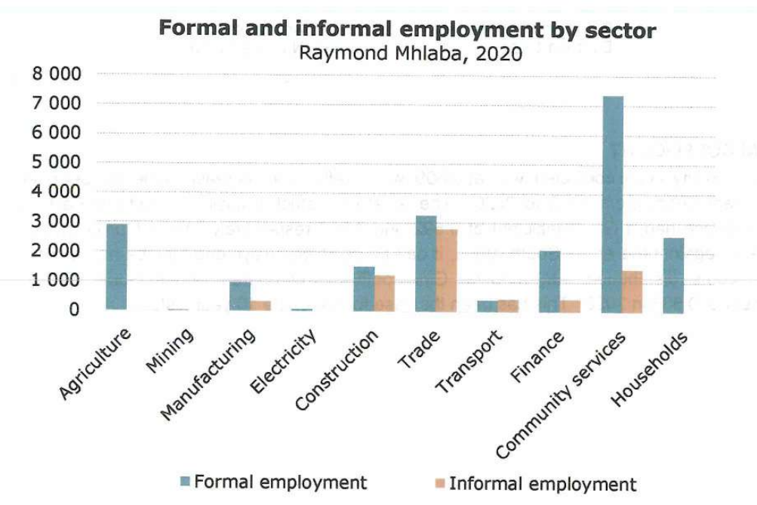
Figure 10-12: The formal and informal employment sector of the Raymond Mhlaba Local Municipality (RLM IDP, 2022).

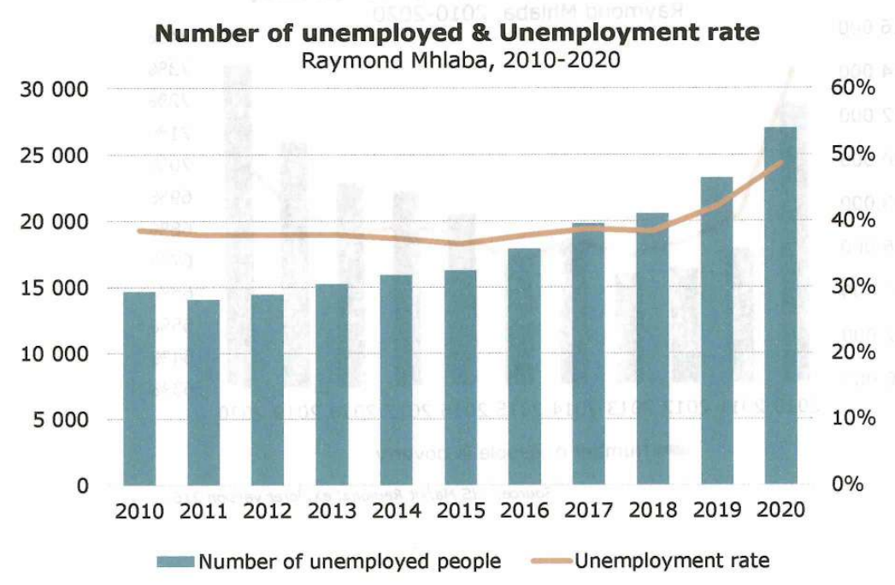
Figure 10-13: The number of unemployed & the unemployment rate within the Raymond Mhlaba Local Municipality (RMLM IDP 2022).

Household Information & Income Levels
The municipality had a total of 44 832 households by the end of 2019. Of these, 31 707 had a formal dwelling type, 2 703 had an informal dwelling, 10 574 had traditional dwelling types and 148 had other dwelling types.

The average annual household income equates to roughly R 14 600 per annum. In terms of service delivery, 94.5 % of the residents are getting water from a regional or local service provider and only 1.5 % of the residents have no access to electricity.

Ngqushwa Local Municipality

Demographic Profile & Trends
Ngqushwa Local Municipality has an estimated population of 66 227 (Stats SA: 2016). Compared to the previous census figures prior to 2011, the population of Ngqushwa has decreased by 8.1 %. As seen in Figure 10-14, a high dependency rate is reflected with numbers of children aged between 0 and 19 years being the highest. Those within the school going age are estimated at 28 800, with approximately 14 899 being males, and 13 901 females. Those who fall above the economically active population (over 60 years) are estimated at 11 675. Therefore, the youth and elderly constitute for 40 475 which accounts for roughly 56 % of the total population.

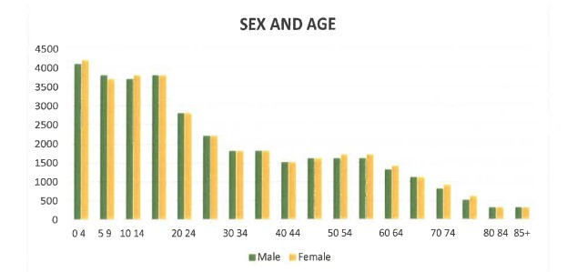
Figure 10-14: Sex and age of residents of Ngqushwa Municipality (Stats SA, 2016).

Education Levels
In terms of the levels of education of the residents of the Nqgushwa Local Municipality, of the residents over the age of 20, 7.8 % have no form of schooling, 21.4 % have matric, and 5.3 % have a higher education qualification.

Unemployment
As seen in Figure 10-15, there are decreasing poverty levels between 2011, being roughly 66 % to 41 % in 2016. Unemployment on the other hand also shows a decrease from 40 % in 2011 to about 31 % in 2016. The employment rate, however, was on the increase from 60 % in 2011 to 69 % in 2016.

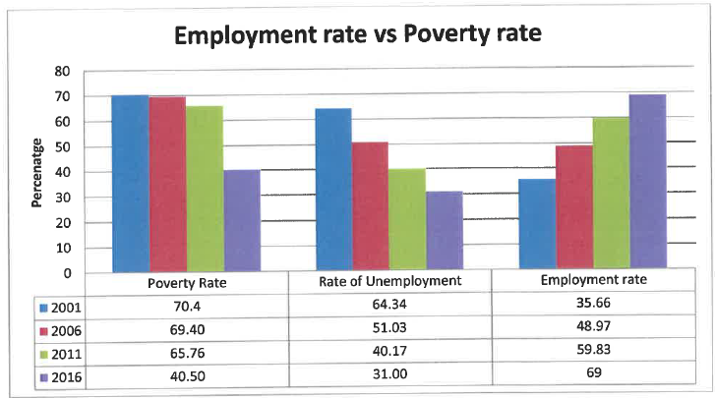
Figure 10-15: Employment rate vs poverty rate of residents in the Ngqushwa Local Municipality (Stats SA, 2011).

Household Information & Income Levels
As seen in Figure 10-16, the majority of the households are earning very low incomes. Statistics SA (2011) information shows the number of employed households (11 538) earning between R 9 601 and R38 200 per annum. Ward meetings revealed that the majority of the population relies heavily on social grants. They raised that there is a need for projects to provide the community with food security. Proposals for skills development and provision of institutions of higher learning that will ensure improvement of the labour force also came up strongly from the wards.

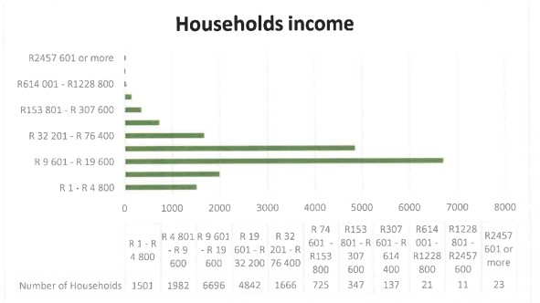
Figure 10-16: Household incomes depicted for the Ngqushwa Local Municipality (ECSEC 2019).

Findings of National web-based Environmental Screening Tool
In addition to the project screening tool included in the ESMF, the project activities were screened using the National web-based Environmental Screening Tool (NEST), developed by the DFFE, and as required by the National Environmental Management Act, 1998 (Act 107 of 1998) (NEMA): Environmental Impact Assessment (EIA) Regulations (2014, as amended). Table 10-8 below indicates the level of sensitivity of each of the themes identified in the Screening Tool Report. A copy of this Screening Report is attached to Appendix H of this Report.

Table 10-8: Summary of the environmental sensitivities for the themes identified by the Screening Tool Report
THEME | SENSITIVITY
 | VERY HIGH | HIGH | MEDIUM | LOW
Agriculture
Animal Species
Aquatic Biodiversity
Archaeological and Cultural Heritage
Civil Aviation
Defence Theme
Palaeontology
Plant species
Terrestrial Biodiversity

Based on the above sensitivities, the following specialist assessments have been recommended by the Screening Tool, and the EAPs opinion/motivation, subsequent to site visits on the 20th of October 2020 and 9th of March 2021 and discussions with various specialists, for the requirements of these environmental sensitivities, have been provided in the Table 10-9 below.

Table 10-9: Specialist Assessments Recommended as per the Screening Tool Report and motivations/ opinions detailing why the studies have or have not been conducted as part of the Basic Assessment Process.
SCREENING TOOL SPECIALIST ASSESSMENT RECOMMENDATION | EAP MOTIVTION / OPINION
Agricultural Impact Assessment | Agriculture was identified as having a VERY HIGH sensitivity. The proposed site is surrounded by farming properties. The zoning of several farm portions within the GFRNR, which fall within the jurisdiction of the Makana Local Municipality, are all zoned as Agriculture Zone 1. This, together with animal grazing, most probably explains the agricultural sensitivity identified. No agricultural activities are currently taking place within the reserve. Furthermore, it is highly unlikely that the proposed development will have any impact on these surrounding properties hence this impact assessment is not relevant.
Landscape / Visual Impact Assessment | In terms of the Civil Aviation Theme for which the sensitivity was identified as HIGH by the Screening Tool - It is believed that this sensitivity was rated “high” due to the presence of two (2) small airfield (runway) strips within the reserve and presence of the airfield at Kwandwe Private Game Reserve (west of GFRNR) and possibly also the Makhanda Aerodome. Upgrades to the runways within the GFRNR will form part of the infrastructure upgrading.  Airfields at GFRNR will not be used for civilian traffic.  Flights will be infrequent and largely for emergencies. No more than 2 flights per week are currently being undertaken and these are shared between the 2 airfields. Aircraft will operate according to the Civil Aviation Regulations and will not pose a threat to air traffic.  It is anticipated that the proposed upgrading will have a negligible impact on aviation per se, and as such, a Visual Impact Assessment should not be required.
Animal Species Assessment | According to the Screening Tool, the Animal species sensitivity of the study area is classified as HIGH.  A Terrestrial Animal Species Assessment has been undertaken by a specialist registered with the South African Council for Natural Scientific Professions (SACNASP) with a field of practice relevant to the taxonomic group (“taxa”) for which the assessment is being undertaken.
Aquatic Biodiversity Impact Assessment | The Aquatic Biodiversity theme was identified as VERY HIGH.  Based on a desktop review of the study area, NFEPA rivers, several small drainage lines and wetlands were identified within the study area (NFEPA, 2014). In addition, the study area and development / upgrading components will be located within the Regulated Area of a wetland (500m) or drainage lines (100m), as set out by the National Water Act (Act 36 of 1998).  In accordance with The Protocol for the Specialist Assessment and Minimum Report Content Requirements for Environmental Impacts on Aquatic Biodiversity (March 2020), an Aquatic Biodiversity Assessment has been prepared by a suitably qualified specialist registered with the SACNASP, with expertise in the field of aquatic sciences.  The Aquatic Biodiversity Assessment has assessed the aquatic ecosystem components of the surface water features in relation to the proposed development.
Hydrology Assessment
Archaeological and Cultural Heritage Impact Assessment | According to the Section 38 (8) as set out in the National Heritage Resource Act (Act 25 of 1999), should more than 5000 m² of vegetation will need to be cleared, a Heritage/Archaeological Impact assessment must be undertaken. This together with the Archaeological theme being classified as HIGH, requires an Archaeology Impact Assessment which has been conducted and assessed the archaeological and cultural heritage of the proposed development site.
Palaeontology Impact Assessment | Based on the initial consultation with a Palaeontological Specialist, and a review of the SAHRIS Palaeontological desktop map, the sensitivity of the site is classified as VERY HIGH, which is in agreement with the findings of the Screening Tool. As such, the Basic Assessment is supported by a Palaeontological Impact Assessment.
Plant species Assessment | According to the Screening Tool, the Terrestrial Biodiversity and Plant species sensitivities of the study area are respectively classified as VERY HIGH and MEDIUM sensitive.  The study area is located within a Critical Biodiversity Area (CBA) as identified by the ECBCP (2019).  A full Terrestrial Biodiversity Assessment has been undertaken and included a Plant Species component, as required by The Protocol for the Specialist Assessment and Minimum Report Content Requirements for Environmental Impacts on Aquatic Biodiversity (March 2020), of which the findings are presented in the Basic Assessment Report.  The assessment has been prepared by a specialist registered with the South African Council for Natural Scientific Professionals (SACNASP) with expertise in the field of terrestrial biodiversity.
Terrestrial Biodiversity Impact Assessment
Socio-Economic Assessment | A Socio-Economic Assessment is not deemed necessary as the nearest social receptors are located outside the reserve, and it is unlikely that these receptors will be impacted on by the proposed development and upgrading works taking place within the reserve. This aspect will, however, be adequately assessed in this Basic Assessment Report.

Findings of the specialist assessments, those identified by the Screening Tool and motivated by the EAP are described in Section 11 below.

FINDINGS OF SPECIALIST INVESTIGATIONS
The specialist investigation that was undertaken as part of the Basic Assessment Report is discussed in Sections 11.1– 11.5 of this Basic Assessment Report.

Aquatic Assessment
An aquatic assessment has been conducted by GCS Water and Environmental Consultants in August 2021. A copy of the Aquatic Assessment Report is attached to Appendix E1 of this Final Basic Assessment Report. A summary is provided below.

The results of the Aquatic Ecology Assessment relate to wetlands and watercourses that occur within the boundaries of the Great Fish River Nature Reserve. Specific areas of assessment made provision for the areas within 100 m of the edges of the watercourses that have been identified for watercourse crossing repairs.

Aquatic Features
The available desktop information that was used in this assessment consisted of the following:
- National Freshwater Ecosystem Priority Areas (NFEPA) (2011);
- Wetland Database managed by the SANBI (2008);
- South African Inventory of Inland Aquatic Ecosystems (SAIIAE) (2018); and
- 1:50 000 Topographical Maps.

The site assessment confirmed the presence of the wetland features identified by the interrogated databases and did not find any additional wetland areas other than additional stock watering that were not mapped by the datasets. It must be noted that since no wetlands were identified that may be impacted by the activities associated with the proposed project, no further assessment of these were undertaken.
The watercourse information that was gathered from the 1:50 000 Topographical Maps has indicated the presence of a number of watercourses within the nature reserve. The majority of these are seasonal watercourses that will only carry water during rainfall events directly in their catchments. As these watercourses are small and seasonal in nature, the riparian vegetation along them is not well developed. These seasonal watercourses all form part of the Great Fish River catchment.
Three watering points are proposed to be upgraded as part of the project. Two of these watering points are considered to be off-stream watering points as no watercourses were found to drain into them. In this regard, Watering points 1 and 3 are located on high points in the landscape and are considered to be associated with old diggings in the area (see Figure 11-1 and Figure 11-2 below). Watering point 2 is directly associated with a watercourse that drains into the basin from the southwest (see Figure 11-3 below). Watering point 2 is therefore considered to be an in-stream watering point and all upgrading works are considered to take place within the “regulated area of a watercourse” as defined by the National Water Act (Act No. 36 of 1998).

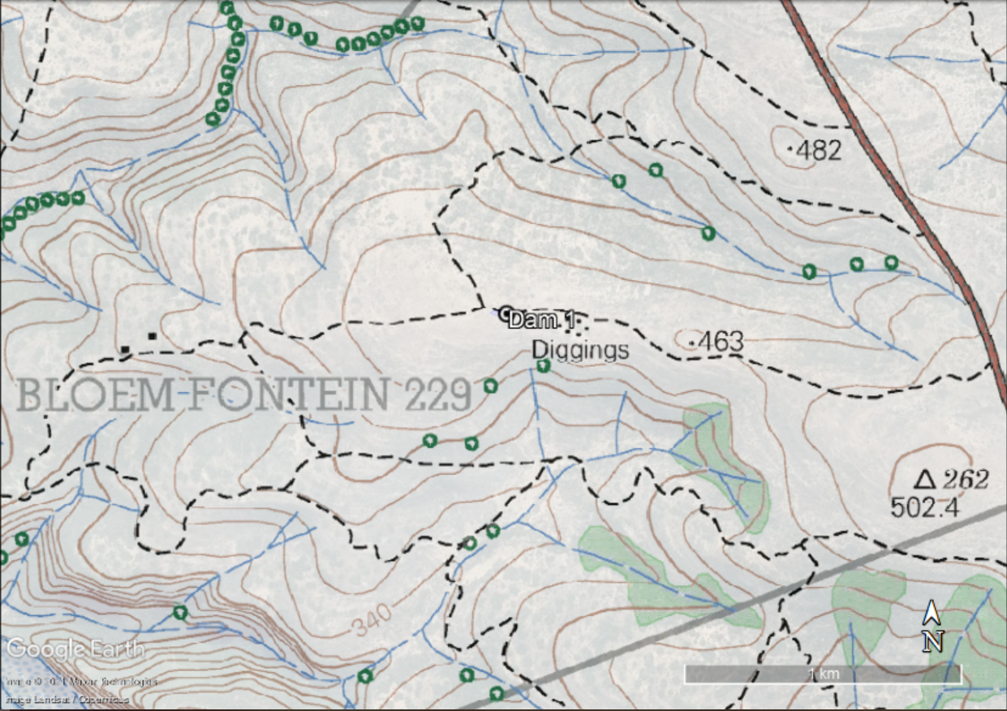
Figure 11-1: Location of Watering point 1 on a high point in the topography (1:50 000 topographical map sheet 3326BB)

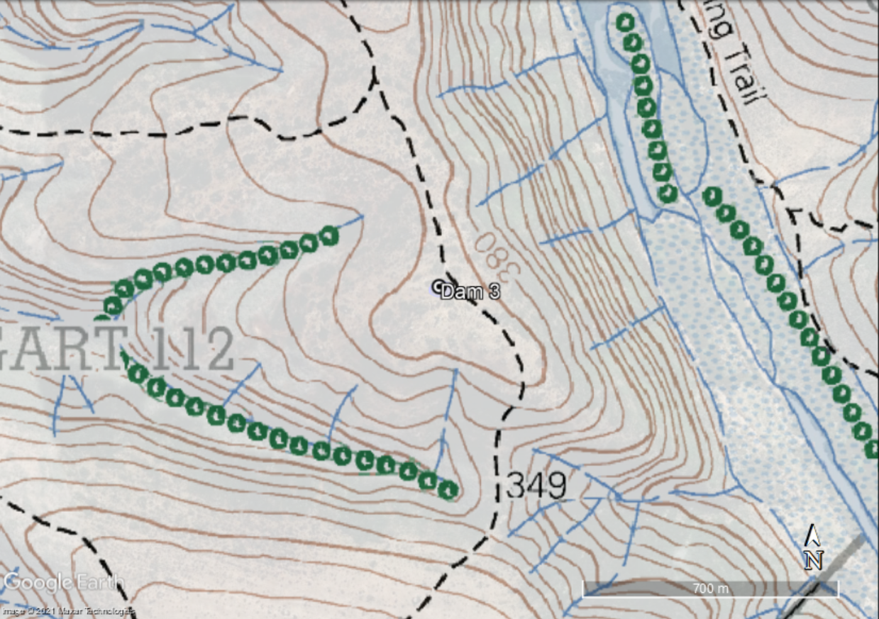
Figure 11-2: Location of Watering point 3 on a high point in the topography (1:50 000 topographical map sheet 3326BB).

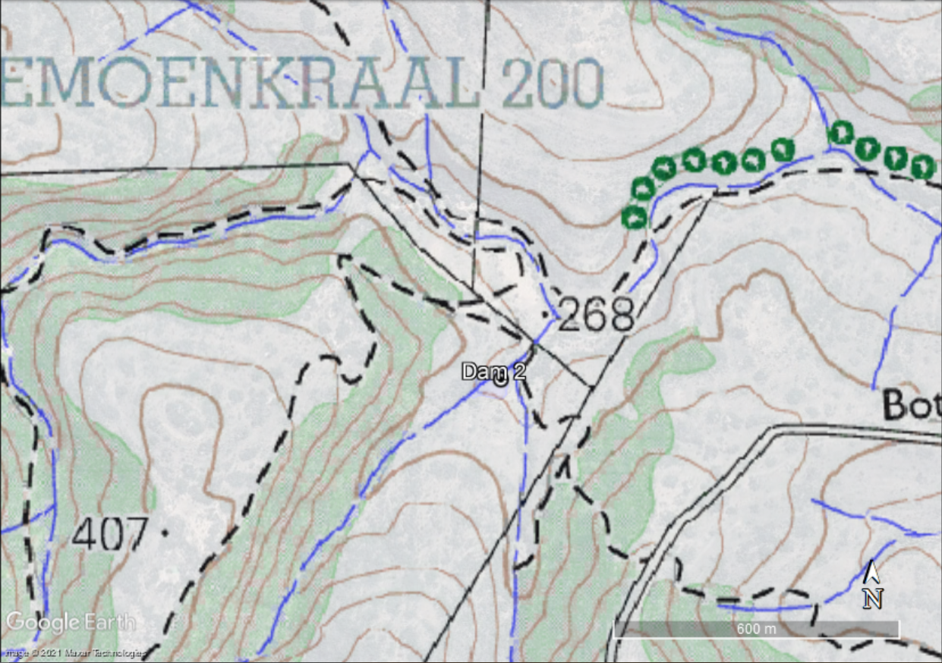
Figure 11-3: Watering point 2 is associated with a watercourse draining into the basin from the southwest (1:50 000 topographical map sheet 3226DC).

All eleven watering points that will be decommissioned are considered to be in-stream watering points so all the works associated with the decommissioning will take place within the “regulated area of a watercourse” as defined by the National Water Act (Act No. 36 of 1998).

Riparian Delineation
The activities listed below, associated with the project are considered to be within the “regulated area of a watercourse” as defined by the National Water Act (Act No. 36 of 1998) as well as within 32 m or within a watercourse as defined by the National Environmental Management Act (Act No. 107 of 1998): Environmental Impact Assessment Regulations (2014), as amended:
- Upgrading of Watering point 2;
- Decommissioning of Watering point A to K (or 1 to 11); and
- Upgrading of existing road crossings over the seasonal watercourses.

As all these activities are taking place within their associated watercourses, the need to delineate the riparian edges was considered superfluous. However, for the purposes of the assessment, the following determination was made, “Category 1” watercourses (channel width of less than 2 m) has a riparian edge (where present) of 4 m either side of the channel and “Category 2” watercourses (channel width of more than 2 m) has a riparian edge of 8m either side of the channel (refer to Plate 8-1 and 8-2 in Aquatic Assessment Report included under Appendix E1).

Watercourse Classification
In the case of the watercourses directly associated with the activities to be undertaken in the nature reserve, these watercourses are all seasonal and will only contain flowing water during rainfall events or for short periods thereafter. As with all aquatic features, the key drivers of these watercourses are their hydrology (presence and or movement of water) and their geomorphology (landform characteristics and processes).

Soils and Function of watercourses
The soils within the channel beds of the watercourses vary from bedrock to alluvial deposits of fine, weathered shale from the surrounding catchment. The presence of soil deposition is very limited as a result of the periodic and high velocity runoff in the catchment.

The key ecosystem service that watercourses provide is therefore the facilitation of movement of water (and associated materials) through the water cycle. These watercourses typically will sustain riparian vegetation along the watercourse banks which provides habitat for aquatic and terrestrial species. The presence or absence and extent of this riparian vegetation is a direct function of the period of time that water is present within the watercourse channels.

Present Ecological State and Ecological Importance and Sensitivity of the watercourses
The table below (Table 11-1) provides the Present Ecological State as well as the Ecological Importance and Sensitivity of the watercourses that may be impacted by the project activities. This classification is based on the findings of Kleynhans (2000).

Table 11-1: Present Ecological State and Ecological Importance and Sensitivity of the watercourses (per quaternary catchment) (Kleynhans, 2000).
Quaternary Catchment | Present Ecological State | Ecological Importance and Sensitivity
Q93A | Class D – Largely Modified | Moderate
Q93B | Class D – Largely Modified | Moderate
Q91C | Class D – Largely Modified | Moderate
Q94F | Class D – Largely Modified | High
R10J | Class D – Largely Modified | High
R10K | Class D – Largely Modified | High

Buffer Determination
As the activities associated with the upgrading of Watering point 2, decommissioning of eleven watering points, and upgrading of crossings, will occur within the channels of the watercourses, no buffers are proposed for the actual activities. However, buffers are prescribed for the location of the site camps, construction storage areas or ablution facilities. All such facilities associated with each of the construction sites must be placed at a distance greater than 40 m from the demarcated edge of the riparian vegetation.

Hydropedological Conditions
Due to the limited impact that the development will have on the hydropedological conditions in the study area, a desktop assessment of these conditions was undertaken. This assessment has indicated that the soils in the study site consists of soils that are derived from the underlying shale, mudstone, and sandstone bedrock. The soils on the site are typically coarse grained lithosols (shallow soils on hard or weathered rock).

Water will therefore move through these soils in a vertical direction until it reaches the impermeable bedrock from where the water will move in a horizontal direction along the bedrock. The water in the soils will daylight at locations where the soil/bedrock interface daylight, such as at the watercourses.

As a result of these soil characteristics, the soils in the study area are classified as interflow soils. These soils and how the water moves through them are depicted in Figure 11-4.

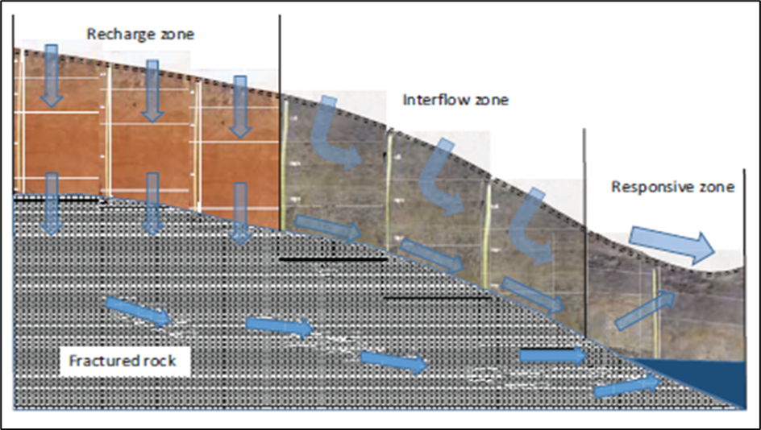
Figure 11-4: Hydropedological characteristics of the interflow soils in the study area.

Impacts
No-Go impacts associated with the infrastructure in the Great Fish River Nature Reserve
- The current impacts will persist to impact on the aquatic features which will result in a degradation of the characteristics of these features.
Construction impacts associated with the infrastructure in the Great Fish River Nature Reserve
- Impact to the water quality in the aquatic feature because of inadequate stormwater management.
- Impact to the hydrological characteristics of the aquatic feature due to changes in the catchment.
- Impact to the water quality in the aquatic features because of the leakages from the portable chemical toilets that will be used during construction.
- Impact to the water quality in the aquatic features because of petrochemical spillages from plant and equipment.
- Impact to the water quality in the aquatic features as a result of leaking petrochemical facilities.
Operational impacts associated with the infrastructure in the Great Fish River Nature Reserve
- Impact to the hydrological characteristics of the aquatic feature due to changes in the catchment.
- Impact to the water quality in the aquatic features because of inadequate stormwater management.
- Impact to the water quality in the aquatic features as a result of leakages from vehicles and plant using the road.
Cumulative impacts associated with the infrastructure in the Great Fish River Nature Reserve
- The establishment of the proposed infrastructure has the potential to impact the current hydrological regime of the catchment, which will have an impact on the hydrological characteristics of the wetland areas identified.
However, considering the design dimensions of the proposed infrastructure, the hydraulic structures associated with these as well as their location outside of the proposed 40 m buffer, it is considered that the cumulative impact of the infrastructure on the wetland hydrology will be low.
- The stormwater management measures as well as the crossing structures proposed for the road crossings is considered to be adequate to ensure that the stormwater runoff from the infrastructure does not result in uncontrolled runoff from these areas which the resultant siltation.
As such, the cumulative impact of siltation associated with the increased velocities associated with uncontrolled stormwater runoff is considered to be low.

Proposed mitigation and management measures
For No-Go impacts associated with the infrastructure in the Great Fish River Nature Reserve
- None, as the No-Go option reflects the status quo.
For construction impacts associated with the infrastructure in the Great Fish River Nature Reserve
- The stormwater outlets associated with the infrastructure must make provision for energy dissipators at the mouth of the outlets. This will reduce the risk of erosion and associated siltation which can contaminate the water quality.
- The provision for adequate stormwater management (as described above) as well as the hydraulic structures that have adequate sizes to prevent any damming of water upstream of the structure must be ensured.
- The following management and mitigation measures must be included into the ESMPr Report for the project to limit the potential impacts of leakages from the ablution facilities:
  - Only portable chemical toilets with a sealed reservoir will be allowed on site.
  - The capacity of the reservoirs in the portable chemical toilets must be monitored daily to ensure that they can be serviced timeously.
  - All removal of the collected sewage waste from the portable chemical toilets must be conducted by a registered service provider for disposal at a municipal wastewater treatment facility.
- The following management and mitigation measures must be included into the ESMPr for the project:
  - All plant and equipment that make use of petrochemical substances must be checked for leakages daily before operations commence.
  - All plant and equipment that are found to be leaking must be removed immediately from the property by the contractor and only returned once the leakages have been addressed.
  - If any petrochemical substances are stored on the property, this storage must be done on an impermeable surface in a bunded area that makes provision for 110 % of volume of the substances that are stored.
  - All refuelling of plant and equipment must be conducted over a drip tray.
  - Servicing of plant, machinery or equipment must be undertaken as and when required. Inspection hereof must be done on a regular basis.
  - If any plant or equipment is to be parked on the site, these must be parked within the demarcated construction footprint that has been cleared.
  - If any spillages from plant or equipment occur, the spill must be immediately contained by means of a drip tray placed underneath. A spill kit must be readily available and be effectively utilised. The contaminated soils must be collected and bagged in impermeable bags and stored on site to be removed and disposed of by a registered service provider.
- If a camp with associated petrochemical storage will be established, the following management and mitigation measures must be included in the ESMPr:
  - All storage containers must be contained in a bunded area that has the capacity of 110 % of the total volume of the storage containers.
  - The bunded area must consist of an impermeable floor as well as walls and be fitted with a valve that can be used to drain any spillages.
  - If the storage facility will be in use during the rainy season, the bunded area must be rooved to prevent any rainwater entering the bund and reducing its capacity.
Operational impacts associated with the infrastructure of the Great Fish River Nature Reserve
- The stormwater outlets associated with the infrastructure must make provision for energy dissipators at the mouth of the outlets. This will reduce the risk of erosion and associated siltation which can contaminate the water quality.
- In addition, to the provision for adequate stormwater management (as described above) as well as the hydraulic structures that have adequate sizes to prevent any damming of water upstream of the structure must be ensured.
- These hydraulic structures will also need to be monitored on a regular basis to ensure that they are free draining and have not blockages that can cause damming on the upstream side.
- As many of the vehicles, plant and equipment that will travel on the road will be used on the reserve, the regular management and maintenance of these vehicles, plant and equipment must be ensured to limit the risk of any leakages. All vehicles and equipment must be maintained in a good condition to minimise the risk of leakage and possible contamination of the soil or stormwater by fuels, oils, and hydraulic fluids. Earthmoving equipment and vehicles should be inspected and services regularly to allow for timeous identification of fluid leaks.

Specialist Opinion
Based on the consideration of the above, it is considered that the upgrading of existing infrastructure and establishment and operations of the proposed new infrastructure will not result in a reduction of the current, Class D PES or the MODERATE to HIGH EIS of the identified aquatic features. Similarly, with the implementation of the management and mitigation measures as described in this report, the current Ecosystem Service provision of these aquatic features will not change. These management and mitigation measures must be included in the Environmental and Social Management Programme for the operations. As such, it is the specialist’s opinion that the establishment and operations of the proposed infrastructure associated with the implementation and operation of the proposed infrastructure at the Great Fish River Nature Reserve should be authorised as the activities pose a LOW to NO risk to the characteristics of the identified aquatic features.

Terrestrial Biodiversity and Plant Species Assessment
A Terrestrial and Plant Biodiversity Impact Assessment was undertaken by Blue Leaf Environmental in November 2021. A summary of the findings and recommendations made by the Specialist is provided below. A copy of the Terrestrial and Plant Biodiversity Impact Assessment Report is attached to Appendix E2 of this Final Basic Assessment Report.

Specialist Findings
The project area is in a dynamic landscape with a diversity of habitat types and ecotones, which provide great diversity in plant communities. The area itself comprises largely of a vegetated undulating landscape ranging between various thicket ecotones ranging between open patched, almost savanna type vegetation to dense valley thicket. Water is readily available as the Great Fish River transects the GFRNR. The GFRNR is a legislated Nature Reserve where no agricultural of urban development are allowed.
All these factors contribute greatly to providing a variety of vegetation units. Various existing databases were investigated during the desktop section to determine the potential of finding specific plant species on site. This was done in addition to the site visit so that all potential species could be identified and not just the species observed during the site visit. As the Eastern Cape is in the middle of an ongoing drought and the site visit was conducted early summer this assessment could NOT only rely to what was observed on site.
The South African National Biodiversity Institute (SANBI) vegetation map (called the VegMap; 2018) lists various vegetation types occurring within the GFRNR areas. Two biomes namely Savanna and Albany thicket meet within the GFRNR.

Albany thicket is a dense, woody, semi-succulent and thorny vegetation type of average height (2-3 m) and relatively impenetrable in an unaltered condition. The following thicket vegetation units occur within the study site. The proposed development activities within each vegetation unit are also listed (Table 11-2).

Table 11-2: Albany Thicket Vegetation Units present within the GFRNR as well as the activities proposed within each vegetation unit.
Albany Thicket Vegetation Units | Activities proposed within the Vegetation unit
Crossroads Grassland Thicket  Thicket clumps are typical of Fish Thicket with sneezewood (Ptaeroxylon obliquum), katdoring (Scutia myrtina) and the emergent kiepersol (Cussonia spicata) as dominants. The rooigras - (Themeda triandra) dominated grassland matrix lacks sweet thorn (Vachelia karroo) when in a pristine condition. | - Road section S23.  - Small portion of the start of road section S15.
Doubledrift Karroid Thicket  Thicket clumps consist of species typical of Fish Valley Thicket, such as katdoring (Scutia myrtina); and the matrix is a mosaic of succulent karoo (Pteronia incana and Aloiampelos tenuior) and grassland (Themeda triandra). | - Numerous gabion upgrades along the property boundary.  - Small portion of the start of road section 23.  - Small portion of the start of road section 22.  - One of the three watering point upgrades.  - Most of road section S15.
Fish Arid Thicket  Grows in the driest parts of the thicket biome, usually where the rainfall is less than 300 mm yr⁻¹. This thicket is much sparser in cover than the other types (it is often easy to walk between the thicket clumps) and is much shorter, seldom exceeding 3m in height. Universally common plants are gwarrie (Euclea undulata), spekboom (Portulacaria afra), pendoring (Gymnosporia polyacantha) and species of noors (Euphorbia coerulescens and E. bothae) | - Numerous gabion upgrades along the property boundary.  - Road section S1.  - Road section S2.  - Road section S3.  - Development of a fuel storage site near the existing Kamadolo Runway.  - Extension of the existing Kamadolo Runway.
Fish Mesic Thicket  Denser forest like thicket occurring where there is abundant water. | - Road section S22.
Fish Valley Thicket  Woody trees such as doppruim (Pappea capensis) and gwarrie (Euclea undulata) are abundant, along with shrubs such as needlebush (Azima tetracantha), but tree euphorbias (Euphorbia tetragona) are sparse. This unit gives way rapidly to other thicket units in areas where fire can reach, while grazing impacts this unit so much that it appears nowadays to be as a mosaic thicket type. | - Road section S4, S5, S6 and S7.  - Road section S9, S10, S11, S12 and S13.  - Road section S15, S16, S17, S18, S19, S20 and S21.  - Road sections S24, S25 and S26.  - Two of the three watering point upgrades.  - Numerous gabion upgrades along the property boundary  - Various crossing upgrades

Most Savanna has an herbaceous layer usually dominated by grass species and a discontinuous to sometimes very open tree layer. Savanna grasslands may grade into tree savanna, shrub savanna, savanna woodland and savanna parkland. Only one savanna type vegetation unit occurs within the GFRNR, namely Bhisho Thornveld (Table 11-3).

Table 11-3: Savanna Vegetation Unit present within the GFRNR as well as the activities proposed within the vegetation unit.
Savanna Vegetation Unit | Activities proposed within the Vegetation unit
Bhisho Thornveld  Is a sub-escarpment type savanna that occurs on undulating to moderately steep slopes, sometimes in shallow, incised drainage valleys. The open savanna component is characterized by small trees of Vachellia natalitia with a short to medium, dense, sour grassy understory, usually dominated by Themeda triandra when in good condition. A diversity of other woody species also occurs, often increasing under conditions of overgrazing. | - A Single gabion upgrades along the property boundary

All these vegetation units are in pristine to near pristine conditions on site and carries a high probability for high plant biodiversity to occur. Various common as well as sensitive plant species occur on site. The GFRNR is a proclaimed protected area (according to the National Environmental Management Protected Areas Act; NEMPAA) which increases the probability for high biodiversity environments and a variety of plant SCC’s.

A total of 244 plant species were identified to potentially occur in the GFRNR. Refer to Appendix E2 of specialist report for a complete list of all plant species. A high amount of plant species is expected to occur in the construction area, some only seasonally and depending on the availability of resources like water and sunlight.
Sensitive Plant Species
A variety of plant species were identified during the site visit. See Appendix A of the specialist report for a full list of all plant species identified on site. Species biodiversity is considered as high to very high with little alien invasive plants present. Various plant SCCs were observed during the site visit and are included in Table 11-4. The list also includes potential species not observed but indicated in literature to potentially occur in the area. Species listed in the Screening Report are also included. According to SANBI, the names of some of the sensitive species identified in the Screening Report may not appear in the final BAR nor any of the specialist reports released into the public domain and are therefore just referred to as “Sensitive Species #”

It is important to note that the list is probably not complete. The size of the site was enormous while the proposed development sections were scattered throughout the site. A variety of vegetation units also exist, each with unique species that occur within their boundaries.

Table 11-4: List of plant SCC that may occur on site.
FAMILY | SPECIES NAME | COMMON NAME | SENSITIVITY CLASSIFICATION
- | Sensitive species 1252* | - | VU (Red Data List)
- | Sensitive species 72* | - | VU (Red Data List)
- | Sensitive species 248* | - | VU (Red Data List)
- | Sensitive species 828* | - | VU (Red Data List)
- | Sensitive species 354* | - | VU (Red Data List)
- | Sensitive species 1248* | - | VU (Red Data List)
- | Sensitive species 19* | - | VU (Red Data List)
Apocynaceae | Pachypodium bispinosum | Thick foot | VU (Red Data List)
Fabaceae | Aspalathus steudeliana | Cape gorse | VU (Red Data List)
Geraniaceae | Pelargonium exhibens | Pelargonium | NT (Red Data List)

All proposed development footprints must undergo a Search and Rescue (S&R) exercise before any clearing commences. The S&R must be done by a qualified botanist. A Threatened or Protected Species (ToPS) permit must be obtained for any SCC found on site. This includes species found on site but not listed in this report.

Provincial Ordinance Permits
The following plant species (in Table 11-5), identified during the site visit, are NOT considered as SCC but will still require permits for relocation as per Ordinance 19 of 1974. These permits must be obtained prior to commencement of any activity on site:

Table 11-5: List of plant species requiring permits.
FAMILY | SPECIES NAME | CONSERVATION STATUS
Aizoaceae | Malephora verruculoides | Sc 4 (PNCO)
 | Mesembryanthemum cordifolium | Sc 4 (PNCO)
 | Mesembryanthemum granulicaule | Sc 4 (PNCO)
 | Mesembryanthemum splendens | Sc 4 (PNCO)
Amaryllidaceae | Cyrtanthus smithiae | Sc 4 (PNCO)
 | Haemanthus albiflos | Sc 4 (PNCO)
Apocynaceae | Ceropegia ampliata | Sc 4 (PNCO)
 | Ceropegia haygarthii | Sc 4 (PNCO)
 | Cynanchum gerrardii | Sc 4 (PNCO)
 | Cynanchum ellipticum | Sc 4 (PNCO)
 | Pachypodium succulentum | Sc 4 (PNCO)
 | Raphionacme zeyheri | Sc 4 (PNCO)
 | Raphionacme flanaganii | Sc 4 (PNCO)
Iridaceae | Moraea polystachya | Sc 4 (PNCO)
 | Tritonia laxifolia | Sc 4 (PNCO)
Orchidaceae | Eulophia streptopetala | Sc 4 (PNCO)
 | Mystacidium capense | Sc 4 (PNCO)
Scrophulariaceae | Diascia cuneata | Sc 4 (PNCO)

Site sensitivity
Site sensitivity was determined for two environmental themes as listed in the DFFE Screening Report as well as for the entire GFRNR. Because the site is a Nature Reserve with intact and pristine faunal habitats occurring throughout the site, the entire GFRNR site has been classified as follows:
- Very High to High Sensitivity for Terrestrial Biodiversity
- High of Plant Species
This would usually mean that no development be allowed in the site but because of the nature of the proposed development within the GFRNR (upgrading internal infrastructures to improve security and management efficiency), the proposed development activities may be allowed provided all mitigation activities as described in this report are implemented. This will ensure a reduced risk on identified plant and terrestrial biodiversity sensitivities within the GFRNR.
Alternatives
No site alternatives or layout alternatives are proposed. The proposed development is NOT considered as fatally flawed provided that all mitigation measures provided in this report are implemented.

Cumulative impacts
In terms of Environmental Impact Assessment, Cumulative Impact is defined as:
“Means the past, current and reasonably foreseeable future impact of an activity, considered together with the impact of activities associated with that activity, that in itself may not be significant, but may become significant when added to the existing and reasonably foreseeable impacts eventuating from similar or diverse activities”.
The following cumulative impacts were identified:
- Loss of natural plant communities. This will result in the loss of natural plant communities providing ecological support for a variety of ecosystem services. This impact is mitigated by classifying all areas outside the construction footprint as No-Go areas. No construction, temporary or permanent, must occur in the No-Go area.
- Loss of sensitive plant species. This will result in the loss of a variety of plant SCC and other sensitive species located within the GFRNR. As per point 1, this impact is mitigated by classifying all areas outside the construction footprint as No-Go areas. No construction, temporary or permanent, must occur in the No-Go area.
- Increased risk of alien vegetation spreading to surrounding areas because of vegetation clearing. This impact can be easily managed through the development and implementation of an Alien and Invasive Species Management Plan. It is important to note that this plan must be implemented in both construction and operational phases of the proposed new development.
Levels of acceptable change
The proposed development is considered as an acceptable change to the environment provided all proposed mitigations are implemented.

Levels to be avoided
The proposed development may result in the negative impact on biodiversity and plant species loss. Provided that all mitigation measures proposed in this report are implemented, including the classification of the No-Go area where no construction activities, vegetation clearing or poaching may occur, these risks are considered as an acceptable change to the local environment.

Current impacts
The following impacts are currently occurring on site and will be reduced/altered through the proposed development:
- Encroachment of alien vegetation that pose a threat to the long-term survival of the Nature Reserve. Left unmitigated, it is likely that alien vegetation will continue to spread and reduce the quality of local habitats.
- Plant harvesting for trade or use in traditional medicines is always an indirect threat to plant species, especially sensitive species within the Nature Reserve. It is believed that developing the park and upgrading infrastructure will result in better management opportunities to reduce this risk.
Mitigations
The following mitigations must be included into the final ESMPr for the project:
- Legal compliance
- All relevant permits must be obtained prior to commencement of any activity on site from the competent authorities to remove SCC and protected plant species.
- Loss of natural vegetation
- The construction footprint must be surveyed and demarcated prior to construction commencing. All contractors must be made aware of this demarcation. For linear activities, the construction footprint at that point in time must be demarcated with barrier mesh (barricade) netting.
- All areas outside the demarcated footprint will be considered as No-Go areas.
- No construction activities (temporary or permanent) will be allowed in these No-Go areas.
- Temporary infrastructure such as the construction site camp / office laydown areas and storage areas must be placed in areas already transformed and within the construction footprint.
- No on-site fires will be permitted. This will reduce the risk of accidental veld fires and further vegetation loss.
- The ECPTA Standard Environmental Management Programme for Construction and Maintenance Projects (Appendix G) must be always adhered to.
- Loss of plant SCC
- Permits must be obtained to remove any plant SCC and protected species identified prior to commencement of any activity on site.
- A Plant Search and Rescue must be conducted by a qualified botanist prior to commencement of any activity on site.
- As many SCC and permitted plants as possible must be relocated into the surrounding areas.
- A nursery will not be required if all plant species are immediately relocated to the surrounding environment.
- No plant harvesting by the contractors and their labourers for personal use will be allowed.
- Spread of Alien and Invasive plant species
- Develop and implement an Alien Vegetation Management Plan to mitigate the establishment and spread of undesirable alien plant species during construction.
- All visible alien plants must be continually removed during construction phase.
- Removal must occur through appropriate methods such as hand pulling, application of chemicals, cutting, etc. as in accordance with the NEMBA: Alien Invasive Species Regulations.
- Illegal harvesting of plant species
- No harvesting of any plants by the contractors and their labourers for personal will be allowed.
- All construction workers will undergo a detailed induction before working on site. GFRNR will contribute information to this induction.
- The ECPTA Standard Environmental Management Programme for Construction and Maintenance Projects must be always adhered to (Appendix G).
- Erosion of impacted areas
- Weekly monitoring of site and surrounding areas for erosion.
- Maintain a monitoring register.
- Any erosion must be addressed immediately.
- Develop and implement a Rehabilitation Management Plan (RMP). This can also be in the form of a method statement.
- Rehabilitated areas must be monitored until the entire site is revegetated by primary growth.
- Degradation of impacted areas
- Implement all previous mentioned mitigation measures throughout construction and rehabilitation.
- Draft all proposed management measures and method statements prior to commencement of construction or approval by the EAP/Environmental Officer.
- Avoid any risk of veldfires on site. No fires will be allowed on site.

General rehabilitation measures
Rehabilitation measures are recommended for inclusion into the ESMPr. This should include (at minimum) measures for control alien vegetation management. The following rehabilitation conditions must be included into the ESMPr:
- Alien Vegetation Management
- Institute an eradication/control programme for early intervention, which is stipulated in the Alien vegetation management plan, if invasive species are detected, so that their spread to surrounding natural ecosystems can be prevented.
- Rehabilitate disturbed areas as quickly as possible to reduce the area where invasive species would be at a strong advantage and most easily able to establish.
- Institute a monitoring programme to detect alien invasive species early, before they become established and, in the case of weeds, before the release of seeds.

Additional mitigations
Any specific faunal mitigations enforced by the GFRNR as part of their Management Plan for the Nature Reserve must be acknowledged and incorporated into the project ESMPr.

Specialist opinion
The proposed development is NOT considered to be Fatally Flawed and no components of the proposed project have been identified as flawed.

Terrestrial Animal Species Impact Assessment
A Terrestrial Animal Species Impact Assessment has been undertaken by BlueLeaf Environmental in November 2021. A summary of the findings and recommendations made by the Specialist is provided below. A copy of the Terrestrial Animal Impact Assessment Report is attached to Appendix E3 of this Final Basic Assessment Report.
Specialist Findings
The DFFE Screening Report indicated the Animal Species Theme Sensitivity as HIGH SENSITYIVITY. BlueLeaf Environmental (Pty) Ltd (BlueLeaf) was appointed to conduct a full Animal Species Impact Assessment as part of the EIA for the proposed development of the Great Fish River Nature Reserve Project in the Eastern Cape Province. This report addresses the Animal Species Impact Assessment theme as listed in the Screening Report.
The project area is in a dynamic landscape with a diversity of habitat types and ecotones, which provide diverse opportunities for fauna. The area itself comprises largely of a vegetated undulating landscape ranging between various thicket ecotones ranging between open patched, almost savanna type vegetation to dense valley thicket. Water is readily available as the Great Fish River transects the GFRNR. The GFRNR is a legislated Nature Reserve where no agricultural of urban development are allowed.
All these factors contribute greatly to providing a variety of faunal habitats. Various existing databases were investigated during the desktop section to determine the potential of finding specific faunal species on site. This was done in addition to the site visit so that all potential species could be identified and not just the species observed during the site visit. As the Eastern Cape is in the middle of an ongoing drought and the site visit was conducted early summer this assessment could NOT only rely to what was observed on site.
A total of 383 faunal species were identified to potentially occur naturally in the GFRNR. Refer to Appendix A within the specialist report for a complete list of all faunal species. Most of these species are expected to occur in the area, some only seasonally and depending on the availability of resources.
A variety of birds occur commonly in the area. Up to 70 species has been identified. A list of these species can be found in Appendix A of the specialist report. Only 1 % (4 species) of the Faunal SCC’s were identified as birds. These birds SCCs are listed in Table 5.1 (see Faunal Impact Assessment Report in Appendix E3) together with all faunal SCC’s.
Because this is a proclaimed nature reserve and numerous habitats exist for a variety of mammals, there is a very high probability of a wide variety of mammals occurring in the site ranging from small rodents to large mammals. Up to 23 % (87 species) of all the faunal species that may occur on site are mammals with 5 % of those being faunal SCC (16 species). Five of the 16 SCC identified were also listed in the DFFE Screening Report. Sixteen species that are not Faunal SCC but still requires permits for relocation/removal from DEDEAT were identified. Refer to Table 5.3 (see Faunal Impact Assessment Report in Appendix E3) for a complete list of non-SCC faunal species which still require permits for relocation.
Most reptiles and all frogs are protected in the Eastern Cape. Only one (1) reptile and one (1) frog were identified as Faunal SCC, the rest of the frogs and most of the reptile merely requires removal permits from DEDEAT. These permits must be obtained prior to commencement of any activities on site.
No scorpion species were identified as Faunal SCC or requiring permits. All scorpions as well as Baboon Spiders are however indication species and must be relocated if observed or found on site.
Current threats to faunal species
While faunal habitats in the GFRNR are all intact, meaning intact faunal communities and faunal mediated processes, the GFRNR is a closed system with various impacts being exerted from outside the Nature Reserve. This includes encroachment of alien vegetation that pose a threat to the long-term survival of the Nature Reserve, and it is imperative to control them. Other common anthropogenic threats: for example, the direct hunting of fauna for bushmeat or use in traditional medicines, and grazing effects of domestic livestock that limit foraging opportunities for large herbivores ‒ are imperceptible in the management of the GFRNR.
Threats to faunal species also means threats to the ecological processes facilitated by fauna, (including trophic processes such as browsing, grazing, frugivory and predation), transport (pollination, seed dispersal, nutrient dispersal), habitat architecture (through the impact on plant forms), and biopedturbation (digging, hoof action) processes.

Site Sensitivity
Site faunal sensitivity was determined for the entire GFRNR in the Eastern Cape Province. Because the site is a nature reserve with intact and pristine faunal habitats occurring throughout the site, the entire GFRNR site has been classified as Very High Sensitivity for faunal species. This would usually mean that no development be allowed in the site but because of the nature of the proposed development within the GFRNR (upgrading internal infrastructures for the better management of the Nature Reserve and to provide income through tourism), the proposed development activities may be allowed provided all mitigation activities as described in this report are implemented. This will ensure a reduced risk on identified faunal sensitivities within the GFRNR.
Mitigations
The following mitigations must be included into the final ESMPr for the project:
Legal compliance –
- All relevant permits must be obtained from the competent authorities to remove any protected animal species.
Vegetation clearing and construction –
- The construction footprint must be surveyed and demarcated prior to construction commencing. All contractors must be made aware of this demarcation.
- All areas outside the demarcated footprint will be considered as No-Go areas.
- No construction activities (temporary or permanent) will be allowed in these No-Go areas.
- Temporary infrastructure such as the site camps, laydown areas and storage areas must be placed in areas already transformed and within the construction footprint.
- No on-site fires will be permitted. This will reduce the risk of accidental veld fires and further loss of habitats.
- The ECPTA’s standard ESMPr for construction and maintenance projects must be always adhered to (Appendix G).
Loss of animal SCC –
- Permits must be obtained to remove any animal SCC and protected species identified prior to commencement of any activity on site.
- A Faunal Search and Rescue must be conducted by a qualified Faunal specialist prior to commencement of any activity on site.
- As many SCC as possible must be relocated into the surrounding areas.
- No animals must be kept in cages or containers for longer than necessary during relocation.
- It is recommended that only small mammals, frogs, scorpions, baboon spiders and reptiles be relocated. There is no need to relocate any big faunal species as they will naturally move away from the construction areas.
- The construction site must be daily inspected (before activities for the day starts) for any trapped faunal species. These species must be relocated to nearby No-Go areas by an employee that is qualified in dangerous animal handling.
Spread of alien and invasive plant species –
- Develop and implement an Alien Vegetation Management Plan to mitigate the establishment and spread of undesirable alien plant species during construction.
- All emergent alien plants must be removed continually. Removal must occur through appropriate methods such as hand pulling, application of chemicals, cutting, etc. as in accordance with the NEMBA: Alien Invasive Species Regulations.
Poaching of faunal species –
- No poaching or trapping of any wild animal will be allowed.
- All construction workers will undergo a detailed induction before working on site. GFRNR will contribute information to this induction.
- The ECPTA Standard Environmental Management Programme for Construction and Maintenance Projects must be always adhered to (Appendix G).
General rehabilitation measures
Rehabilitation measures are recommended for inclusion into the ESMPr. This should include (at minimum) measures for control alien vegetation management. The following rehabilitation conditions must be included into the ESMPr:
Alien Vegetation Management –
- Institute an eradication/control programme for early intervention if invasive species are detected, so that their spread to surrounding natural ecosystems can be prevented.
- Rehabilitate disturbed areas as quickly as possible to reduce the area where invasive species would be at a strong advantage and most easily able to establish.
Institute a monitoring programme to detect alien invasive species early, before they become established and, in the case of weeds, before the release of seeds.
Additional mitigations
Any specific faunal mitigations enforced by the GFRNR as part of their Management Plan for the Nature Reserve must be acknowledged and incorporated into the project ESMPr.
Specialist opinion
The proposed development is NOT considered to be Fatally Flawed and no components of the proposed project have been identified as flawed. No site or layout alternatives are proposed. The faunal impacts of all aspects for the proposed GFRNR development project were assessed and considered to be acceptable, provided that all mitigation measures provided in this report are implemented.

Phase 1 Archaeological Impact Assessment
Eastern Cape Heritage Consultants cc was appointed to conduct a Phase 1 Archaeological Impact Assessment (AIA) for the proposed infrastructure development and upgrades within the Great Fish River Nature Reserve (GFRNR).

Specialist Findings
The areas investigated are mostly covered with short grass and dense vegetation in places. In general, the archaeological visibility was poor, but the visibility was relatively good in areas disturbed by agricultural and other activities. No archaeological sites or stone artefacts were found in the areas earmarked for the proposed infrastructure development and upgrades. The proposed activities will take place near the Great Fish River, the Kat River and the Keiskamma River in an area where one would expect to find freshwater mussel middens. It is recommended that if such features or any other concentrations of archaeological material are exposed, it must be reported to the archaeologist at the Albany Museum in Makhanda (Grahamstown) or to the Eastern Cape Provincial Heritage Resources Authority (ECPHRA) so that a systematic and professional investigation can be undertaken. These are important archaeological sites and special care must be taken that these sites are not destroyed during development. The main impact on possible archaeological sites/remains will be the physical disturbance of the material and its context. However, from the investigation, it would appear that the proposed areas earmarked for the development are of low archaeological sensitivity and the visual impact on the surrounding cultural landscape will also be low.

Due to the cultural significance of the wider area within the GFRNR it is important that special care must be taken where upgrading and maintenance is done near any of the heritage sites along the perimeter fence and elsewhere within the reserve such as historical buildings or graves. Should there be any doubt about the impact of the use of heavy machinery or equipment on any of these sites a historian / heritage practitioner must be appointed to assess the site/s and to make recommendations for mitigation (if required). This is also applicable if any British military or other historical artefacts or structures are exposed as a result of the activities. In general, the majority of the heritage resources within the reserve are not well maintained and as a result the recommendation in the Protected Area Management Plan 2019-2029 for the GFRNR namely that their Heritage Management Plan must be revised, is supported.

Recommendations
- Although it would seem unlikely that any significant archaeological remains will be exposed during the development, there is always a possibility that human remains and/or other archaeological remains such as freshwater shell middens and historical material may be uncovered during the development. Should such material be exposed during construction, the actions as set out in the Chance Finds Procedure included in the ESMPr will need to be followed. The Chance Finds procedure stipulates, among other that, all work must cease in the immediate area (depending on the type of find) and it must be reported to the archaeologist at the Albany Museum in Makhanda (Grahamstown) (Tel.: 046 6222 312) or to the Eastern Cape Provincial Heritage Resources Authority (Tel.: 043 7450 888), so that a systematic and professional investigation can be undertaken. Sufficient time should be allowed to investigate and to remove/collect such material. Recommendations will follow from the investigation (See appendix B in AIA Report for a list of possible archaeological sites that maybe found in the area).
- All clearing activities and other developments must be monitored. Managers/foremen (site supervision) should be informed before clearing/construction starts on the possible types of heritage sites and cultural material they may encounter and the procedures to follow when they find sites. Alternatively, it is suggested that a person must be trained (ECO) as a site monitor to report to the foreman when heritage sites/materials are found.
- A walkthrough must be conducted by an archaeologist / heritage specialist of the watering points proposed for upgrading as well as for any new roads that will be developed after these areas have been cleared of vegetation.

General remarks and conditions
Note: This is an Archaeological Impact Assessment (AIA) report compiled for the Eastern Cape Provincial Heritage Resources Authority (ECPHRA) to enable them to make informed decisions regarding the heritage resources assessed in this report and only they have the authority to revise the report. This Report must be reviewed by the ECPHRA where after they will issue their Review Comments to the EAP/developer. The final decision rests with the ECPHRA who must grant permits if there will be any impact on cultural sites/materials as a result of the development.

This report is a Phase 1 Archaeological Impact Assessment and does not exempt the developer from any other relevant heritage impact assessments as specified below:

In terms of the National Heritage Resources Act, No. 25 of 1999 (section 38) ECPHRA may require a full Heritage Impact Assessment (HIA) to assess all heritage resources, that includes inter alia, all places or objects of aesthetical, architectural, historic, scientific, social, spiritual, linguistic, or technological significance that may be present on a site earmarked for development. A full Heritage Impact Assessment (HIA) should assess all these heritage components, and the assessment may include archaeology, shipwrecks, battlefields, graves, and structures older than 60 years, living heritage, historical settlements, landscapes, geological sites, palaeontological sites, and objects.

It must be emphasized that this Phase 1 AIA is based on the visibility of archaeological sites/material and may not therefore reflect the true state of affairs. Sites and material may be covered by soil and vegetation and will only be located once this has been removed. In the event of such finds being uncovered during construction activities, ECPHRA or an archaeologist must be informed immediately so that they can investigate the importance of the sites and excavate or collect material before it is destroyed (see attached list of possible archaeological sites and material in the Archaeological Impact Assessment Report under Appendix E4). The developer must finance the costs should additional studies be required as outlined above. The onus is on the developer to ensure that the provisions of the National Heritage Resources Act No. 25 of 1999 and any instructions from ECPHRA are followed. The EAP/developer must forward this report to ECPHRA in order to obtain their Review Comments, unless alternative arrangements have been made with the heritage specialist to submit the report.

Palaeontological Impact Assessment
Banzai Environmental was appointed by JG Afrika to conduct the Palaeontological Impact Assessment (PIA) to assess the proposed Development and Upgrades within the Great Fish River Nature Reserve. This PIA is compiled to comply with the National Heritage Resources Act (No 25 of 1999, section 38) (NHRA), to confirm if fossil material could potentially be present in the planned development area and to evaluate the impact of the proposed development on the Palaeontological Heritage and to mitigate possible damage to fossil resources.

Specialist Findings
The proposed development is underlain by a small area of Quaternary superficial sediments along the Fish River, Jurassic Dolerite, the Middleton and Koonap Formations of the Adelaide Subgroup (Beaufort Group, Karoo Supergroup). According to the PalaeoMap of South African Heritage Resources Information System the Palaeontological Sensitivity of the Quaternary superficial deposits is Moderate; that of the Adelaide Subgroup is Very High while the Palaeontological Sensitivity of the Jurassic Dolerite is Zero.

Findings
In the last few decades extensive research and collecting have been conducted by paleontologists and the National Paleontological databases indicate that the GFRNR area is fossiliferous. A two day-site-specific field survey of the development footprint was conducted on foot and motor vehicle in late February and early March 2023. New fossiliferous sites containing in situ Glossopteris leaves, and trace fossils were detected within the sub-project areas (see Figures 26 and 28 in PIA Report). Loose fragments of fossilized wood were also detected during the site visit (Figure 29 in PIA Report).

It is recommended that a buffer of 5m is placed around the in-situ trace fossil and 15m buffer around the Glossopteris and loose wood fossils (Figure 11-5). If possible, these fossils could be used for educational purposes with information available for the tourists. By implementing mitigation measures the significance of the impact will be reduced to low. If mitigation measures are followed the development will not lead to detrimental impacts on the paleontological reserves of the area and construction of the development may be authorised to its whole extent.

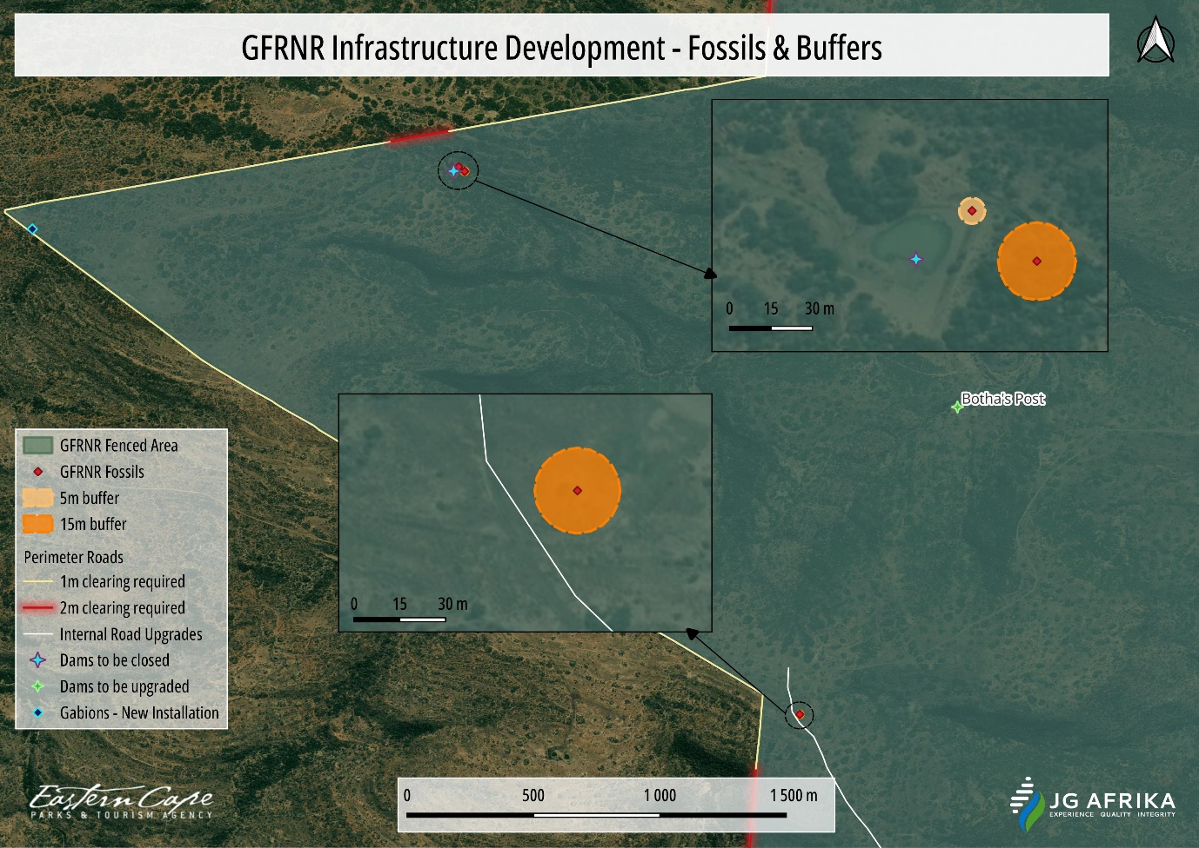
Figure 11-5: Buffers indicated around fossiliferous sites as identified through the PIA.

Recommendations:
- The Environmental Control Officer (ECO) for this project must be informed that the Adelaide Subgroup (Beaufort Group, Karoo Supergroup) has a Very High Palaeontological Sensitivity.
- Training of accountable supervisory personnel by a qualified palaeontologist in the recognition of fossil heritage is necessary.
- If Palaeontological Heritage is uncovered during surface clearing and excavations the Chance Find Protocol (attached to PIA Report) should be implemented immediately. Fossil discoveries ought to be protected and the ECO/site manager must report to South African Heritage Resources Agency (SAHRA) (Contact details: SAHRA, 111 Harrington Street, Cape Town. PO Box 4637, Cape Town 8000, South Africa. Tel: 021 462 4502. Fax: +27 (0)21 462 4509. Web: www.sahra.org.za) so that mitigation (recording and collection) can be carried out.
- Before any fossil material can be collected from the development site the specialist involved would need to apply for a collection permit from SAHRA. Fossil material must be housed in an official collection (museum or university), while all reports and fieldwork should meet the minimum standards for palaeontological impact studies proposed by SAHRA (2012).
- These recommendations should be incorporated into the ESMPr for the proposed development.

PUBLIC PARTICIPATION PROCESS
Between April 2021 and August 2023, the following Pre-Application PPP has been undertaken:
- Identification of potential Interested & Affected Parties (I&APs) which included landowners/occupiers of the affected property, adjacent landowners/occupiers, applicable national, provincial, and local organs of state which may have jurisdiction in the area, and any other potentially affected stakeholder which may include but are not limited to community organisations, and the municipal ward councillors;
- Notification of Application of EA above-mentioned identified and potential I&APs;
- Placement of an advert in the local/provincial newspaper advertising the application process and inviting the registration of I&APs; and
- Placement of Site Notices of an appropriate size and language in the study area.

To fulfil the necessary public participation required as part of the BA Process, the following methods of stakeholder engagement were and will be conducted by the EAP, as outlined below.

Newspaper Notice
A newspaper advertisement was published at the onset of the project to inform the public of the BA Process. The advertisement was published in English in the Public Notices section of the local newspaper, The Herald, on 06 April 2021. A second advert was published in English in the Public Notices section of The Herald on 17 July 2023 to notify the public of the availability of the Draft BAR for review and comment from 17 July 2023 up to and including 17 August 2023. Copies of the advertisements are included in Appendix F.

Site Notice
Six (6) site notice boards, measuring 60 x 42 cm, were placed at conspicuous locations at and around the reserve in March 2021 and September 2022 during the pre-application Public Participation Process (PPP). The purpose of the site notices was to inform neighbours and community members of the proposed BA Application. The details of the EAP were also provided should any member of the public require additional information or wish to register as an I&AP in the Application process. Appendix F includes a copy of the relevant site notice, co-ordinates of the locations and photographic proof of notices at their locations.

Interested and Affected Party Register
A register of I&APs has been compiled as per Section 42 of the EIA Regulations (2014, amended). This register includes all relevant authorities, government departments, the local municipalities, district municipalities, relevant conservation bodies and non-governmental organisations (NGO’s), ward councillors as well as neighbouring landowners and the surrounding community leaders. This register has been updated throughout the process as additional I&AP’s / Stakeholders register. A copy of the I&AP Register is included as Appendix F of this report.

Written notification
Written notifications were e-mailed to landowners surrounding the proposed study area in June 2021 and September 2022. Written notification was also circulated to all identified government entities and NGOs via e- mail in June 2021. The intention of the e-mails was to notify landowners directly of the proposed development and upgrading activities within the GFRNR, as well as opening up direct communication channels between the EAP and the surrounding landowners. Copies of the e-mails are included as Appendix F of this report.

A Background Information Document (BID) was compiled in English and circulated to all surrounding landowners and identified I&APs and stakeholders via the notification e-mail as part of the pre-application PPP in June 2021 and September 2022. The purpose of the BID was to provide preliminary information regarding the project and its location. Furthermore, the BID invited preliminary comments from I&APs and requested those notified to provide details of other potential I&APs which they may be aware of. A copy of the BID is included as Appendix F of this report.

Other Notification Methods
All surrounding landowners and community leaders without email contact details were contacted telephonically in June 2021 and July 2023 in order to confirm contact details and method of preferred communication. In addition, Mr Melikhaya Pongolo, employed by the ECPTA, served as Community Liaison Officer to engage with those surrounding chiefs and community leaders without email contact details. Mr Pongolo circulated A4 size copies of the notice board to these community members, and where necessary engaged in Xhosa with them. The DBAR availability was circulated to these members via WhatsApp as all members do possess cell phone numbers - refer to Appendix F for proof.

Comments Received from Interested and Affected Parties
Following the publication of newspaper advertisements, placement of on-site notice boards, the distribution of written notifications and the BID (during pre-application PPP), as well as the notification of the availability of the Draft BAR, comments have been received by authorities, stakeholders and I&APs. Please refer to Appendix F for comments received, and responses provided by JG Afrika (Pty) Ltd.

Circulation of Draft BAR for Public Review and Comment
Formal Public Participation commenced 17 July 2023 and ended 17 August 2023. An advert was placed in the local newspaper, The Herald, on 17 July 2023 to notify the public of the availability of the Draft BAR for public review and comment. Stakeholders and I&APs were notified of the availability of the Draft BAR via e-mail (where e-mails are available) or WhatsApp on 17 July 2023. Furthermore, a copy of the report was uploaded onto the following websites for public review:
- JG Afrika (Pty) Ltd website: www.jgafrika.com; and,
- ECPTA website: www.visiteasterncape.co.za;

Hard copies of the Draft BAR were also made available for review at the following locations:
- Sam Knott and Double Drift offices of the GFRNR; and,
- Front desks of the Makana Local Municipality, Raymond Mhlaba Local Municipality, and Ngqushwa Local Municipality
Proof of delivery is contained in Appendix F.

Public Meeting
Due to limited interest in the proposed project to date, no Public Meeting was held.

Adherence to ESS10
ESS10 provides the need for stakeholder engagement activities both during project preparation and project implementation, identification of vulnerable groups and measures to ensure their participation, information disclosure, grievance mechanisms, etc. The public participation activities carried out, as well as those planned to be implemented in the future, as applicable, are consistent with the provisions of ESS10. JG Afrika (Pty) Ltd’s adherence to ESS10’s provisions are indicated in the table below.
Table 12-1: Details regarding JG Afrika’s adherence to ESS10.
ESS10: Stakeholder Engagement and Information Disclosure
ESS Objectives | South African National Laws and Regulations | Project Approach to Align National and World Bank Requirements | Relevant E&S Instrument | JG Afrika Comment
Establish a systematic approach to stakeholder engagement that helps Borrowers identify stakeholders and maintain a constructive relationship with them. | South Africa has strict measures regarding public participation, including through the Access to Information Act. For example, re. legislative initiatives: a law cannot be valid unless the public has been heard and consulted upon with the public. The EIA regulations specifically require that impacted and affected persons be consulted regarding Project measures. | All environmental and social impact work will be conducted with involvement of impacted and affected persons. Project activities under Component 1 specifically respond to community need and interest wherefore community members will be closely involved in project design and implementation, including identification of environmental and social risk and impact. Local language will be used during community engagements | The ESMF is accompanied by the SEP, which is part of the Project design to ensure systematic stakeholder engagement, assessment of interests and on-going information sharing. | JG Afrika has, to date, undertook a project specific public participation process (PPP) which forms part of the Basic Assessment Report’s stakeholder engagement process which effectively identified I&APs in and around the project area as well as other stakeholders, and notified them of the application for EA and notification of the availability of the Draft BAR by means methods described in section 12.1 to section 12.5.
Assess stakeholder interest and support for the activity and enable stakeholders’ views to be considered in activity design. |  |  |  | The main goal for conducting the PPP is to receive as much public comment as possible, that can provide valuable insights, feedback, and perspectives that can improve the quality and legitimacy of the Basic Assessment. Refer to section 12.6.
Promote and provide means for effective and inclusive engagement with activity-affected parties throughout the activity life cycle. |  |  |  | JG Afrika has ensured that all potentially affected local and neighbouring communities are reached in their native language – refer to section 12.5.
Ensure that appropriate information is disclosed to stakeholders in a timely, understandable, accessible, and appropriate manner. |  |  |  | JG Afrika has made use of various avenues to ensure that adequate project information was provided to all I&APs. Refer to sections 12.1 to 12.5.
To provide project-affected parties with accessible and inclusive means to raise issues and grievances and allow Borrowers to respond to and manage such grievances. |  |  |  | I&APs have been given reasonable means and timeframes in which to comment on the proposed project – refer to section 12.1 to 12.5 and 12.7.

Public engagement during construction phase
This will be conducted by the relevant persons as and when required during the construction phase.

IMPACT ASSESSMENT

Impact Assessment Methodology
The EIA Regulations (2014, as amended), prescribe requirements to be adhered to and objectives to be reached when undertaking Impact Assessments. These are noted in the following sections contained within the EIA Regulations (2014, as amended):
- Regulation 326, Appendix 1, Section 2, and Section 3 – Basic Assessment Impact Requirements; and
- Regulation 326, Appendix 2, and Appendix 3 – Environmental Impact Assessment Requirements.
Impacts identified were assessed according to the criteria outlined below (Table 13-1). Each impact was ranked according to the nature, extent, duration, magnitude, probability, irreplaceable loss of resources and reversibility. These criteria are based on the Department of Environmental Affairs (DEA) Guideline Document to the EIA Regulations (1998). A significance rating was calculated as per the methodology outlined below. The significance rating of each identified impact / effect was further reviewed by the EAP and/o specialist(s) by applying professional judgement.

Table 13-1: Criteria by which impacts identified are assessed.
NATURE OF THE IMPACT
The environmental impacts of an activity are those resultant changes in environmental parameters, in space and time, compared with what would have happened had the activity not been undertaken. It is an appraisal of the type of effect the activity would have on the affected environmental parameter. Its description includes what is being affected, and how |  | Negative effect (i.e., at a cost to the environment) (-)
 |  | Positive effect (i.e., a benefit to the environment) (+)
 |  | Neutral effect on the environment – No impact
EXTENT OF THE IMPACT
This addresses the physical and spatial scale of the impact. |  | Site – The impact area extends only as far as the activity – i.e., within the boundaries of the  development site. |  | 1
 |  | Local - The impacted area extends slightly further than the actual physical disturbance footprint and could affect the whole, or a measurable portion of adjacent areas (within approx. 5 km of the boundaries of the development site), that may be linked to the site in terms of ecosystem functioning. |  | 2
 |  | Regional - The impact could affect the site including the neighbouring areas, transport routes and  surrounding towns etc. |  | 3
 |  | National - The impacted area extends beyond provincial boundaries. |  | 4
 |  | International - The impacted area extends beyond  national boundaries. |  | 5
DURATION OF IMPACT
This describes the predicted lifetime / temporal scale of the predicted impact. |  | Short term - Quickly reversible. Less than the project lifespan. The impact will either disappear with mitigation or will be mitigated through natural process in a span shorter than any of the project  phases or within 0 -5 years. |  | 1
 |  | Medium term – Some mitigation will be required to  reduce the duration of the impact – 6-15 years. |  | 3
 |  | Long term - the impact will cease when the operation stops. |  | 5
 |  | Permanent - no mitigation measure will reduce the impact after construction. |  | 7
MAGNITUDE OF THE IMPACT
 | This provides a qualitative assessment of the severity of a predicted impact / effect. | None - where the aspect will have no impact on the environment |  | 0
 |  | Minor - The affected environment is altered, but  natural function and processes continue. |  | 1
 |  | Low - where the impact affects the environment in such a way that the natural, cultural and/or social functions / processes are slightly affected. |  | 2
 |  | Moderate - where the affected environment is altered but natural, cultural and/or social functions  / processes continue, albeit in a modified way. |  | 3
 |  | High - natural, cultural and/or social functions / processes are altered to the extent that they will  temporarily cease. |  | 4
 |  | Very High - natural, cultural and/or social functions  / processes are altered to the extent that they will permanently cease. |  | 5
 | PROBABILITY OF OCCURRENCE
 | The likelihood of the impact actually occurring. | Remote possibility / unlikely |  | 0
 |  | Possibility |  | 1
 |  | Low probability / anticipated |  | 2
 |  | Medium probability / strongly anticipated |  | 3
 |  | High probability / to be expected |  | 4
 |  | Absolute certainty / will occur |  | 5
 | IRREPLACEABLE LOSS OF RESOURCES
 | Environmental resources cannot always be replaced; once destroyed, some may be lost forever. It may be possible to replace, compensate for or reconstruct a lost resource in some cases, but substitutions are rarely ideal. The loss of a resource may become more serious later, and the assessment must take this into account. | Short-term – Quickly recoverable. Less than the project lifespan. The resource can be renewed / recovered with mitigation or will be mitigated through natural process in a span shorter than any of the project phases, or in a time span of 0 to 5  years. |  | 1
 |  | Loss of an ‘expendable’ resource - one that is not deemed critical for biodiversity targets, planning goals, community welfare, agricultural production, or other criteria. |  | 2
 |  | Medium term – The resource can be recovered within the lifespan of the project. The resource can be renewed / recovered with mitigation or will be mitigated through natural process in a span  between 5 and 15 years. |  | 3
 |  | Loss of an ‘at risk’ resource - one that is not deemed critical for biodiversity targets, planning goals, community welfare, agricultural production, or other criteria, but cumulative effects may render  such loss as significant. |  | 4
 |  | Long term – The loss of a non-renewable / threatened resource which cannot be renewed / recovered with, or through, natural process in a time span of over 15 years, but can be mitigated by  other means. |  | 5
 |  | Permanent – The loss of a non-renewable / threatened resource which cannot be renewed / |  | 7
 |  | recovered with, or through, natural process in a time span of over 15 years, or by artificial means.
REVERSIBILITY / POTENTIAL FOR REHABILITATION
The distinction between reversible and irreversible impacts is a very important one and the irreversible impacts not susceptible to mitigation can constitute significant impacts in an EIA (Glasson et al, 1999). The potential for rehabilitation is the major determinant factor when considering the temporal scale of most predicted impacts. |  | Short term – The impact / effect will be returned to its benchmark state through mitigation or natural  processes in a span shorter than any of the phases of the project, or in a time span of 0 to 5 years. |  | 1
 |  | Medium term – The impact / effect will be returned to its benchmark state through mitigation or natural processes in a span shorter than the lifetime of the  project, or in a time span between 5 and 15 years. |  | 3
 |  | Long term - The impact / effect will be returned to its benchmark state through extensive mitigation or natural processes in a time span between 15 and 25  years. |  | 5
 |  | Permanent – The impact/ effect is permanent and  will never be returned to is benchmark state |  | 7
IMPACT SIGNIFICANCE
The overall significance of an impact / effect has been ascertained by attributing numerical ratings to each identified impact. The numerical scores obtained for each identified impact have been multiplied by the probability of the impact occurring before and after mitigation. High values suggest that a predicted impact / effect is more significant, whilst low values suggest that a predicted impact / effect is less significant.

((Spatial Extent + Severity + Duration + Resource Lost + Reversibility) * Probability) = Significance
NEGATIVE |  | POSITIVE | Overall Score
Insignificant – the impact is meaningless has no influence on the decision to develop |  | Insignificant – the impact is meaningless has no influence on the decision to develop | < 14
Low – the impact would not have a direct influence on the  decision to develop in the area; |  | Low – the impact would not have a direct influence  on the decision to develop in the area; | 15 - 34
Medium – the impact could influence the decision to develop in the area unless it is effectively managed /  mitigated; and |  | Medium – the impact could influence the decision to develop in the area unless it is effectively  managed / mitigated; and | 35 - 64
High - the impact must have an influence on the decision- making process for development in the area. |  | High - the impact must have an influence on the decision-making process for development in the  area. | > 65

Mitigation
In terms of the assessment process, the potential to mitigate the negative impacts is determined and rated for each identified impact and mitigation objectives that would result in a measurable reduction, or enhancement of the impact, are considered. The significance of environmental impacts has therefore been assessed considering any proposed mitigation measures. The significance of the impact “without mitigation” is therefore the prime determinant of the nature and degree of mitigation required.

Impact Management Hierarchy
The NEMA and the EIA Regulations (2014, as amended) also call for a hierarchical approach to impact management when considering impact assessment. The mitigation of negative impacts that a proposed development may have on the receiving environment must take on different forms depending on the significance of the impact and the area which may be affected. Therefore, mitigation requires proactive planning which is enabled by following the impact mitigation hierarchy. In this regard, during the assessment of alternatives it is preferable to investigate alternatives that avoid negative impacts in their entirety, and if this is not feasible, then alternatives which will reduce an unavoidable negative impact must be assessed through the adoption of mitigation and management measures. Progressing down the impact mitigation hierarchy, the rehabilitation of the negative impact must be considered and lastly, should the unavoidable impact remain post-mitigation and remediation, options to offset the negative impacts must be investigated. An illustration of the impact mitigation hierarchy is provided in Figure 13-1.
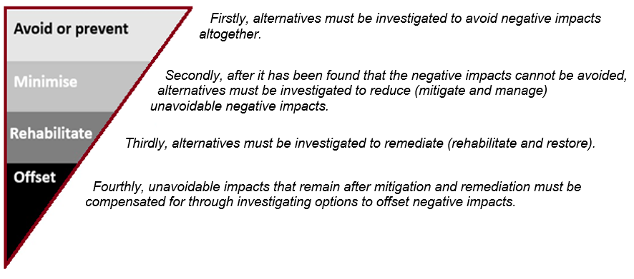
Figure 13-1: Impact Mitigation Hierarchy

Construction Phase

Impacts and Mitigation Measures
Table 13-2: Construction phase impacts identified and associated mitigation measures (blue text indicates proposed mitigation measures from the World Bank ESMF)
CONSTRUCTION RELATED IMPACTS
IMPACT | DESCRIPTION | MITIGATION
Alteration to surface water features | Impact to the hydrological characteristics of the aquatic features due to changes in the catchment. | - The stormwater outlets associated with the infrastructure must make provision for energy dissipators at the mouth of the outlets. This will reduce the risk of erosion and associated siltation which can contaminate the water quality.  - The provision for adequate stormwater management as well as the hydraulic structures that have adequate sizes to prevent any damming of water upstream of the structure must be ensured.
Surface water and ground water contamination | - Impact to the water quality in the aquatic feature because of inadequate stormwater management.  - Impact to the water quality in the aquatic features because of the leakages from the portable chemical toilets that will be used during construction.  - Impact to the water quality in the aquatic features because of petrochemical spillages from plant and equipment. | - All unauthorised activities should be conducted at least 32m away from all watercourses.  - The stormwater outlets associated with the infrastructure must make provision for energy dissipators at the mouth of the outlets. This will reduce the risk of erosion and associated siltation which can contaminate the water quality.  - The provision for adequate stormwater management (as described above) as well as the hydraulic structures that have adequate sizes to prevent any damming of water upstream of the structure must be ensured.  - No garbage/refuse, oily wastes, fuels/waste oils should be discharged into drains or water bodies.  - Fuel storage tanks/sites should be properly secured.  - Construction activities, including camps to include measures to control runoff.  - The following management and mitigation measures must be included into the ESMPr for the project:  - All plant and equipment that make use of petrochemical substances must be checked leakages daily before operations commence.  - All plant and equipment that are found to be leaking must be removed from the property and only returned once the leakages have been addressed.  - If any petrochemical substances are stored on the property, this storage must be done on an impermeable surface in a bunded area that makes provision for 110% of volume of the substances that are stored.  - All refuelling of plant and equipment must be conducted over a drip-tray.  - If any plant or equipment is to be parked on the site, these must be parked within the demarcated construction footprint that has been cleared.  - If any spillages from plant or equipment occur, the spill must be immediately contained, the contaminated soils must be collected and bagged in impermeable bags and stored on site to be removed and disposed of by a registered service provider.  - The following management and mitigation measures must be included into the ESMPr for the project to limit the potential impacts of leakages from the ablution facilities:  - Only portable chemical toilets with a sealed reservoir will be allowed on site.  - The capacity of the reservoirs in the portable chemical toilets must be monitored on a daily basis to ensure that they can be serviced timeously.  - All removal of the collected sewage waste from the portable chemical toilets must be conducted by a registered service provider for disposal at a municipal wastewater treatment facility.  - If a construction camp associated petrochemical storage will be established, the following management and mitigation measures must be included in the ESMPr:  - All storage containers must be contained in a bunded area that has the capacity of 110% of the total volume of the storage containers.  - The bunded area must consist of an impermeable floor as well as walls and be fitted with a valve that can be used to drain any spillages.  - If the storage facility will be in use during the rainy season, the bunded area must be rooved to prevent any rainwater entering the bund and reducing its capacity.
Site Contamination | The use of inappropriate methods of mixing construction materials, including cement, and the use of poorly maintained construction equipment, which could result in oil and fuel spills, during the construction phase, could lead to soil contamination. | - Hazardous Chemical Substances Regulations promulgated in terms of the Occupational Health and Safety Act (Act No. 85 of 1993) must be adhered to. This applies to solvents and other chemicals possibly used during the construction process;  - If cement is to be used it must only be mixed in the area(s) demarcated for this purpose and on impermeable surfaces;  - Drip trays must be placed under stationary construction machinery to avoid soil contamination;  - The ECO and/or Contractor must determine the most suitable method of treatment of polluted soil, should soil pollution occur during the construction phase. Depending on the nature of the spill, these methods could involve the application of soil absorbent materials, oil-digestive powders to the contaminated soil or the excavation of the contaminated soil;  - If refuelling occurs on site, a demarcated area must be established, and refuelling must only take place within this demarcated area and on impermeable surfaces;  - Should fuel be stored on site, it must be stored in a bunded area;  - All construction vehicles must be in sound working order to reduce the risk of oil and fuel leaks.  - All hazardous materials that are stored on site must be done under lock and key.
Vegetation | Loss of natural vegetation –  A total of 244 plant species were identified to potentially occur in the GFRNR. A high amount of plant species is expected to occur in the construction area, some only seasonally and depending on the availability of resources like water and sunlight.  Loss of SCCs –  Ten plant SCC (including those identified in the DFFE Screening Report) and 18 other plants requiring permits before relocation were identified. While most of these species were not observed during the site visit, they are still included due to the vastness of the site and proposed construction.  Invasion of Alien species –  Few alien plants are present on site; however, removal of natural vegetation will increase the risk of alien plant species invasion. | Legal compliance  - All relevant permits must be obtained prior to commencement of any activity on site from the competent authorities to remove SCC and protected plant species.  Loss of natural vegetation  - The construction footprint must be surveyed and demarcated prior to construction commencing. All contractors must be made aware of this demarcation.  - No plants outside the demarcated work areas may be damaged. All areas outside the demarcated footprint will be considered as No-Go areas. No construction activities (temporary or permanent) will be allowed in these No-Go areas.  - Temporary infrastructure such as the site camps, laydown areas and storage areas must be placed in areas already transformed and within the construction footprint.  - No on-site fires will be permitted. This will reduce the risk of accidental veld fires and further vegetation loss.  - The GFRNR rules and regulations must be always adhered to.  Loss of plant SCC  - Avoid access to sensitive habitat where possible.  - Permits must be obtained to remove any plant SCC and protected species identified prior to commencement of any activity on site.  - A Plant Search and Rescue must be conducted by a qualified botanist prior to commencement of any activity on site.  - As many SCC and permitted plants as possible must be relocated into the surrounding areas.  - A nursery will not be required if all plant species are immediately relocated to the surrounding environment.  - No plant harvesting, without the relevant permits will be allowed.  Spread of Alien and Invasive plant species  - Develop and implement alien vegetation management /control, as part of the ESMP to mitigate the establishment and spread of undesirable alien plant species during construction.  - All visible alien plants must be continually removed during construction phase.  - Removal must occur through appropriate methods such as hand pulling, application of chemicals, cutting, etc. as in accordance with the NEMBA: Alien Invasive Species Regulations.  Illegal harvesting of plant species  - No harvesting of any plants will be allowed.  - No firewood or plant material may be collected in any area of the Protected Area.  - All construction workers will undergo a detailed induction before working on site. GFRNR will contribute information to this induction.  - The GFRNR rule and regulations must be always adhered to.  Erosion of impacted areas  - Weekly monitoring of site and surrounding areas for erosion.  - Maintain a monitoring register.  - Any erosion must be addressed immediately.  - Develop and implement rehabilitation management measures. This can also be in the form of a method statement.  - Rehabilitated areas must be monitored until the entire site is revegetated by primary growth.  Degradation of impacted areas  - Implement all previous mentioned mitigation measures throughout construction and rehabilitation.  - Draft all proposed management measures/method statements prior to commencement of construction or approval by the EAP/Environmental Officer.  - Avoid any risk of veldfires on site. No fires will be allowed on site.
Fauna | Because this is a proclaimed nature reserve and numerous habitats exist for a variety of animal species, there is a possibility that the animals may be injured or disturbed during the clearance of vegetation. There is a very high probability of a wide variety of mammals occurring in the site ranging from small rodents to large mammals  A total of 383 faunal species were identified to potentially occur naturally in the GFRNR. Most of these species are expected to occur in the area, some only seasonally and depending on the availability of resources.  A variety of these faunal species were identified as SCC’s including birds, mammals, one reptile and one frog.  Non-SCC faunal species requiring permits for relocation/removal from DEDEAT were also identified. These permits must be obtained prior to commencement of any activities on site. | Legal compliance –  - All relevant permits must be obtained from the competent authorities to remove any protected animal species.  Loss of animal SCC –  - Permits must be obtained to remove any animal SCC and protected species identified prior to commencement of any activity on site.  - A Faunal Search and Rescue must be conducted by a qualified Faunal specialist prior to commencement of any activity on site.  - As many SCC as possible must be relocated into the surrounding areas.  - For linear activities, the construction footprint at that point in time must be demarcated with barrier mesh (barricade) netting.  - No animals must be kept in cages or containers for longer than necessary during relocation.  - It is recommended that only small mammals, frogs, scorpions, baboon spiders and reptiles be relocated. There is no need to relocate any big faunal species as they will naturally move away from the construction areas.  - The construction site must be daily inspected (before activities for the day starts) for any trapped faunal species. These species must be relocated to nearby No-Go areas by an employee that is qualified in dangerous animal handling.  Poaching of faunal species –  - No poaching or trapping of any wild animal will be allowed.  - All construction workers will undergo a detailed induction before working on site. GFRNR will contribute information to this induction.  - The GFRNR rules and regulations must be always adhered to.
Soil disturbance | Potential disturbances include compaction, physical removal, erosion and pollution:  - Soil erosion will take affect any unprotected soils that have suffered disturbances, including unprotected stockpiles of stored topsoil.  - Drainage features established within the road reserve areas will also induce erosion impacts.  - Soil stripping, soil compaction and vegetation removal will increase rates of erosion and entry of sediment into the general environment and surrounding watercourses.  - The exposed soil surfaces have the potential to erode easily if left uncovered which could lead to the loss of soil and vegetation.  - Potential loss of stockpiled topsoil and other materials if not protected properly.  - The additional hardened surfaces created during construction will increase the amount of stormwater runoff which has the potential to cause erosion.  - The use of inappropriate methods of mixing construction materials, including cement, and the use of poorly maintained construction equipment, which could result in oil and fuel spills, during the construction phase, could lead to soil contamination.  - Physical disturbance of soil and plant removal may result in soil erosion/loss; and  Erosion and potential soil loss from cut and fill activities (if any). | - Erosion must be strictly controlled through the utilization of silt traps, silt fencing, Gabions, etc. This is especially pertinent within areas of steeper gradients.  - Topsoil stockpiles should be protected from erosion through the utilisation of silt traps, silt fencing, gabions, etc.  - The site must be monitored weekly for any signs of off-site siltation and erosion. All areas impacted by earth-moving activities must be re-shaped post-construction to ensure natural flow of runoff and to prevent ponding. All exposed earth must be rehabilitated promptly with suitable vegetation to stabilise the soil.  - Topsoil should be excavated and stockpiled separately from the subsoils to be used during the rehabilitation of the road verges.  - Drip trays shall be provided in construction areas for stationary plant and for "parked" plant. Drip trays, sumps and bunds must be emptied regularly, especially before a known rain event and after a rain event, and the contents disposed of at a licensed disposal facility.  - All vehicles and equipment shall be kept in good working order and serviced regularly. Leaking equipment shall be repaired immediately or removed from the Site.  - Should cement be mixed on site, it must be mixed on an impervious surface.  - All areas disturbed during the construction phase (such as road verges etc) shall be rehabilitated as soon as construction activities are completed to prevent erosion issues.  - The removal of vegetation must be kept to a minimum where possible. The time that soil is exposed must be limited and re-vegetation or another covering method must be applied during the construction and post construction phase.  - The establishment of exotic plants must be avoided.  - Where possible the area where construction will take place should be demarcated. Demarcation of the construction areas will ensure that only the required area is cleared of vegetation
Solid Waste Pollution | There is potential for the site and surrounding areas to become polluted if construction activities are not properly managed. Waste generation could be created by the following:  - litter from personnel on-site,  - Construction waste - plastics, metal, wood, concrete, stone, asphalt. | - A waste management plan (method statement)/construction site management plan is to contain all appropriate control and implementation measures.  - An appropriate number of chemical, portable, toilets (1 toilet for every 20 workers) must be provided for labourers during the construction phase. These must be maintained in a satisfactory condition and be located outside of the watercourses.  - All waste generated on-site during construction must be adequately managed. Separation and recycling of different waste materials is encouraged.  - All solid waste must be disposed of at a registered landfill site and records maintained to confirm safe disposal.  - Adequate scavenger-proof refuse disposal containers must be supplied to control solid waste on-site and throughout the various construction camps.  - It must be ensured that existing waste disposal facilities in the area are able to accommodate the increased waste generated from the proposed construction.  - Chemical waste must be stored in appropriate containers and disposed of at a licensed disposal facility - Provide drums/containers for temporary storage on site, in lined, bunded areas away from water sources, of waste oil from equipment and vehicles.  - Portable sanitation facilities must be erected for construction personnel. Use of these facilities should be enforced (these facilities should be kept clean so that they are a desired alternative to the surrounding vegetation). These facilities should also be monitored and serviced regularly to prevent contamination of the watercourses.  - Soil that is contaminated with, e.g., cement, petrochemicals, or paint, must be disposed of at a registered waste disposal site and is NOT to be deposited into the any watercourses or drainage lines.  - Concrete and cement preparation activities shall not be permitted in any sensitive environments.  - It is illegal to bury any type of waste within the Protected Area boundaries.
Archaeological and Cultural heritage sites | The main impact on possible archaeological sites/remains will be the physical disturbance of the material and its context. However, the proposed areas earmarked for the development are of low archaeological sensitivity and the visual impact on the surrounding cultural landscape will also be low. | - Due to the cultural significance of the wider area within the GFRNR it is important that special care must be taken where upgrading and maintenance is done near any of the heritage sites along the perimeter fence and elsewhere within the reserve such as historical buildings or graves.  - Should there be any doubt about the impact of the use of heavy machinery or equipment on any of these sites a historian / heritage practitioner must be appointed to assess the site/s and to make recommendations for mitigation (if required). This is also applicable if any British military or other historical artefacts or structures are exposed as a result of the activities.  - In general, the majority of the heritage resources within the reserve are not well maintained and as a result the recommendation in the Protected Area Management Plan 2019-2029 for the GFRNR namely that their Heritage Management Plan must be revised, is supported.  - Should any human remains and/or other archaeological remains such as freshwater shell middens and historical material be uncovered during construction, all work must cease in the immediate area (depending on the type of find) and it must be reported to the archaeologist at the Albany Museum in Makhanda (Grahamstown) (Tel.: 046 6222 312) or to the Eastern Cape Provincial Heritage Resources Authority (Tel.: 043 7450 888), so that a systematic and professional investigation can be undertaken. Sufficient time should be allowed to investigate and to remove/collect such material.  - All clearing activities and other developments must be monitored. Managers/foremen should be informed before clearing/construction starts on the possible types of heritage sites and cultural material they may encounter and the procedures to follow when they find sites. Alternatively, it is suggested that a person must be trained (ECO) as a site monitor to report to the foreman when heritage sites/materials are found.  - A walkthrough must be conducted by an archaeologist / heritage specialist of the watering points proposed for upgrading as well as for any new roads that will be developed after these areas have been cleared of vegetation.  - Archaeological walk-throughs should be conducted after vegetation clearing has been done and archaeological reports (Phase 1b) submitted for the following areas:  - Internal roads and associated culvert and/or gabion structures.  - Dams and pipeline infrastructure associated with existing boreholes.  - Accommodation units:  - The overgrown cemetery near Double Drift should be fenced with an access gate, and a sketch plan and photographic record submitted to EC PHRA.  - Old buildings/structures as well as the cemetery should be included in the CMP.  - There should be archaeological training for ECO-on-site monitoring.
Palaeontological sites | The proposed development is underlain by a small area of Quaternary superficial sediments along the Fish River, Jurassic Dolerite, the Middleton and Koonap Formations of the Adelaide Subgroup (Beaufort Group, Karoo Supergroup). According to the PalaeoMap of South African Heritage Resources Information System the Palaeontological Sensitivity of the Quaternary superficial deposits is Moderate; that of the Adelaide Subgroup is Very High while the Palaeontological Sensitivity of the Jurassic Dolerite is Zero.  New fossiliferous sites containing in situ Glossopteris leaves, and trace fossils were detected (see Figures 26 and 28 in PIA Report) during a field survey. Loose fragments of fossilized wood were also detected. (Figure 29 in PIA Report). | - It is recommended that a buffer of 5m is placed around the in-situ trace fossil and 15m buffer around the Glossopteris and loose wood fossils.  - If possible, these fossils could be used for educational purposes with information available for the tourists.  - The ECO for this project must be informed that the Adelaide Subgroup (Beaufort Group, Karoo Supergroup) has a Very High Palaeontological Sensitivity.  - Training of accountable supervisory personnel by a qualified palaeontologist in the recognition of fossil heritage is necessary.  - If Palaeontological Heritage is uncovered during surface clearing and excavations the Chance Find Protocol (see below) should be implemented immediately. Fossil discoveries ought to be protected and the ECO/site manager must report to South African Heritage Resources Agency (SAHRA) (Contact details: SAHRA, 111 Harrington Street, Cape Town. PO Box 4637, Cape Town 8000, South Africa. Tel: 021 462 4502. Fax: +27 (0)21 462 4509. Web: www.sahra.org.za) so that mitigation (recording and collection) can be carried out.  - Chance Find Protocol:  - If a chance find is made the person responsible for the find must immediately stop working and all work that could impact that finding must cease in the immediate vicinity of the find.  - The person who made the find must immediately report the find to his/her direct supervisor which in turn must report the find to his/her manager and the ESO or site manager. The ESO or site manager must report the find to the relevant Heritage Agency (South African Heritage Research Agency, SAHRA). (Contact details: SAHRA, 111 Harrington Street, Cape Town. PO Box 4637, Cape Town 8000, South Africa. Tel: 021 462 4502. Fax: +27 (0)21 462 4509. Web: www.sahra.org.za). The information to the Heritage Agency must include photographs of the find, from various angles, as well as the GPS co-ordinates.  - A preliminary report must be submitted to the Heritage Agency within 24 hours of the find and must include the following: 1) date of the find; 2) a description of the discovery and a 3) description of the fossil and its context (depth and position of the fossil), GPS co-ordinates.  - Photographs (the more the better) of the discovery must be of high quality, in focus, accompanied by a scale. It is also important to have photographs of the vertical section (side) where the fossil was found.  - Upon receipt of the preliminary report, the Heritage Agency will inform the ESO (or site manager) whether a rescue excavation or rescue collection by a palaeontologist is necessary.  - The site must be secured to protect it from any further damage. No attempt should be made to remove material from their environment. The exposed finds must be stabilized and covered by a plastic sheet or sand bags. The Heritage agency will also be able to advise on the most suitable method of protection of the find.  - In the event that the fossil cannot be stabilized the fossil may be collected with extreme care by the ESO (site manager). Fossils finds must be stored in tissue paper and in an appropriate box while due care must be taken to remove all fossil material from the rescue site.  - Once Heritage Agency has issued the written authorization, the developer may continue with the development on the affected area.  - Before any fossil material can be collected from the development site the specialist involved would need to apply for a collection permit from SAHRA. Fossil material must be housed in an official collection (museum or university), while all reports and fieldwork should meet the minimum standards for palaeontological impact studies proposed by SAHRA (2012).  These recommendations should be incorporated into the Environmental and Social Management Programme for the proposed development.
Air Emissions | - Potential dust generation from soil stripping, excavations, vehicle traffic on the roads and motor vehicle fumes will have an impact on air quality.  - Dust will be created during the construction phase, which may impact on staff and tourists. | - All construction machinery and equipment must be regularly serviced and maintained to keep noise, dust, and possible leaks to a minimum.  - Road dampening should be undertaken to prevent excess dust during construction.  - Operational Hours: No works shall be executed between sunset and sunrise and on the non-working and special non-working days as stated in the Contract Data unless otherwise agreed between the ECPTA and Contractor; and  - Heavy vehicles and machinery should be serviced regularly to minimise exhaust fume pollution.  - Limit vehicle speeds on dirt road deviations to 40km/h.  - Removal of vegetation will be avoided until such time as soil stripping is required.  - Soil stockpiles will be located in sheltered areas to limit the erosive effects of the wind.
Noise | - Potential increase in noise from the operation of machinery and equipment, as well as the construction vehicle traffic;  - Noise will be created during the construction phase, which may impact on staff and tourists. | - All construction machinery and equipment must be regularly serviced and maintained to keep noise, dust, and possible leaks to a minimum.  - Use good quality fuel and lubricants.  - Operational Hours: No works shall be executed between sunset and sunrise and on the non-working and special non-working days as stated in the Contract Data unless otherwise agreed between the ECPTA and Contractor; and  - Construction personnel should be made aware of the need to prevent unnecessary noise such as hooting and shouting.  - Provide workers with PPE for noise pollution.  - Train workers on the use of PPEs for noise mitigation and reprimand those not complying.  - Equipment should be operated within its specifications and capacity and should not be overloaded.  - No amplified music will be allowed on the site. The use of radios, tape recorders, compact disc players, television sets etc. will not be permitted unless at a level that does not serve as an intrusion to adjacent landowners.  - The Contractor will take preventative measures (e.g., screening, muffling, timing, pre-notification of affected parties) to minimise complaints regarding noise and vibration nuisances from sources such as power tools.  - Switch off engines when not in use.
Visual and aesthetic intrusion | The construction activities associated with the development will result in visual changes to the site, however these changes will be short term and only for the duration of the construction period. | - Place notices and warning signs at working areas.  - No painting or marking of natural features shall take place. Marking for surveying and other purposes shall only be done with pegs and beacons.  - Landscaping of facilities after construction, and restoration of disturbed areas must be implemented.  - All disturbed areas should be fully rehabilitated.  - All temporary structures, materials and waste (including areas contaminated during the project, e.g. oil spillages on soil) should be removed from the Protected Area.
Fire Risk | Fire poses a big threat to the environment, in particular the GFRNR identified as a Protected Area. | - Fires are only permitted at designated locations.  - The Contractor shall take all reasonable steps to avoid increasing the risk of fire through activities on site.  - The Contractor shall ensure that basic fire-fighting equipment is available at all construction activities on site.  - Firebreak should be maintained around offices (including temporary construction offices).  - The Contractor shall ensure that all site personnel are aware of the procedure to be followed in the event of a fire.  - Due to the threat fire poses to the reserve, no smoking is allowed. If required, a designated smoking area should be provided and clearly demarcated and signposted with a facility for safe containment and disposal of cigarette butts.  - All fire management should be done in compliance with the Fire Management Plan of the Protected Area.
Construction Traffic impedance | During the construction phase, construction vehicles will travel to and from the site delivering construction materials. This will have an impact on traffic volumes in the area. | - The delivery of construction materials must be scheduled out of peak hours to avoid traffic, where possible;  - Road repairs must be made immediately should construction machinery cause damage to any of the existing roads; maintenance and cleaning of vehicles, trucks and equipment should take place offsite.  - All construction vehicles must be roadworthy and must be serviced regularly;  - Experienced drivers are to be used.  - Construction worker’s / construction vehicles must take heed of normal road safety regulations; thus, all personnel must obey and respect the law of the road. A courteous and respectful driving manner should be enforced and maintained so as not to cause harm to any individual.  - A designated speed limit must be set by the developer to limit possible road collisions.  - Flag staff must regularly patrol areas especially on site to prevent onsite incidents;  - Construction vehicles must adhere to the relevant speed limits; and  - Appropriate signage must be used to indicate the construction site.  - Enforce safe driving and take disciplinary action against repeat offenders.
Occupational health & safety, staff management | Occupational Health and Safety needs to be implemented to ensure that incidents and grievances are resolved/prevented via regular site inspections, training, and the use of PPE. | - The contractor must ensure that a health and safety plan is in place for all construction, including emergency procedures and COVID-19 mitigation for the duration of the pandemic, in the form of a simplified OHS Plan in line with the requirements of ESS2.  ESS2 OHS Requirements:  - The OHS measures will be designed and implemented to address:  - identification of potential hazards to project workers, particularly those that may be life threatening;  - provision of preventive and protective measures, including modification, substitution, or elimination of hazardous conditions or substances;  - training of project workers and maintenance of training records;  - documentation and reporting of occupational accidents, diseases, and incidents;  - emergency prevention and preparedness and response arrangements to emergency situations;  - remedies for adverse impacts such as occupational injuries, deaths, disability, and disease.  - All parties who employ or engage project workers will develop and implement procedures to establish and maintain a safe working environment, including that workplaces, machinery, equipment, and processes under their control are safe and without risk to health, including by use of appropriate measures relating to chemical, physical and biological substances, and agents. Such parties will actively collaborate and consult with project workers in promoting understanding, and methods for, implementation of OHS requirements, as well as I providing information to project workers, training on occupational safety and health, and provision of personal protective equipment without expense to the project workers.  - Workplace processes will be put in place for project workers to report work situations that they believe are not safe or healthy, and to remove themselves from a work situation which they have reasonable justification to believe presents an imminent and serious danger to their life or health. Project workers who remove themselves from such situations will not be required to return to work until necessary remedial action to correct the situation has been taken. Project workers will not be retaliated against or otherwise subject to reprisal or negative action for such reporting or removal.  - Project workers will be provided with facilities appropriate to the circumstances of their work, including access to canteens, hygiene facilities, and appropriate areas for rest. Where accommodation services are provided to project workers, policies will be put in place and implemented on the management and quality of accommodation to protect and promote the health, safety, and well-being of the project workers, and to provide access to or provision of services that accommodate their physical, social, and cultural needs.  - Where project workers are employed or engaged by more than one party and are working together in one location, the parties who employ or engage the workers will collaborate in applying the OSH requirements, without prejudice to the responsibility of each party for the health and safety of its own workers.  - A system for regular review of occupational safety and health performance and the working environment will be put in place and include identification of safety and health hazards and risks, implementation of effective methods for responding to identified hazards and risks, setting priorities for taking action, and evaluation of results.  - The contractor must adhere to healthy and safety regulations by making use of cover buckets for trucks carrying construction materials such as sand, quarry dust, etc.  - The contractor must mark active construction areas with high-visibility tape  - The contractor needs to ensure that open trenches and excavated areas are backfilled and or secured  - The contractor must provide adequate sanitary facilities  - The contractor must provide PPEs for construction workers  - The contractor must ensure that construction workers are educated on the on-site rules/regulation and hygiene and disease (HIV/AIDS) prevention  - The contractor must make provision for the availability of clean drinking water to all staff as well as proper sanitation services – one ablution facility must be present for every 20 workers; all such facilities associated with each of the construction sites must be placed at a distance greater than 40m from the demarcated edge of the riparian vegetation.  ESMF OHS Requirements:  - In accordance with the PA’s OHS policies, every individual engaged has the duty to:  - Uphold health and safety in the premises and outside of SANParks premises.  - Take care of their own health and safety and that of other persons who might be affected by their acts or omissions.  - Comply with all the health and safety rules, instructions, training, supervision and all the safety systems provided through the program.  - Attend health and safety training sessions.  - Use personal protective equipment (PPE) provided by the employer.  - Refrain from damaging, misusing or interfering with anything that has been provided for health and safety reasons.  - Inform the safety representatives, safety committees and any health and safety organ of any situation that may be considered to be threatening the health and safety or any shortcomings in the safety program.  - Undertake only those tasks that they are trained and authorized to undertake.  - The GFRNR is required to ensure the availability of health and safety policies and guidelines, alert employees to potential hazards, retain updated risk assessments and post risk profiles, have clear health surveillance arrangements, provided adequate PPE, and maintain clear accident and emergency procedures.  - Safety induction is coordinated between the OHS office and the HR department. Training, including refresher courses, must be provided to ensure that all employees have instructions proportionally to their assigned tasks and responsibilities.  - Persons who are required to use PPE must receive proper training in use. Registers will be kept of training and acceptance of PPE.  - Every supervisor and at least one of every 50 employees must have first aid training. These first aid representatives must retain a valid certificate of competence.  - First aid boxes are posted in accessible and well-known locations in the work locations and content must be replenished upon use.  - Any incidents requiring first aid are recorded; in case of serious incidents the heads of departments must be notified.  - The PA must regularly conduct fire drills, inspect escape routes, and maintain fire warning systems and equipment.  ESMF Staff Management:  - Age of Employment  - The minimum age for engagement in the Project is 18.  - Project activities may not engage child labour, defined as any person below 18 years of age. The GFRNR, contractors, and sub-contractors are therefore required to retain records of anyone engaged in activities funded by the Project and verify age through details obtained from the South African National Identify Card.  - Should contractor or sub-contractor be found to be in violation of this policy they will be suspended pending further investigation and may face government prosecution.  - Terms & Conditions  - The employer will obtain a signed agreement with the following details when a worker is engaged. The information captured shall be readily available during inspection of contractor records by the GFRNR and during World Bank supervision missions. The agreement, as applicable to the type of engagement, should be jointly signed by worker and employer.  - Name of employer(s)  - Job description  - Employee details  - South African National Identify Card  - Name  - Date of Birth  - Contact details/address  - Resident in PA community (yes/no)  - Date of employment commencement  - Wage agreement:  - Remuneration  - Frequency of payment  - Method of payment  - Mandatory deductions, as relevant (taxes, other)  - The employer must keep a signed record that affirms that the following information has been provided to the worker and associated induction training records:  - Collective agreement, if applicable  - Hours of work  - Probation period  - Notice period  - Acknowledgement of knowledge of access to grievances related to Project and/or employment (signature)  - Leave entitlements  - Code of Conduct (see following section)  - Other benefits, as relevant (Pension, Transport, Housing, Holiday, Education, Health)  - Code of Conduct  - The GFRNR has a strict policy to prevent sexual harassment as well as procedures for settling complaints or grievances. To reflect these procedures, and associated GBV or SEA, as well as procedures required to adhere to good procedures for OHS, all persons engaged under the Project must adhere to standard principles reflected in the GFRNR’s Code of Conduct related to promote exemplary conduct in the workplace.  - The GFRNR must ensure that any employer is responsible to ensure that any persons engaged, including consultants, are appraised of the principles and keep diligent records of acceptance along with the records affirming terms and conditions (see prior section).  - Contractor and sub-contractor’s personnel procured for works may submit their existing Codes of Conduct for review of equivalence in response to request for proposals or adopt Code of Conduct from the World Bank’s Standard Procurement Document, which is provided in Annex 9 of the ESMF. This document, or the Contractors approved Code of Conduct, must be signed by the worker engaged and maintained as part of the labour management procedure.
Safety and security | - There is potential for construction labourers to trespass onto areas not demarcated for construction within the reserve and any areas outside the reserve.  - Dangerous animals (e.g., buffalo and rhino) occur within the reserve and might pose a threat to labourers.  - Injury of animals, particularly within the reserve, due to construction activities not confined to demarcated areas. | - Any construction personnel found to be trespassing must be subjected to a disciplinary hearing.  - Training, safety, and human rights protocols should be implemented via  - Competency training  - Annual human rights training  - Firearms control measures and security engagement protocol  - All staff and equipment must always remain within the demarcated work areas. This should be monitored by the Contractor or by the Reserve Manager. Permission should be obtained from the Nature Reserve Manager prior to the movement of staff and/or equipment outside the boundaries of the agreed work areas.  - All personnel shall be off site by gate closing time unless permission was granted by the Reserve Manager to stay on site and provided for as part of the contract.  - All Contractors, subcontractors and staff shall be identified by clothing with company logos and be in possession by valid SA identity documents.
Existing infrastructure disturbance | - Damage to fences, or other existing structures or infrastructure could occur during the construction phase.  - The proposed development/ registration will take place within the vicinity of the following Eskom powerlines:-  - Committees/Breakfastvlei 66kV Overhead Line  - Peddie/Naudeshoek 22kV Overhead Line (Albany CNC section)  - Fort Beaufort/Katberg 11kV Overhead Line (Alice CNC section)  - Committees/Fort Brown 22kV Overhead Line  There is a building and tree restriction from the centre/structure of the powerline which must be observed in all future developments:  - 11m from the 66kV powerline and  - 9m from the 11&22kV powerline | - Avoid damage or disturbance to all existing structures and infrastructure where possible.  - The following standard conditions must be adhered to:  - Eskom services and equipment must be always acknowledged and may not be tampered or interfered with. The proposed development must be registered subject to Eskom existing powerlines.  - No construction work may be executed closer than 9m of the Eskom Distribution structure or 6 meters from structure supporting mechanism.  - Natural ground level must be maintained within Eskom servitude area.  - All work within Eskom servitude area must be carried out in accordance with the requirements of the Occupational Health and Safety Act, 85 of 1993. Special attention must be given to clearances between Eskom’s conductors, structures, cables, electrical apparatus and proposed work as stipulated in Government notice GN R1593 of 12 August 1998 amended to GN R1185 of 1 June 1990 promulgated under the aforementioned act.  - Eskom shall not be liable for the death or injury of any person, or for loss of or damage to any property, whether as a result of encroachment or use of the area where Eskom has its services, by applicant, his/her agents, contractors, employees or successors in title.  - The applicant indemnifies Eskom against loss, claims or damages, including claims pertaining to interference with Eskom services, apparatus, or otherwise.  - Eskom shall always have unobstructed access to and egress from its services.  - No dumping shall be allowed with Eskom servitude area.  - Any developments which necessitate the relocation of Eskom service will be to the account of the developer. Quote for relocations can be lodged with Eskom contact centre at number 086 0037566.  - Should the applicant or his/ her contractor damage any of Eskom service during commencement of any work whatsoever, the incident must be reported to Eskom 24-hour Contact Centre (086 0037566) immediately.
Socio-Economic | - Rhinos are considered an umbrella species that play a crucial role in shaping entire ecosystems on which countless other species depend. This ecosystem contributes to South Africa’s national economy through tourism, job creation, and as an important source of foreign exchange.  - The proposed infrastructure development and upgrading within the GFRNR will bring jobs to local communities through the creation of conservation-related employment in a rural and underserved region of South Africa.  - Creation of job opportunities for skilled personnel (e.g., contractor, specialists etc.) and non-skilled personnel (e.g., labourers).  - Skills development of the local community through employment opportunities.  - Possible economic benefits to local suppliers of building materials as goods and services may be purchased from these entities during the construction phase.  - Safety of security personnel can be threatened by suspected poachers through violent altercations, as well as increase in incidents where good practices associated with firearm use and human rights measures are not adhered to.  - There is a potential risk that the construction process for most of the investment projects could increase HIV/AIDS prevalence in the project areas especially through interactions of the locals with the labour forces. Increase in risk of sexually transmitted diseases, such as HIV/AIDS etc. due to influx of migrant workers; solid waste and effluent discharge from construction camps and risk of increase in vectors of schistosomiasis due to stagnant water associated with construction works/borrow pits, etc. There may be minor community health and safety related impacts during construction or associated with specific community investments, including risk of increased GBV and SEA. Specific risks of GBV/SEA will be considered in subsequent ESMPs, and measures will be put in place to mitigate and manage any risks of incidents.  - Traffic congestion from construction and maintenance could potentially cause disruption of access, health, and safety impacts, as well as economic impacts. The use of construction vehicles and machineries in project sites could cause increased traffic and flow of vehicles resulting in possible traffic safety issues.  - The increase in the number of people in a specific project area or site, especially during construction, has the potential to lead to several negative socio-economic impacts, including increased insecurity and community conflicts, increased incidences of diseases; increased risk of accidents and occupational hazards; and immigration of construction workers and labour force management challenges. However, the Project activities are generally smaller investments that will not require significant labour input and where labour is needed, the Project has an emphasis on engaging local labour wherever possible to have a minimum influx of workers and provide opportunities to local populations. Regardless, all consultants and workers will be required to sign Code of Conducts to encourage respectful behaviour. | - Ensure that the local communities are given preferred employment opportunities and provided with training (skilled) to provide future labour in the project e.g., operation and maintenance.  - A Community Liaison Officer could assist in raising any concerns / complaints noted by the affected community.  - Provide comprehensive training on conflict resolution, de-escalation techniques, and situational awareness.  - Educate personnel on the specific threats and behaviours associated with poachers and how to identify them.  - Ensure reliable communication systems (e.g., radios, satellite phones) to maintain contact with headquarters and other team members.  - Implement a distress signal system or panic button for emergencies.  - Encourage personnel to work in pairs or teams for added security.  - Establish clear communication protocols within teams.  - Conduct HIV/AIDS awareness campaigns to educate workers, contractors, and local communities about the virus, its transmission, and prevention methods.  - Provide information about local healthcare services and resources for HIV testing and treatment.  - Integrate HIV/AIDS policies into the project's overall health and safety plan.  - Ensure that all contractors and subcontractors adhere to these policies.  - Implement controlled access points to the construction site, including fencing, gates, and surveillance cameras.  - Issue identification badges or passes to authorized personnel only.  - Provide security training to construction workers and subcontractors to help them recognize and report suspicious activity.  - Educate workers on how to secure their personal belongings.

Impact Ratings
Table 13-3: Assessment of the Construction Phase Impacts for Preferred (and only) Alternative
Impact | Mitigation required | Type | Nature of the impact | Spatial extent |  | Severity / intensity / magnitude |  | Duration |  | Resource loss | Reversibility |  | Probability |  | Significance without mitigation | Significance with mitigation
 |  |  |  | Without | With | Without | With | Without | With |  | Without | With | Without | With
Alteration to surface water features | Yes | Direct, Indirect, Cumulative | Negative | 3 | 3 | 7 | 3 | 3 | 3 | 5 | 3 | 1 | 3 | 2 | 63 | 30
Surface water and ground water contamination | Yes | Direct, Indirect, Cumulative | Negative | 3 | 3 | 7 | 3 | 3 | 3 | 5 | 3 | 1 | 3 | 2 | 63 | 30
Site Contamination | Yes | Direct, Indirect, Cumulative | Negative | 2 | 1 | 3 | 1 | 3 | 1 | 5 | 3 | 1 | 3 | 1 | 48 | 9
Vegetation | Yes | Direct, Indirect, Cumulative | Negative | 3 | 3 | 7 | 3 | 3 | 3 | 3 | 5 | 3 | 5 | 2 | 105 | 30
Fauna | Yes | Direct | Negative | 3 | 3 | 7 | 3 | 3 | 3 | 3 | 5 | 3 | 3 | 1 | 63 | 15
Soil disturbance | Yes | Direct and Indirect | Negative | 2 | 1 | 3 | 1 | 3 | 1 | 5 | 3 | 1 | 3 | 1 | 48 | 9
Solid Waste Pollution | Yes | Direct and Indirect | Negative | 3 | 1 | 1 | 1 | 3 | 1 | 1 | 1 | 1 | 3 | 1 | 27 | 5
Archaeological and Cultural heritage sites | Yes | Direct | Negative | 1 | 1 | 2 | 1 | 5 | 1 | 5 | 5 | 1 | 2 | 1 | 36 | 9
Palaeontological sites | Yes | Direct | Negative | 1 | 1 | 5 | 3 | 3 | 1 | 5 | 5 | 1 | 3 | 1 | 57 | 11
Air Emissions | Yes | Direct | Negative | 2 | 1 | 1 | 1 | 3 | 1 | 1 | 1 | 1 | 5 | 3 | 40 | 15
Noise | Yes | Direct | Negative | 2 | 1 | 1 | 1 | 3 | 1 | 1 | 1 | 1 | 5 | 3 | 40 | 15
Visual and aesthetic intrusion | Yes | Direct | Negative | 1 | 1 | 1 | 1 | 1 | 1 | 1 | 1 | 1 | 2 | 2 | 10 | 10
Fire Risk | Yes | Direct and Indirect | Negative | 3 | 1 | 7 | 3 | 3 | 1 | 1 | 3 | 1 | 2 | 1 | 34 | 7
Construction Traffic impedance | Yes | Direct, Indirect, Cumulative | Negative | 2 | 1 | 1 | 1 | 3 | 1 | 1 | 1 | 1 | 5 | 3 | 40 | 15
Occupational health & safety, staff management | Yes | Direct | Negative | 1 | 1 | 1 | 1 | 1 | 1 | 1 | 1 | 1 | 2 | 2 | 10 | 10
Safety and security | Yes | Direct | Negative | 1 | 1 | 1 | 1 | 1 | 1 | 1 | 1 | 1 | 2 | 2 | 6 | 6
Existing infrastructure disturbance | Yes | Direct | Negative | 1 | 1 | 1 | 1 | 1 | 1 | 1 | 1 | 1 | 3 | 1 | 9 | 3
Socio-Economic – Rhino conservation | Yes | Direct, Indirect and Cumulative | Positive | 5 | 5 | 1 | 3 | 3 | 3 | 5 | 1 | 1 | 5 | 5 | 45 | 55
Socio-Economic – Job creation | Yes | Direct, Indirect and Cumulative | Positive | 2 | 2 | 1 | 3 | 1 | 1 | 4 | 1 | 1 | 5 | 5 | 20 | 30
Socio-economic – sourcing building materials from local suppliers | Yes | Direct, Indirect | Positive | 2 | 2 | 1 | 3 | 1 | 1 | 4 | 1 | 1 | 5 | 5 | 20 | 30
Socio-Economic – Security personnel | Yes | Direct | Negative | 1 | 1 | 1 | 1 | 1 | 1 | 1 | 1 | 1 | 3 | 1 | 9 | 3
Socio-Economic – Public and community health and safety | Yes | Direct | Negative | 1 | 1 | 1 | 1 | 1 | 1 | 1 | 1 | 1 | 3 | 1 | 9 | 3
Socio-Economic – Traffic | Yes | Direct | Negative | 1 | 1 | 1 | 1 | 1 | 1 | 1 | 1 | 1 | 3 | 1 | 9 | 3
Socio-Economic – Labour influx | Yes | Direct | Negative | 1 | 1 | 1 | 1 | 1 | 1 | 1 | 1 | 1 | 3 | 1 | 9 | 3
Socio-Economic – Crime | Yes | Direct | Negative | 1 | 1 | 1 | 1 | 1 | 1 | 1 | 1 | 1 | 3 | 1 | 9 | 3
Overall impact significance |  |  |  |  |  |  |  |  |  |  |  |  |  |  | 33  MEDIUM | 14  LOW

Significance: Based on the outcome of the significance scoring noted in Table 13-3, the overall significance impact without mitigation, is MEDIUM, with a score of 33. With mitigation, the overall significance impact is LOW, with a score of 14.
The greatest impacts of significance are those associated with vegetation: loss of natural vegetation; loss of plant SCC’s; illegal harvesting of plant species; erosion and degradation of impacted areas. However, with the correct mitigation measures employed as noted in Table 13-2 and as per the ESMPr (Appendix G), these impacts can be significantly reduced.

Operational Phase

Impacts and Mitigation Measures
Table 13-4: Operational phase impacts identified and associated mitigation measures (blue text indicates proposed mitigation measures from the World Bank ESMF)
OPERATIONAL PHASE IMPACTS
IMPACT | DESCRIPTION | MITIGATION
Alien Vegetation | The upgrades associated with this project act as corridors for the introduction and spread of invasive plant species. Vehicles and human activities associated with the infrastructural upgrades may transport seeds or propagate the growth of alien and/or exotic floral species which can outcompete indigenous species and harm the overall biodiversity of the reserve. | - Areas of natural vegetation disturbed by the operational activities must be monitored for invasion by alien vegetation. Appropriate and continual removal and control measures must be implemented as necessary. Removal must occur through appropriate methods such as hand pulling, application of chemicals, cutting, etc. as in accordance with the NEMBA: Alien Invasive Species Regulations.  - Develop and implement alien vegetation management /control, as part of the ESMPr, to mitigate the establishment and spread of undesirable alien plant species.
Vehicle Collisions with wildlife | The increased vehicle activity because of the road upgrades can result in a higher risk of wildlife-vehicle collisions. This can be especially problematic for slow-moving species such as tortoises. | - A designated speed limit must be set by the ECPTA to limit possible vehicle and wildlife collisions. A speed limit of 40km/hr is recommended. Appropriate signage must be used to indicate the speed limit.  - All ECPTA / GFRNR vehicles must be roadworthy and must be serviced regularly;  - Experienced drivers employed by ECPTA are to be used in the GFRNR.  - All vehicles must take heed of normal road safety regulations; thus, all ECPTA personnel and tourists must obey and respect the law of the road. A courteous and respectful driving manner should be enforced and maintained so as not to cause harm to any individual.  - Enforce safe driving and take disciplinary action against repeat offenders.
Stormwater management | - Increased hardened surfaces as a result of the road upgrades may lead to an increase in runoff, which in turn may lead to increased risk of erosion at stormwater discharge points.  - Eroded areas are at higher risk of being invaded by alien vegetation. | - Where possible, energy dissipaters should be installed at stormwater discharge points.  - The discharge points should be monitored for erosion. If necessary, appropriate steps must be taken to repair and prevent erosion.  - Areas of natural vegetation disturbed by the operational activities must be monitored for invasion by alien vegetation. Appropriate alien vegetation removal and control measures must be implemented as necessary.
Fire Risk | Increased staff activity (vehicles patrolling the routes) in the reserve due to the infrastructure upgrades can increase the risk of veld fires. As the surrounding areas comprise natural vegetation, there is a risk that any fire started on the site could spread to these natural areas. | - Fires are only permitted at designated locations.  - ECPTA shall ensure that basic fire-fighting equipment is available at various locations across the reserve.  - Firebreak should be maintained around the reserve’s offices.  - ECPTA shall ensure that all reserve personnel are aware of the procedure to be followed in the event of a fire.  - ECPTA staff and tourists must make use of designated smoking areas in the. These must be clearly demarcated and signposted for safe containment and disposal of cigarette butts.  - All fire management should be done in compliance with the Fire Management Plan of the Protected Area.
Noise pollution | Aircraft operations can generate noise and disturbance. This may disrupt the natural environment, affecting animal behaviour, nesting patterns etc. | - The pilots can adjust their descent profiles so that a level off close to the ground is avoided. This so-called continuous descent approach reduces the requirement for the application of high thrust by the engines, which reduces the noise produced by the aircraft.  - ECPTA staff can familiarise themselves with the behaviour and lifecycles of on-site wildlife, so that you can avoid noisy maintenance during peak foraging or breeding times.  - Properly sited vegetation can help with noise control. The best sound buffers consist of dense, indigenous vegetation that extends down to the ground. A combination of trees and shrubs can provide soundproofing. For maximum impact, the vegetation should be planted close to the noise source (such as a roadway or equipment room), rather than near the natural area you want to protect.
Air emissions | The increase in road accessibility increases the air emissions from vehicles patrolling the routes | - ECPTA vehicles should be serviced regularly to minimise exhaust fume pollution.  - A designated speed limit must be set by the ECPTA to limit dust. A speed limit of 40km/h is recommended. Appropriate signage must be used to indicate the speed limit.
Safety, Security & surveillance | - The upgrading of the boundary fence line adds to the overall safety of the black rhino within the reserve ensuring easier and more rapid access to areas across the reserve.  - Boundary fences enhance security by deterring unauthorised access and protecting the black rhino from external threats. | The operational phase may involve implementing and managing surveillance systems, such as cameras or patrols, to monitor the fences and ensure their effectiveness. This can involve additional staffing and technological investments.
Increased accessibility to and within the reserve via road vehicles and aircraft | - The primary benefit of upgrading the internal roads and airstrips is improved accessibility.  - Overall, this will enhance conservation efforts, facilitate research activities, and support emergency response if needed.  - The runway upgrade will ensure the safety of aircrafts landing on the strip and increase the efficiency of the runway. Travel time will be reduced, and additional fuel (time) can be allocated to monitoring rather than ferrying to and from Makhanda. Staff can be moved from one side of the reserve to the other quickly and this will enable more rapid response and deployment in the event of emergencies (e.g., poaching incidents). | Upgraded infrastructure such as roads and airstrips may require ongoing maintenance to ensure their functionality and longevity. The operational phase must therefore involve the following:  - allocating adequate resources,  - providing sufficient budget, and,  - scheduling maintenance activities to not disrupt the reserve’s operations
Socio-economic | - Rhinos are considered an umbrella species that play a crucial role in shaping entire ecosystems on which countless other species depend. This ecosystem contributes to South Africa’s national economy through tourism, job creation, and as an important source of foreign exchange.  - The proposed infrastructure development and upgrading within the GFRNR will bring jobs to local communities through the creation of conservation-related employment in a rural and underserved region of South Africa. | - The new and upgraded infrastructure related to the rhinos’ habitat and containment will require ongoing maintenance to ensure the infrastructures’ functionality and longevity. This will in turn bolster counter-poaching operations in the GFRNR and thus securing the rhino population in the GFRNR. The operational phase must therefore involve the following:  - allocating adequate resources,  - providing sufficient budget, and,  - scheduling maintenance activities to not disrupt the reserve’s operations.  - Ensure that the local communities from Makana, Ngqushwa and Raymond Mhlaba local municipalities are given preferred employment opportunities and provided with training (skilled) in terms of the reserve’s operation and maintenance tasks.

Impact Ratings
Table 13-5: Assessment of the Operational Phase Impacts for Preferred (and only) Alternative
Impact | Mitigation required | Type | Nature of the impact | Spatial extent |  | Severity / intensity / magnitude |  | Duration |  | Resource loss | Reversibility |  | Probability |  | Significance without mitigation | Significance with mitigation
 |  |  |  | Without | With | Without | With | Without | With |  | Without | With | Without | With
Alien Vegetation | Yes | Direct, Indirect, Cumulative | Negative | 1 | 1 | 3 | 3 | 3 | 1 | 3 | 3 | 1 | 4 | 2 | 52 | 18
Vehicle Collisions with wildlife | Yes | Direct, Indirect, Cumulative | Negative | 1 | 1 | 2 | 1 | 1 | 1 | 0 | 1 | 1 | 2 | 1 | 10 | 4
Stormwater management | Yes | Direct, Indirect, Cumulative | Negative | 1 | 1 | 3 | 1 | 3 | 1 | 3 | 3 | 1 | 3 | 2 | 39 | 14
Fire Risk | Yes | Direct, Indirect, Cumulative | Negative | 2 | 1 | 3 | 1 | 3 | 1 | 0 | 1 | 1 | 3 | 1 | 27 | 4
Noise pollution | Yes | Direct | Negative | 1 | 1 | 1 | 1 | 1 | 1 | 0 | 1 | 1 | 3 | 1 | 12 | 4
Air emissions | Yes | Direct | Negative | 1 | 1 | 1 | 1 | 1 | 1 | 0 | 1 | 1 | 3 | 1 | 12 | 4
Safety, Security & surveillance | Yes | Direct, Indirect, Cumulative | Positive | 1 | 1 | 1 | 3 | 1 | 1 | 4 | 1 | 5 | 5 | 5 | 40 | 70
Increased accessibility to and within the reserve | Yes | Direct, Indirect, Cumulative | Positive | 2 | 2 | 1 | 3 | 1 | 1 | 4 | 1 | 5 | 5 | 5 | 45 | 75
Socio-economic | Yes | Direct, Indirect, Cumulative | Positive | 3 | 3 | 1 | 3 | 1 | 1 | 4 | 1 | 5 | 5 | 5 | 50 | 80
Overall impact significance |  |  |  |  |  |  |  |  |  |  |  |  |  |  | 32  LOW | 30  LOW

Significance: Based on the outcome of the significance scoring noted in Table 13-5, the overall significance impact without mitigation, is considered to be MEDIUM, with a score of 32. With mitigation, the overall significance impact is considered to be INSIGNIFICANT to LOW, with a score of 30.
The greatest negative impact is considered to be invasion of alien vegetation while the most significant positive impact is associated with that of the socio-economy in terms of job creation and tourism. With the correct mitigation measures employed as noted in Table 13-4 and as per the ESMPr (Appendix G), the negative impacts can be significantly reduced.

No-Go Alternative
Table 13-6: Assessment of Impacts for No-Go Alternative
Impact | Mitigation required | Type | Nature of the impact | Spatial extent |  | Severity / intensity / magnitude |  | Duration |  | Resource loss | Reversibility |  | Probability |  | Significance without mitigation | Significance with mitigation
 |  |  |  | Without | With | Without | With | Without | With |  | Without | With | Without | With
Deterioration of the reserve’s infrastructure | Yes | Direct, Indirect, Cumulative | Negative | 1 | 1 | 3 | 3 | 5 | 5 | 3 | 3 | 3 | 5 | 5 | 75 | 75
Deterioration in the safety and security of the reserve | Yes | Direct, Indirect, Cumulative | Negative | 1 | 1 | 3 | 3 | 5 | 5 | 3 | 3 | 3 | 5 | 5 | 75 | 75
Socio-Economic | Yes | Direct, Indirect, Cumulative | Negative | 5 | 5 | 3 | 3 | 5 | 5 | 3 | 5 | 5 | 5 | 5 | 105 | 105
Decreased black rhino population | Yes | Direct, Indirect, Cumulative | Negative | 5 | 5 | 5 | 5 | 5 | 5 | 3 | 5 | 5 | 5 | 5 | 115 | 115
Overall impact significance |  |  |  |  |  |  |  |  |  |  |  |  |  |  | 93  HIGH | 93  HIGH

Significance: Based on the outcome of the significance scoring noted in Table 13-6, the overall significance impact for the No-Go Alternative without mitigation, is considered to be HIGH, with a score of 93. As this is the No-Go Alternative, mitigation will not be implemented as the status quo will continue and therefore impacts associated with the infrastructure in the reserve would deteriorate over time, and so, the reserve’s security would not be bolstered, resulting in an increase in poaching interventions which will lead to more black rhino deaths and a further decline in the population. The No-Go alternative will not meet the need of the activity and is thus not the preferred (and only) alternative.

ENVIRONMENTAL IMPACT STATEMENT
The preferred and only planning alternative proposed for the infrastructure development and upgrading within the GFRNR, refers in summary, to the following:
- Establishment of a 4 x 4 track and installation of new gabions structures and repair works to existing gabions along the reserve’s perimeter fence;
- Maintenance of sections of the existing internal gravel road network and the development of a new road at the Double Drift airfield strip;
- Upgrading of 3 existing watering points and the decommissioning of 11 unwanted small farm watering points; and,
- Extension of the Kamadolo airfield strip.
The greatest negative impacts of significance are considered to be those associated with vegetation disturbance: loss of natural vegetation; loss of plant SCC’s; illegal harvesting of plant species; and erosion and degradation of impacted areas. These impacts were rated as ‘high’ pre-mitigation while the remainder of impacts were rated as low to medium. All identified impacts can be reduced to low negative or insignificant with the adequate implementation of mitigation measures as proposed in Table 13-2 and included in the ESMPr. A positive impact associated with the proposed development and upgrading relates to that of socio-economic during the construction phase mainly through the creation of job opportunities for skilled personnel (e.g., contractors, specialists etc.) and non-skilled personnel (e.g. labourers), skills development of the local community through employment opportunities, and possible economic benefits to local suppliers of building materials. As such, it is recommended that the Preferred and only Alternative be adopted.
The operational aspect of the proposed activity is anticipated to ensure easier and more rapid access to areas across the reserve, thereby adding to the overall safety and security of the black rhino within the GFRNR. This will enhance conservation efforts, facilitate research activities, and support emergency responses if needed. Socio-economic benefits are also associated with the operational phase of this activity as it is likely to contribute to South Africa’s national economy through tourism and afford job opportunities to local communities of the affected municipal areas through the creation of conservation-related employment. It is perceived that these positive impacts identified will be long term and will have sustainable benefits. No significant detrimental impacts, associated with the operational phase, have been identified.

The No-Go alternative (current status quo) has negative impacts associated with it. Should the project not proceed in its entirety, the infrastructure in the reserve would not be upgraded, and so, the reserve’s security would not be bolstered, resulting in an increase in poaching interventions which will lead to more black rhino deaths and a further decline in the population. The No-Go alternative will not meet the need of the activity and is thus not the preferred alternative.

The careful implementation of the proposed mitigation measures is likely to significantly reduce the overall significance of the negative impacts as well as enhance the overall significance of the positive impacts (where recommendations have been provided). The location and the scale of the activity is unlikely to pose significant environmental impacts provided that the mitigation measures listed above, as well as those listed in the ESMPr, are adequately adhered to.
Based on the findings of this BA process, it is the opinion of the EAP that the proposed for the infrastructure development and upgrading within the GFRNR in the Eastern Cape Province should receive a positive EA, provided that the ECPTA (Applicant) and those employed by the ECPTA, complies with the mitigation measures listed above as well as those listed in the ESMPr.
It should be noted that the outcome of the Public and Commentary Authority Consultation Phase are not yet included in this Draft Basic Assessment Report as this Report will be made available for Public and Commentary Authority review at the same time as this Draft Report is reviewed by DFFE. The outcome of the Public and Commentary Authority Consultation Phase may alter the Environmental Impact Statement, as comments may have an impact on the outcome of the Impact Assessment.

RECOMMENDATIONS OF THE EAP
All mitigation measures as outlined in the tables above should be included in the ESMPr. In addition to these mitigation measures, the following additional conditions should be included:

- It is recommended that the Authorisation be valid as per the following, i.e., construction must commence within a period of 18 months from date of issue of the EA and must be completed within a period of 36 months from the date of commencement.
- It is hereby requested that the current ESMPr be approved to be used as the Construction ESMPr for the construction phase of the development.
- The ECPTA’s standard ESMPr for construction and maintenance projects must be always adhered to (Appendix G).
- Floral Search and Rescue must be conducted by a suitably qualified Botanist in all areas where vegetation is to be cleared prior to commencement of construction, with all the required plant removal permits in place.
- Faunal Search and Rescue must be conducted by a suitably qualified Faunal Specialist in all areas where vegetation is to be cleared prior to commencement of construction, with all the required permits in place.
- Rehabilitation measures for the control alien vegetation management are recommended for inclusion into the ESMPr.
- A suitably qualified ECO must be appointed prior to the commencement of the construction phase.
- Should any of the proposed development and upgrading works take place within the vicinity of Eskom powerlines, the standard conditions as listed in Eskom’s letter dated 24 June 2021 must be adhered to during the construction phase. These conditions should be accepted in writing by the ECPTA and the appointed Contractor before any work within Eskom services and structures commences.
- Archaeological recommendations:
  - In general, the majority of the heritage resources within the reserve are not well maintained and as a result the recommendation in the Protected Area Management Plan 2019-2029 for the GFRNR namely that their Heritage Management Plan must be revised, is supported.
  - Although it would seem unlikely that any significant archaeological remains will be exposed during the development, there is always a possibility that human remains and/or other archaeological remains such as freshwater shell middens and historical material may be uncovered during the development. Should such material be exposed during construction, the actions as set out in the Chance Finds Procedure included in the ESMP will need to be followed. The Chance Finds procedure stipulates, among other that, all work must cease in the immediate area (depending on the type of find) and it must be reported to the archaeologist at the Albany Museum in Makhanda (Grahamstown) (Tel.: 046 6222 312) or to the Eastern Cape Provincial Heritage Resources Authority (Tel.: 043 7450 888), so that a systematic and professional investigation can be undertaken. Sufficient time should be allowed to investigate and to remove/collect such material. Recommendations will follow from the investigation (See appendix B in AIA Report for a list of possible archaeological sites that maybe found in the area).
  - All clearing activities and other developments must be monitored. Managers/foremen (site supervision) should be informed before clearing/construction starts on the possible types of heritage sites and cultural material they may encounter and the procedures to follow when they find sites. Alternatively, it is suggested that a person must be trained (ECO) as a site monitor to report to the foreman when heritage sites/materials are found.
  - A walkthrough must be conducted by an archaeologist / heritage specialist of the watering points proposed for upgrading as well as for any new roads that will be developed after these areas have been cleared of vegetation.
  - Archaeological walk-throughs should be conducted after vegetation clearing has been done and archaeological reports (Phase 1b) submitted for the following areas:
    - Internal roads and associated culvert and/or gabion structures.
    - Dams and pipeline infrastructure associated with existing boreholes.
  - Accommodation units:
    - The overgrown cemetery near Double Drift should be fenced with an access gate, and a sketch plan and photographic record submitted to EC PHRA.
    - Old buildings/structures as well as the cemetery should be included in the CMP.
  - There should be archaeological training for ECO-on-site monitoring.

- Palaeontological recommendations:
- It is recommended that a buffer of 5m is placed around the in situ trace fossil and 15m buffer around the Glossopteris and loose wood fossils (Figure 11-5). If possible, these fossils could be used for educational purposes with information available for the tourists.
- The Environmental Control Officer (ECO) for this project must be informed that the Adelaide Subgroup (Beaufort Group, Karoo Supergroup) has a Very High Palaeontological Sensitivity.
- Training of accountable supervisory personnel by a qualified palaeontologist in the recognition of fossil heritage is necessary.
- If Palaeontological Heritage is uncovered during surface clearing and excavations the Chance Find Protocol (attached to PIA Report) should be implemented immediately. Fossil discoveries ought to be protected and the ECO/site manager must report to South African Heritage Resources Agency (SAHRA) (Contact details: SAHRA, 111 Harrington Street, Cape Town. PO Box 4637, Cape Town 8000, South Africa. Tel: 021 462 4502. Fax: +27 (0)21 462 4509. Web: www.sahra.org.za) so that mitigation (recording and collection) can be carried out.
- Before any fossil material can be collected from the development site the specialist involved would need to apply for a collection permit from SAHRA. Fossil material must be housed in an official collection (museum or university), while all reports and fieldwork should meet the minimum standards for palaeontological impact studies proposed by SAHRA (2012).
- These recommendations should be incorporated into ESMPr for the proposed development.

CONSTRUCTION TIMEFRAMES
The Environmental Authorisation should make provision for a proposed 24-month construction period or longer to cater for unexpected delays. Should EA be granted, construction will commence in 2024.

UNDERTAKING
JG Afrika (Pty) Ltd hereby confirms that the information provided in this report is correct at the time of compilation. JG Afrika (Pty) Ltd further confirms that all comments received from Stakeholders and I&APs have been included in this Final BAR for submission to the DFFE.

World Bank. 2016. World Bank Environmental and Social Framework. World Bank, Washington, DC.] License: Creative Commons Attribution CC BY 3.0 IGO
CITES COP18, Doc. 83.1, Annex 2 of AfRSG Report: https://www.researchgate.net/publication/331988665_CoP18_Doc_831_Annex_2_African_and_Asian_Rhinoceroses-Status_Conservation_and_Trade_A_report_from_the_IUCN_Species_Survival_Commission_IUCN_SSC_African_and_Asian_Rhino_Specialist_Groups_and_TRAFFIC_to_/link/5c99e945299bf1116947deb1/download
World Bank. 2016. World Bank Environmental and Social Framework. World Bank, Washington, DC.] License: Creative Commons Attribution CC BY 3.0 IGO

